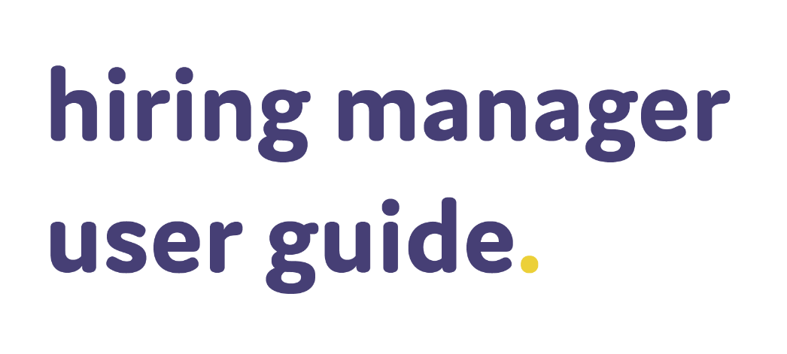



contents.

logging in 2
multi factor authentication 2
resetting your password 5
viewing your jobs/applicants 9
shortlisted applicants email alert 9
jobs list page 9
applicant list page 10
applicant record page 10
updating an applicant’s status 13
statuses available in your system 14
scheduling interviews 16
choosing the applicant(s) you want to schedule for interview 17
booking an interview in 3 steps 18
using self-service interviews 22
vacancy approval module 31

logging in.
When your ATS is setup you’ll receive an email like the below with a link to your hiring manager portal (this is where you login) along with your username and password.
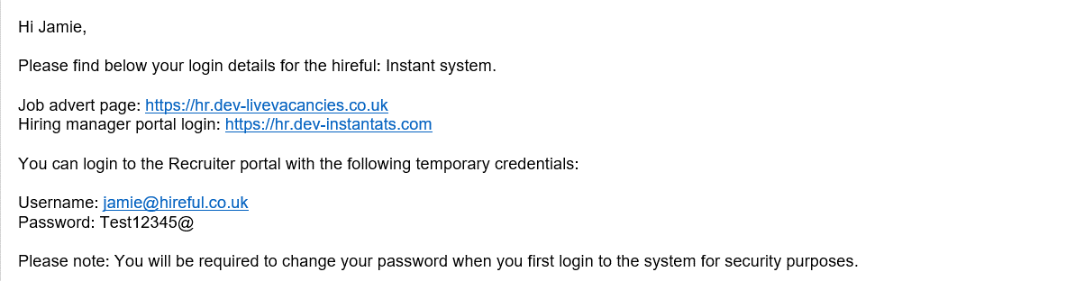
If you have been sent these details but can’t find the email, please check your spam/junk/clutter folders, sometimes it can land in there.
If you still cannot find this email please contact the support team who will be able to assist you (support@hireful.co.uk / 09133 667164).
Multi-factor authentication.
Depending on your company/organisation’s IT security policies, you may find when you log in you have the multi factor authentication (sometimes called two factor authentication) feature enabled on your login. This is an extra level of security when logging into the system.
If multi factor authentication is enabled by your company/organisation, after entering your username and password, you will be asked to enter the mobile number that you wish to register your account against.
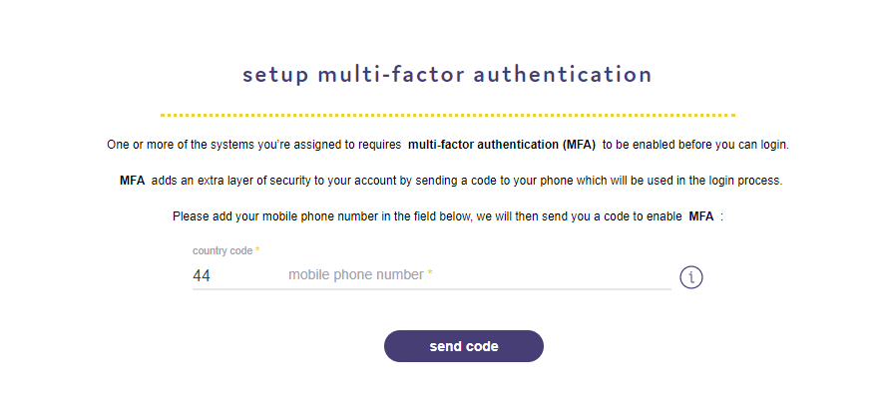Please note when entering the mobile phone number, make sure you remove the first digit of your mobile phone number in line with international dialling standards e.g. for +44 region number, please remove the "0" digit at the start of your number.
You will then be sent an SMS message with your sign in code. Enter that and then press submit.
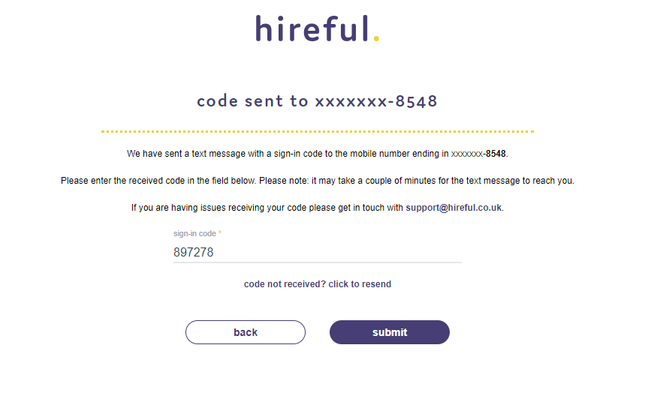
You will then get a confirmation message appearing to say that MFA has been enabled on your login.
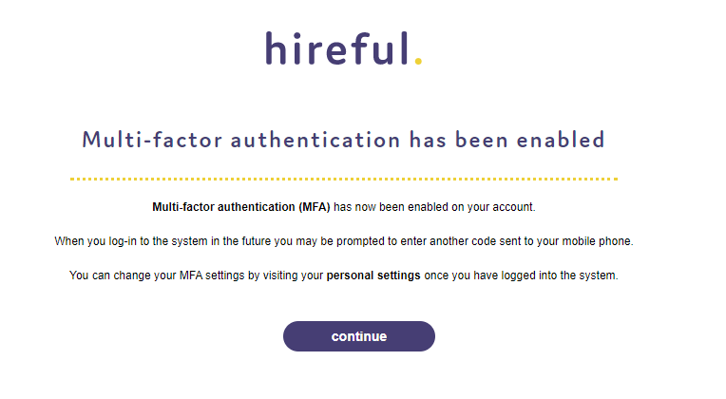
Click continue to login to the ATS.
You can update your MFA settings at any point should you need to. For example if you wanted to change the phone number where the sign in codes are sent. In your settings section, under the My Profile tab there is a section called Multi-factor authentication.
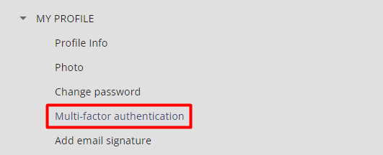
resetting your password.
If you can’t login to the ATS you, don’t panic. You’ll probably just need to reset your password. Your username will always be your work email address, so hopefully, you’ll never forget that part.
To reset your password simply click on the "Forgot Password?" link (see highlighted section below).
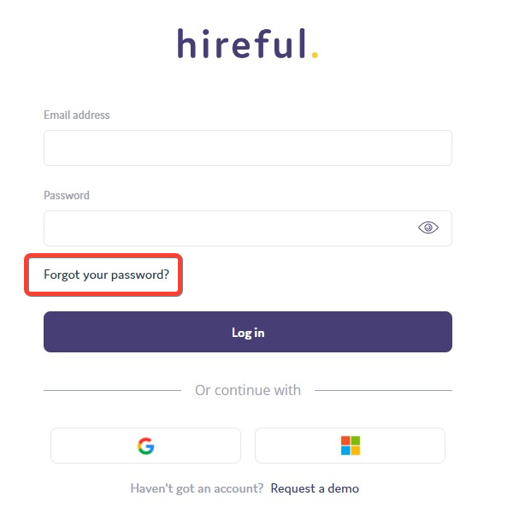
This will bring up the "Get Password" window where you will need to add in your username (Remember this part? It’s your work email address!)
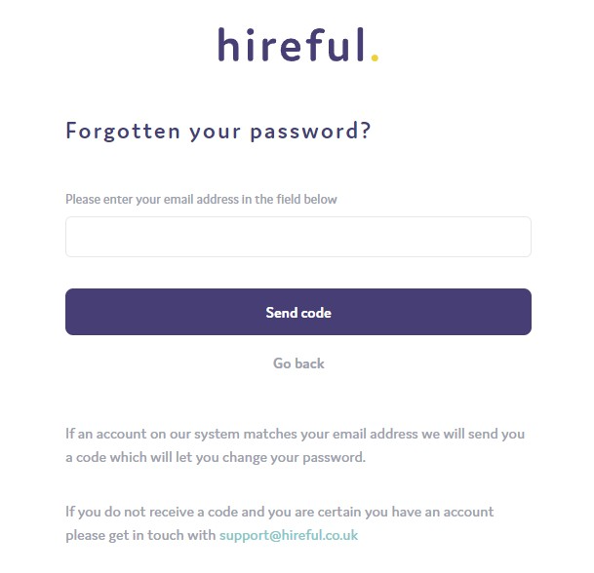
Once you add in your email address you will be sent an email with a reset code that is used as a security check to create a new password for you.
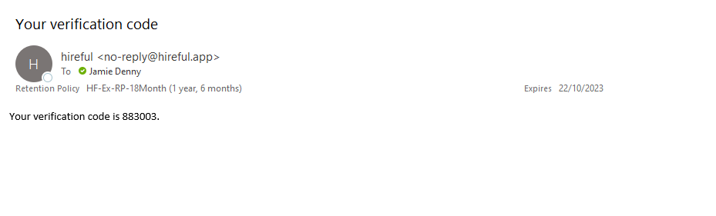
With this code you can now setup your new password. Enter the code and your new password and then click “update password” to save these changes.
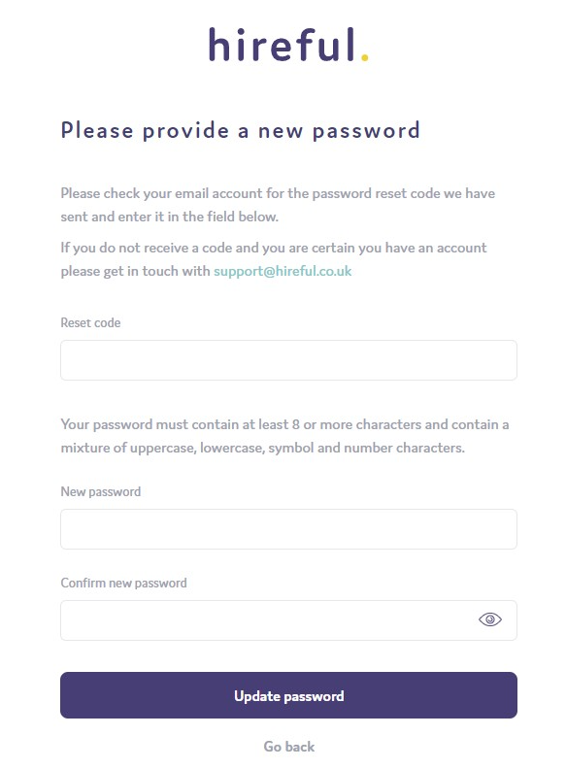
Please note: Your username and password are case sensitive when logging into the system.
viewing your jobs and applicants.
Our recruitment software is designed so that your colleagues over in HR/Recruitment will advertise the organisation’s jobs. Then the relevant applicants for your jobs will be published to your hiring manager portal, it’s great for you because it means you only see the information relevant to you.
You can login to the hiring manager portal at any time and progress/reject these applicants.
shortlisted applicants email alert.
The system will alert you when you have new applicants to view by sending you an email like the one below:
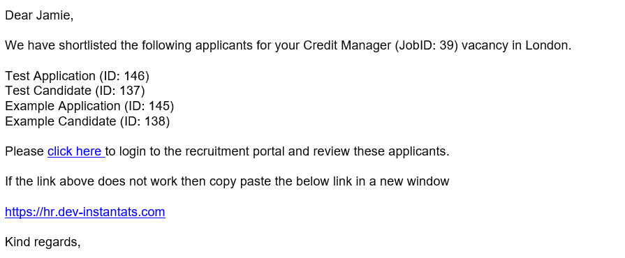
jobs list page.
When you login you will see your jobs list page. This displays all the active jobs where you’re assigned as one of the hiring managers.
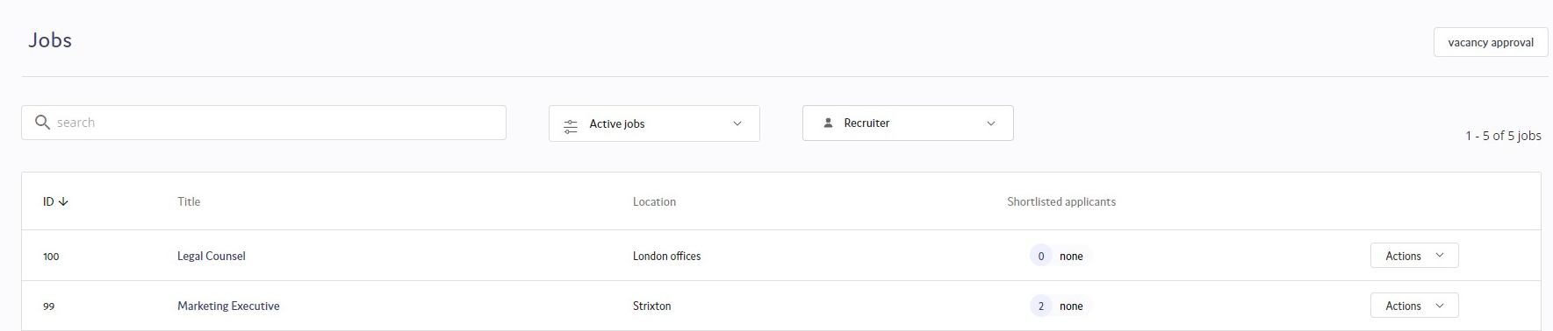
If a job has active applicants, you will see the number of applicants listed in the “Shortlisted applicants” column. This column will also highlight where applicants are “new”. Technically, this does not mean new applicants. It highlights applicants that you haven’t processed yet and are still listed with the status of “Shortlist”.
applicant list page.
From the jobs list page, click on the shortlisted applicants number to go into the list of applicants for the role. This is what we call the ‘applicant list page’.
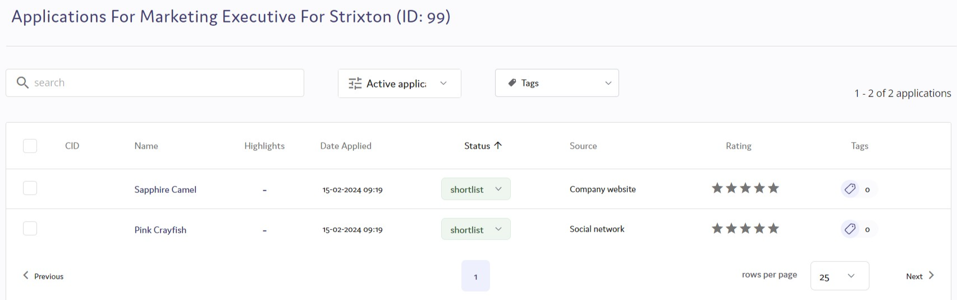
Here you can see:
- the status of each applicant
- their source of the application
- if they have been rated & what they’ve been rated as
- any tags assigned to them
To view an applicant in more detail, you’ll need to click on their name to view their applicant record page.
applicant record page.
If you click on an applicant in the applicant list view, you’ll open the applicant record.
The applicant record has been designed to show you all the information you need in order to make the correct resourcing decision on this applicant. The design is based on two windows, with the left-hand window showing the applicant's completed application form, the job details and the activity log and the right-hand window showing the CV or other relevant documents.
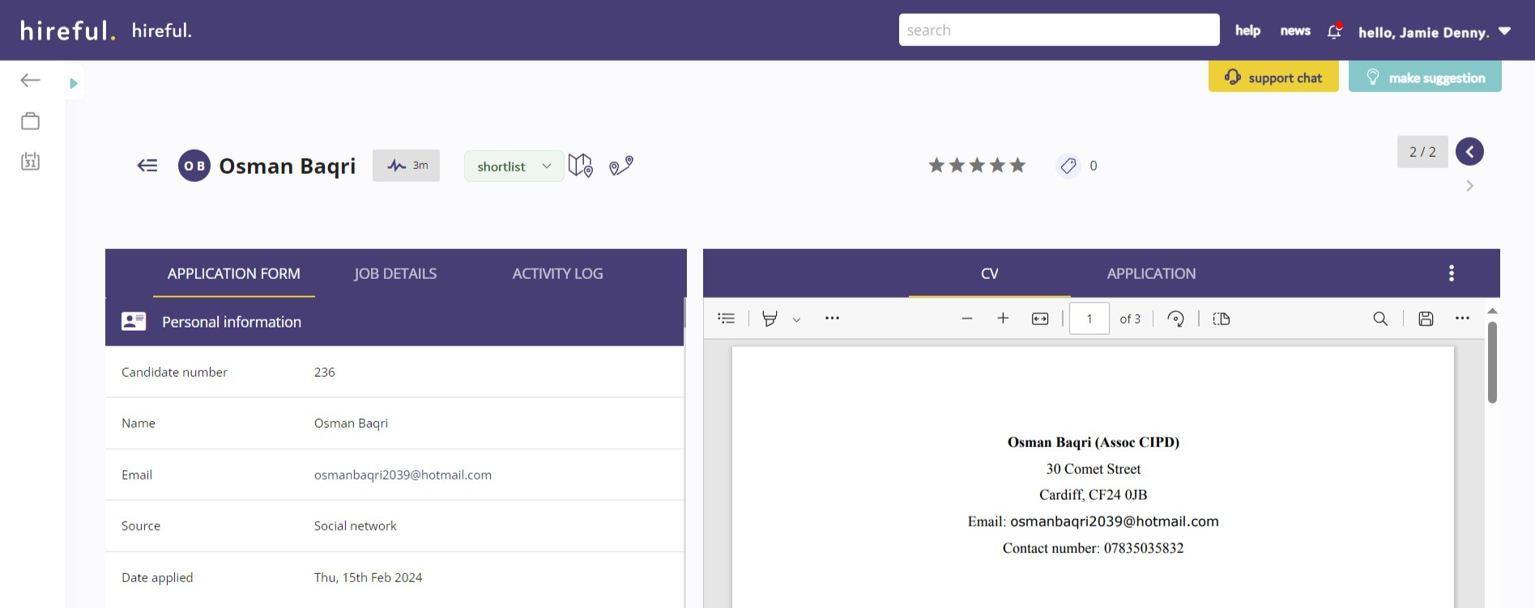
You can choose to change the view in either window by choosing from the heading options in the left hand window (options include: App form, Job details & Activity log) and in the right hand window you can change the view of the document shown by selecting from the list of available documents in the highlighted tabs that currently shows "CV".
Please note: If your organisation does not accept CVs as part of their application process then you will see the application form in the right-hand window.
You can also expand on the view of the document held in the right-hand window by clicking on the three white dots on the right-hand side of the page and then selecting “Open in new window”. This will open the full document in a new window, see below:
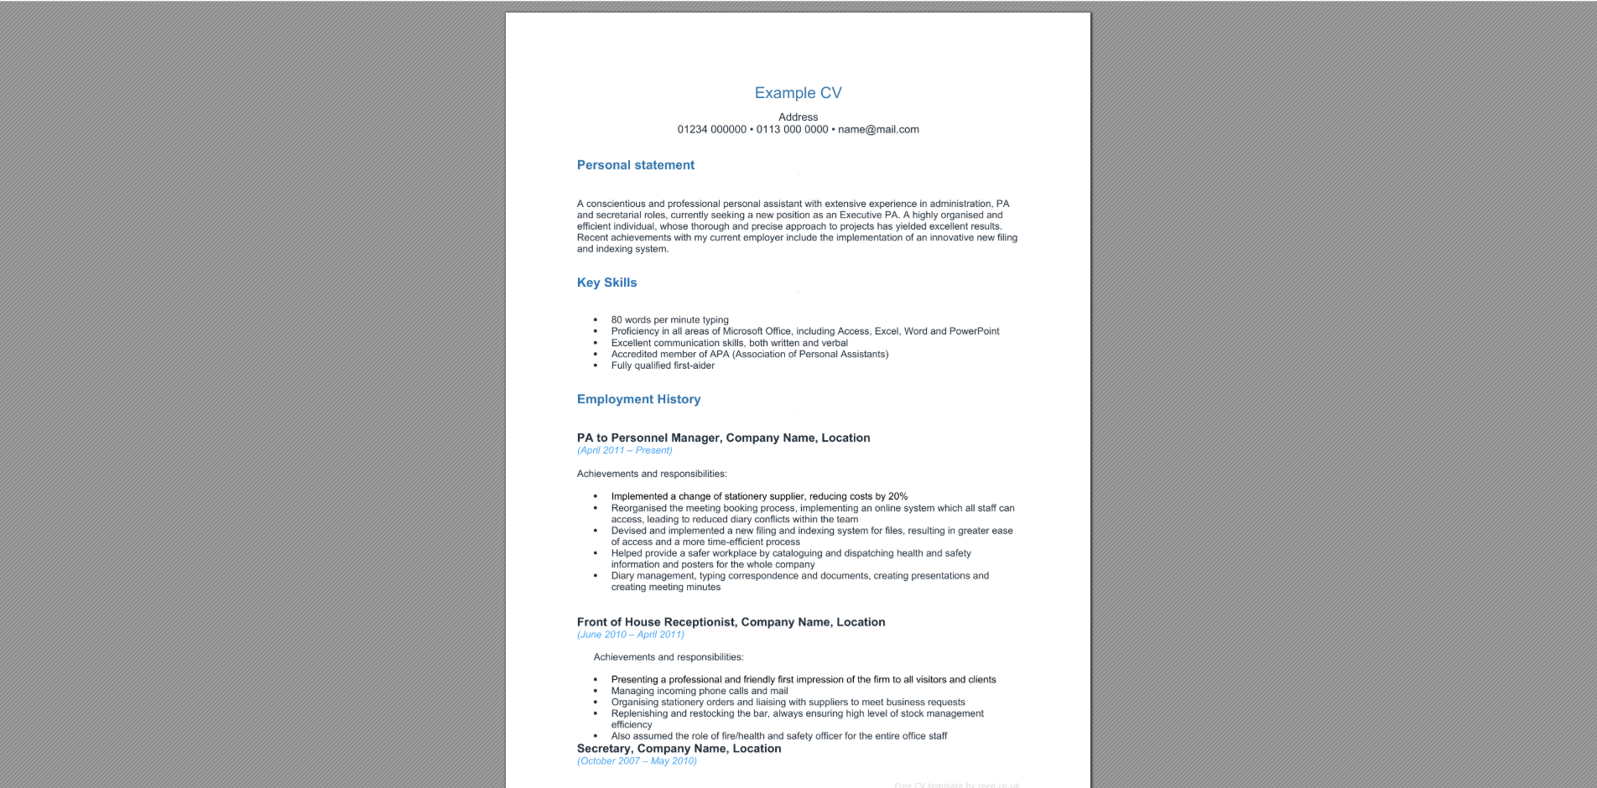
When you’ve reviewed the relevant information, you can choose to update the applicant's status or rate them (see below).
Once you update the applicant record you can choose to either go back to the list of all applicants or stay in the applicant record view but progress to the next applicant.

updating an applicant’s status.
When reach the decision to progress/reject the applicant, you can update their status by using one of the following options:
update status for individual applicant record
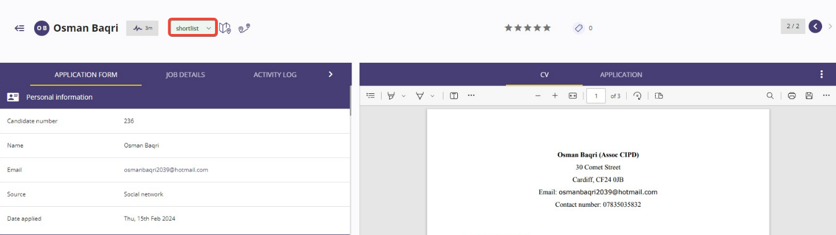
When you are in the applicant record you can see the current status listed in the top of the page near the centre (see image below):

When you click on this area you will see a drop-down list where you will be able to change the applicant’s status.
update statuses of multiple applicants
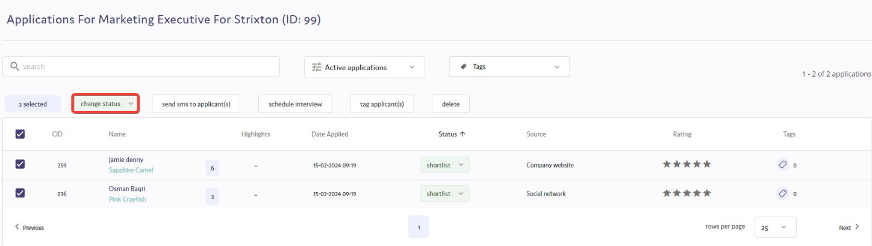
When you are in the applicant list view you can select each of the applicants you want to update the status for by selecting the checkbox to the left of the applicant name. You can then select the option to “Change status”.

statuses available in your system.
Below are some of the more common statuses that appear in the hiring manager portal and an explanation of how they are used.
- Proceed to interview: You would choose this status to signal your opinion that the applicant should be requested for interview
- Interview: This status suggests you have scheduled an interview with this applicant. Depending on how your system is configured, choosing this option might offer you the chance to schedule an interview (see scheduling interviews on page 10).
- Recommended for rejection: Choose this status when you think the applicant should be rejected.
- Reject no email: This status rejects the applicant but does not send them an email confirming this rejection.*
- Reject auto-email: This status rejects the applicant and sends them an email from a generic email address (e.g. jobs@examplecompany.com) confirming this rejection.*
- Proceed to offer: Use this status when you are recommending that an offer of employment be made to this applicant.
- Hold: Use this status when an applicant is potentially suitable, but you are not able to progress them to the interview stage.
- Did not attend interview: This status would record that the applicant did not attend their scheduled interview.
*When you move an applicant to a reject status they may no longer be available for you to view in the hiring manager portal.
Please note: Each system has the potential to have bespoke applicant statuses. So, you might have more or less applicant statuses in your system with different labels. If you are not sure of the purpose of each status you should contact your HR/Recruitment department.
scheduling interviews.
choosing the applicant(s) you want to schedule for interview
The ATS offers you the option to choose to schedule interviews for individual applicants or a batch of applicants. This is assuming the batch of applicants are all interviewing for the same job and will all have the same interviewers.
selecting to book an interview with an individual applicant
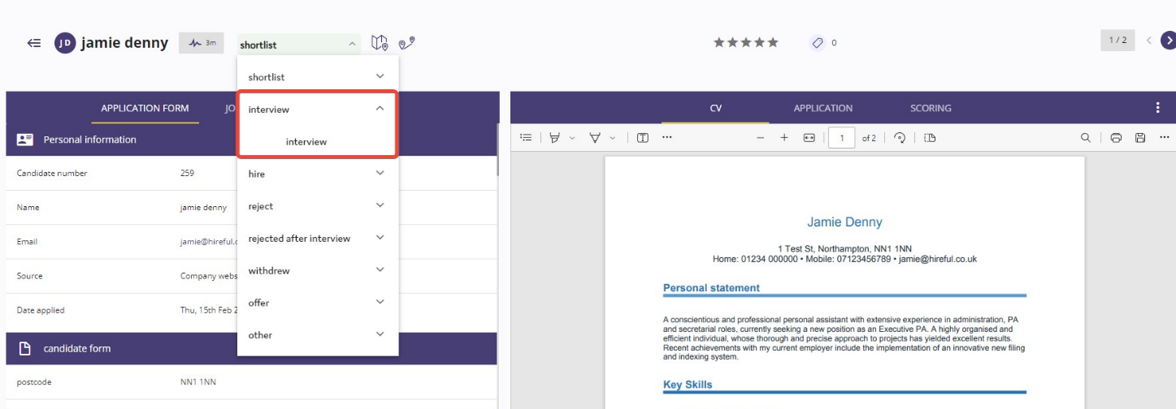
The system will offer you the option to schedule an interview when you move an applicant to any of your interview statuses.

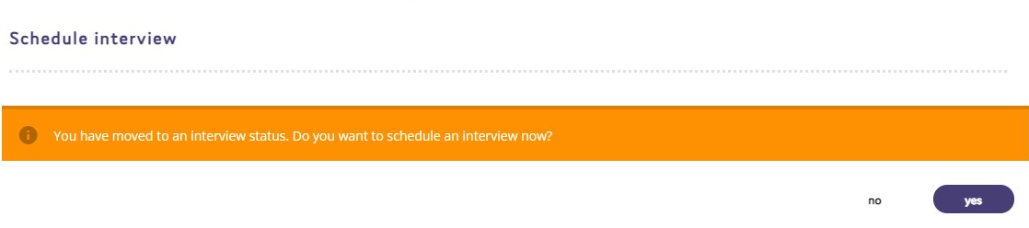
Below is the question offering you the option to schedule the interview via the ATS.
selecting to book an interview with a batch of applicants
You can schedule multiple applicants to interview with the same interviewers for the same job by selecting them from the applicant list and then choosing the option to "Schedule interview".
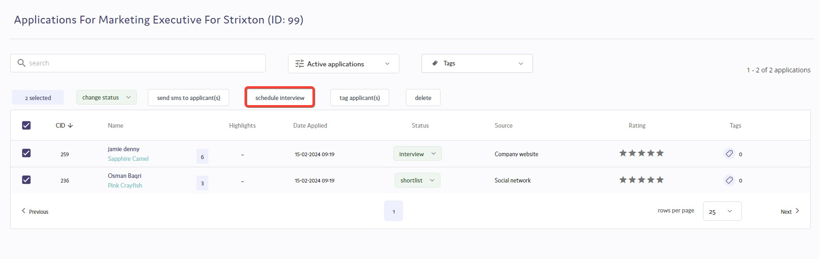

why you should schedule interviews on the ATS.
Scheduling interviews via the ATS offers the following benefits:
- Use of email templates by all users scheduling interviews, will see a more professional and consistent approach to communicating with interviewees and interviewers.
- Interviewers and interviewees can easily add interviews as appointments into their calendar.
- Interviews that need to be changed can be rescheduled with a few clicks and new confirmation details emailed to relevant parties.
- The ATS can report on which applicants went to interview and measure the time taken to get applicants to this important stage in the recruitment process.

booking an interview in 3 steps.
Step 1 - "Interviewers/Candidates"
The candidates for interview have already been confirmed, we only need to confirm the interviewers at this step.
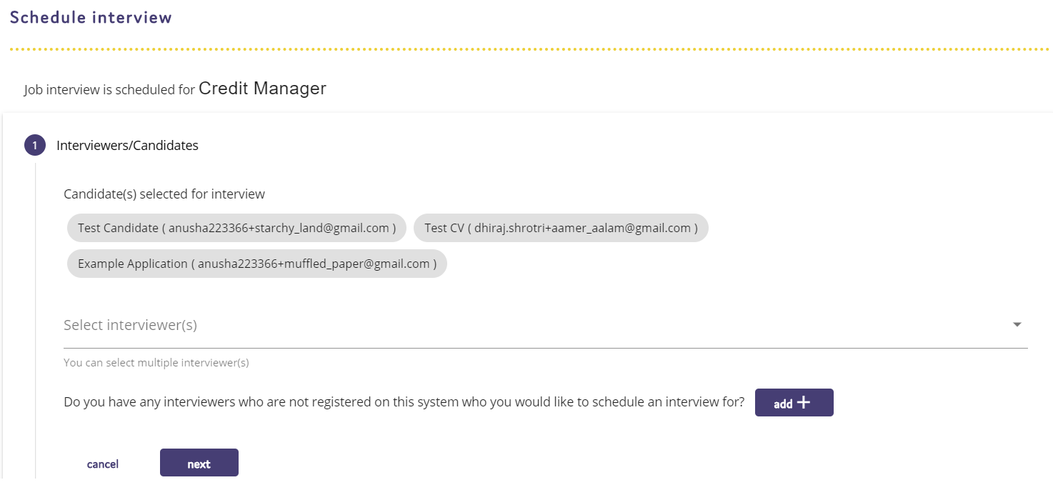
Most users will only need to select the relevant interviewer(s) from the list shown above labelled "Select interviewer(s)".
If you do not see an interviewer who is part of this interview process, then you can choose the option to add them. See example image below:
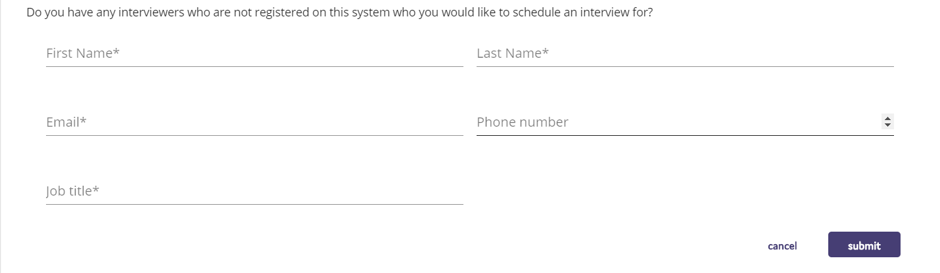
When you’re happy all the relevant interviewers are selected, click NEXT in the bottom right hand corner to proceed to the next step.
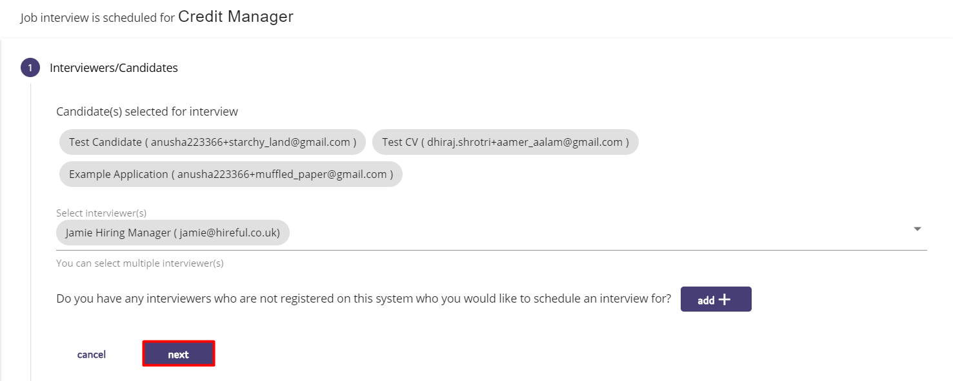
Step 2 - "Confirm time/date"
The next step in the process is to confirm the date/time and the location of the interview(s).
If you are booking more than one interview you will need to confirm if the interviews are happening at the same date/time, for example if this is an assessment centre then you will probably choose the option “Same date/time”. You will also need to confirm if the interviews are happening at the same location.
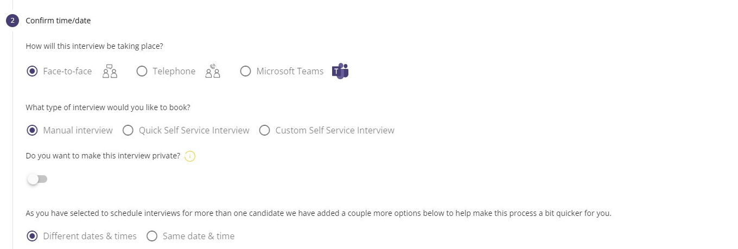
If you confirm that the interviews are not taking place at the same date/time, then you will see the interviewees’ area highlighted in red to remind you that you need to confirm the individual date/time for each interview. The same would apply if you need to confirm individual interview locations for each interview.
Once you have provided all the required date/time and location data you should see no red highlighted areas on this page and you should take one last step to confirm everything and then select the NEXT button in the bottom right hand corner to proceed to the third and final step.
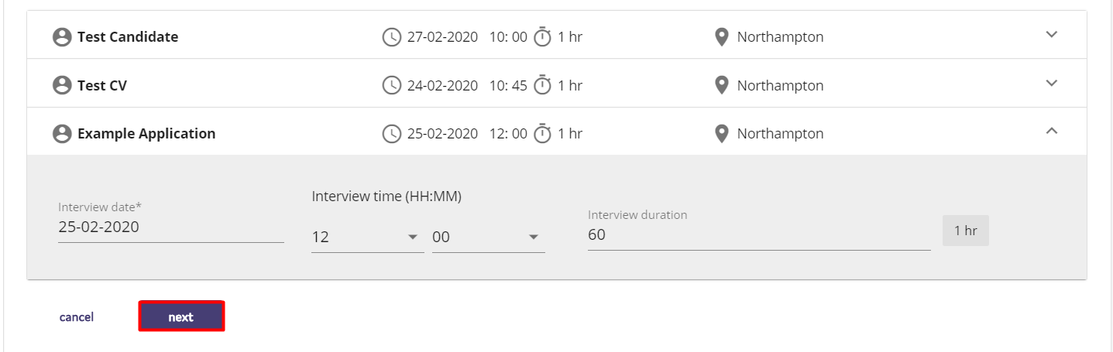
Step 3 - "Interview Communication"
Here you’ll see options to assist you in sending the relevant email to interviewers and candidates. The first half of the page focuses on the options for sending the interview confirmation email to your interviewers. You will see options here for which user you want this email to appear to come from. It can come from the assigned recruiter for this job, the hiring manager or another option. You will also have the option to cc you or any of your colleagues into this email.
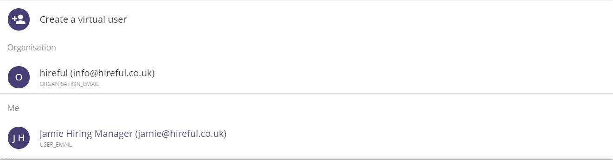
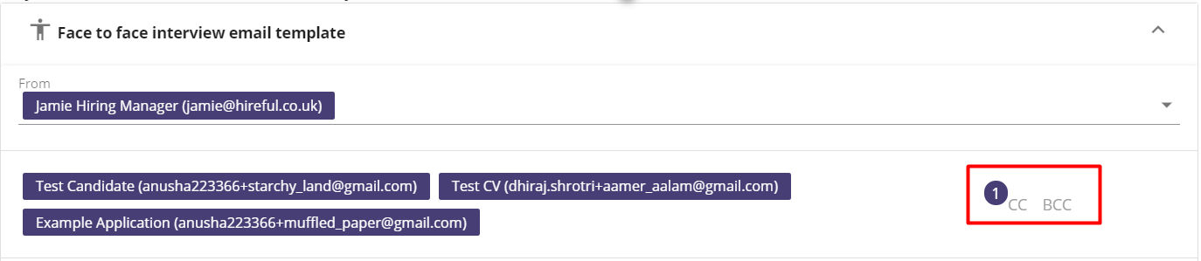
You’ll be able to view and edit the email template that is due to be sent to your interviewers. The ATS can support multiple face-to-face and telephone interview templates, so if you add additional interview email templates you will see these here.
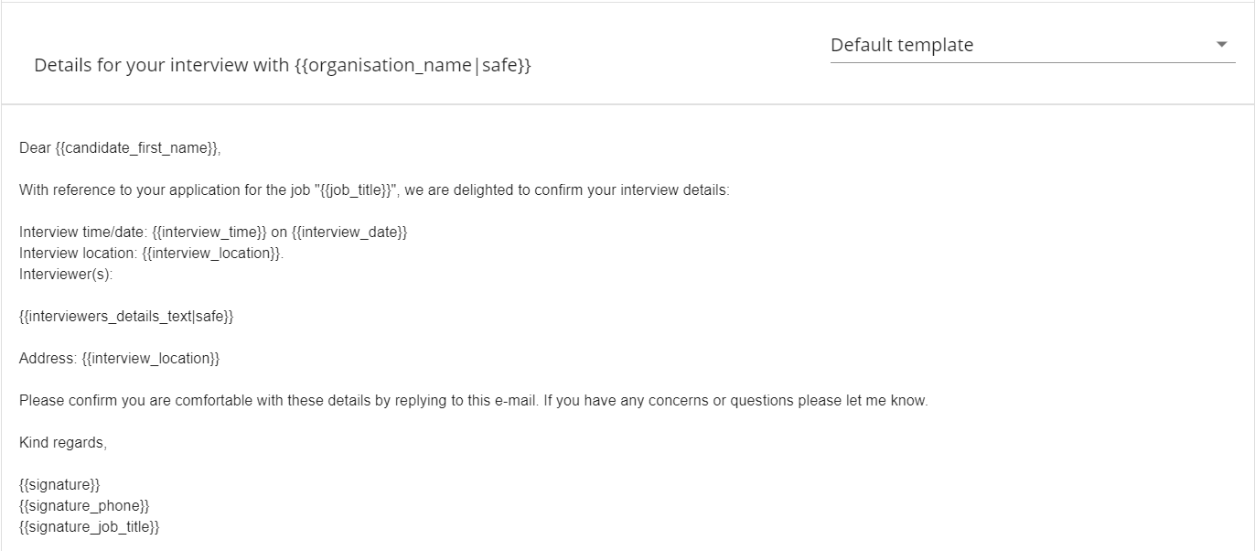
The default setting for emailing interviewers is to attach all relevant documents relating to this candidate’s application to the email. If you do not wish to include these documents, then you can click on the tick icon to not attach them. You can also attach additional files here.
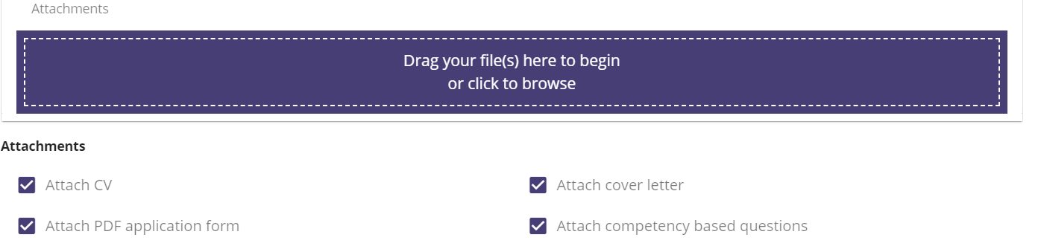
When you are happy with the content and attachments for your email communication then click on the “Send Email” button to confirm these interviews.
You should see a small onscreen message in the bottom right corner confirming that these interviews have been confirmed and emails have been sent.
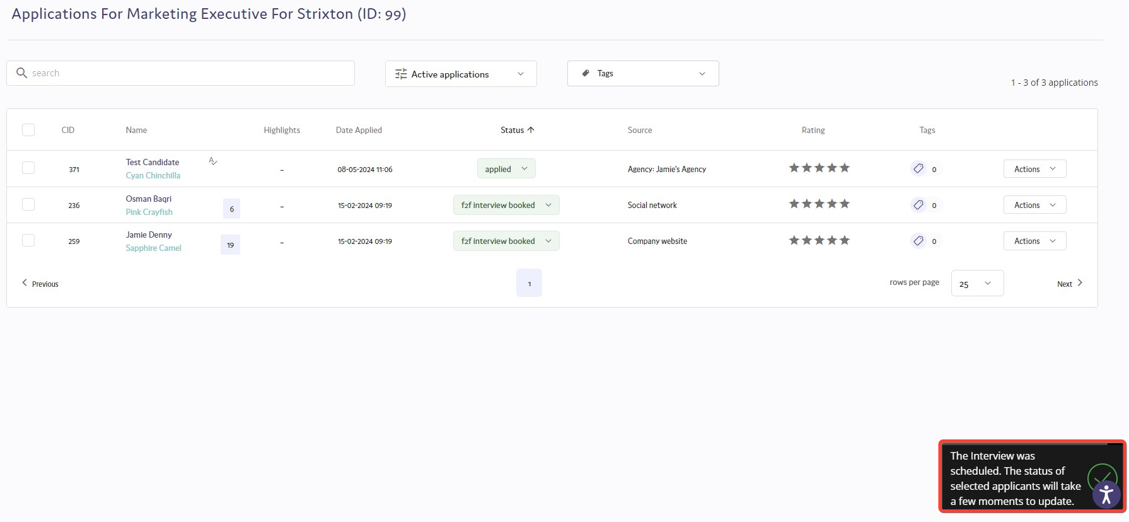
If you refresh the page on your applicant list page, you will see that your applicants have had their status for this position updated to “F2F Interview Booked”. Within a couple of minutes your emails should arrive with your interviewers/interviewees.
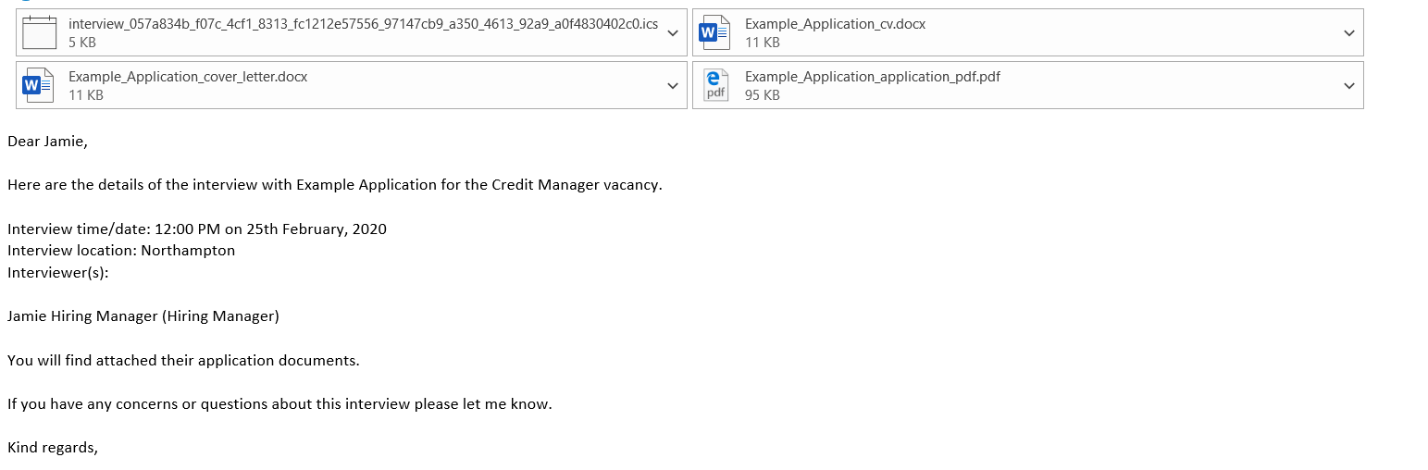
Your interviewers/interviewees will have an appointment file (it is called Interview.ics) attached to their email. We would encourage these users to open this attachment as it will open as an appointment to add to their calendar.
This attachment includes links to all the attachments in the original email, so your interviewers will no longer need to email you to ask for a CV on the day of an interview.

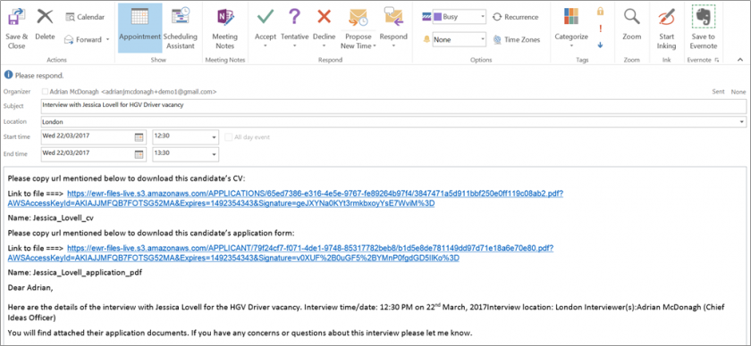
using self-servicing interviews.
What is self-servicing interviews?
There is the option to enable self-servicing interviews with your system. This feature allows for you to select specific date and time slots for candidates to choose their interview slot, and the confirmation emails are then sent once the candidate has selected their date and time slot.
To use the self-servicing interview feature:
Step 1 - Highlight the candidate(s) you’d like to proceed to interview stage:
Step 2 - Confirm and select the interviewer(s) for the role and then press Next:
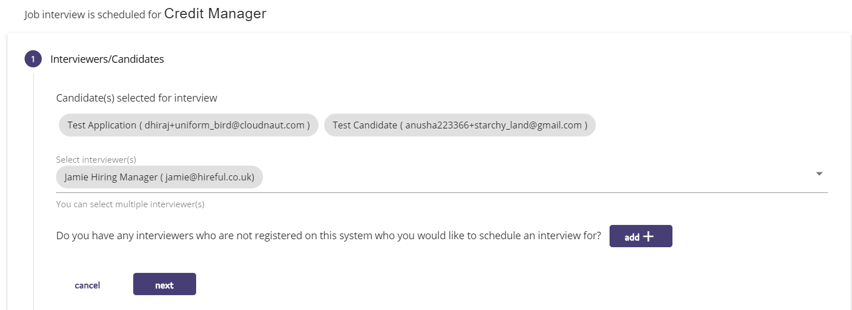
Step 3 - On the Confirm Time / Date tab, you can choose from selecting Quick Self Service Interview or Custom Self Service Interview:
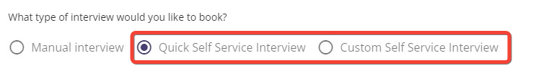
Step 4 – Quick self service interview allows you to select times to follow on after each other, custom self service interview allows you to pick the start time for each individual slot.
​
To schedule quick time slots, enter the duration that you would like each slot to last.
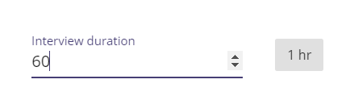
You can decide on what time the first interview slot can start at and the last interview slot can finish.
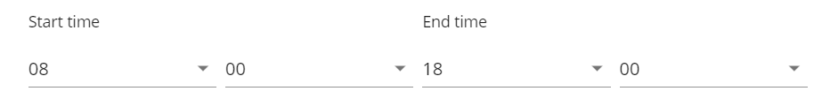
Confirm the date of interview which can be selected from the calendar:
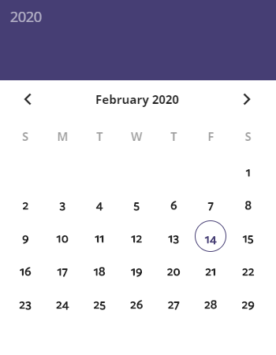
Step 5 - Select the time slots that you would like to make available for candidates to choose:
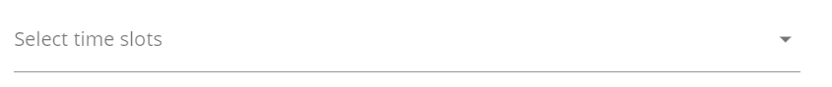
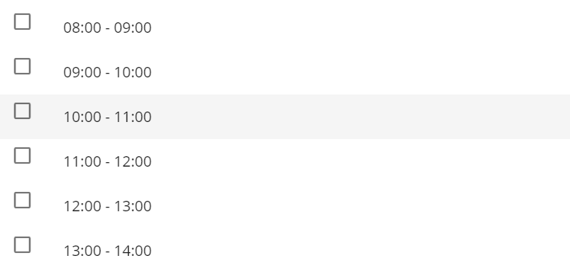
Click on the  button to add further date and time slots.
To book custom time slots, enter the duration in minutes that the slots will last.
​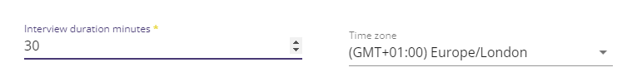​​
You can then select the interview date and then the start hour and minute for the first slot.
​​​
To add in a new slot, click the "add another slot" button. ​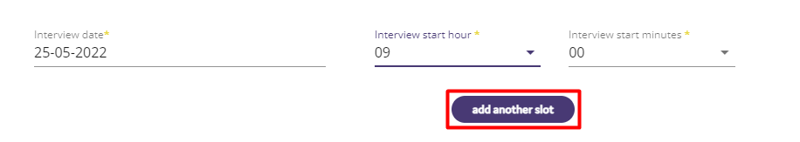​
Repeat the process by selecting the interview date and the start hour and minute for the second slot.
​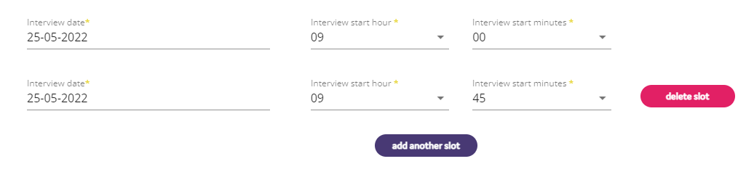​
Step 6 - You’ll then be asked to confirm if the same location is going to be used for all the interview slots. If it is, then move the slider to Yes and confirm the interview location.
Step 7 - Select if the interview is going to be a face-to-face or telephone interview.
If you select a telephone interview, confirm the number you will contact the candidate on, or if a face-to-face interview, confirm the location of the interview.
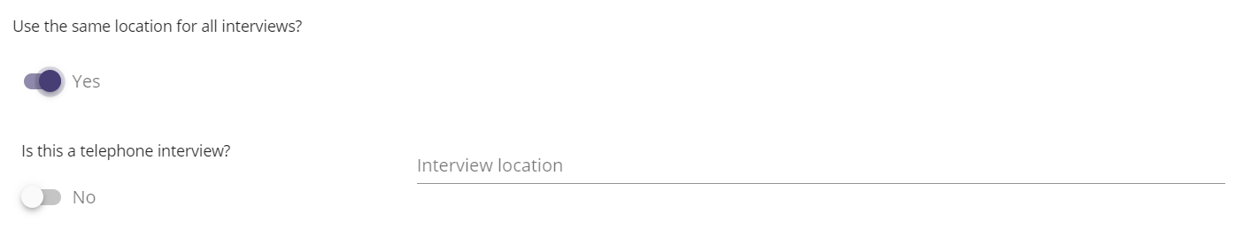
Step 8 - The communication tab will then allow you to send confirmation emails to the interviewers and candidates. At the bottom of the page there will be an additional email option called “Self Service Notification Email to Your Candidate(s)”
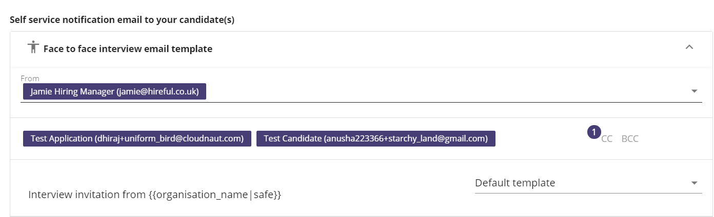
This email is sent to the candidate with a link for them to click on to select their interview slot:
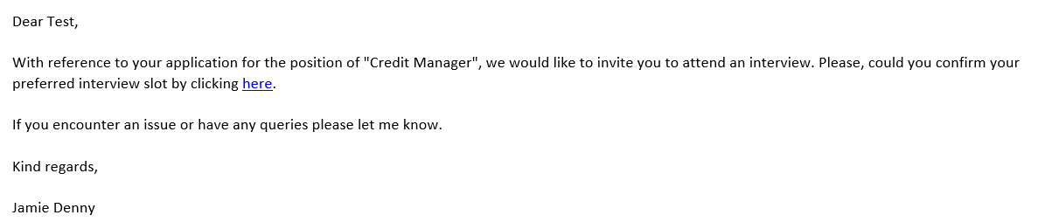
When the candidate clicks on the link, they are taken to a screen to select their date and time slot:
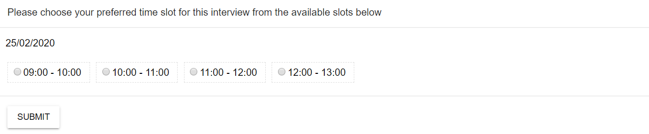
After the candidate has selected their date and time slot, they are informed that this has been successfully submitted, and confirmation emails are then sent to the candidates and interviewers.
The confirmed interview slot will then show in the Interview Calendar, and the time slot will be highlighted green to show the candidate has confirmed this slot:
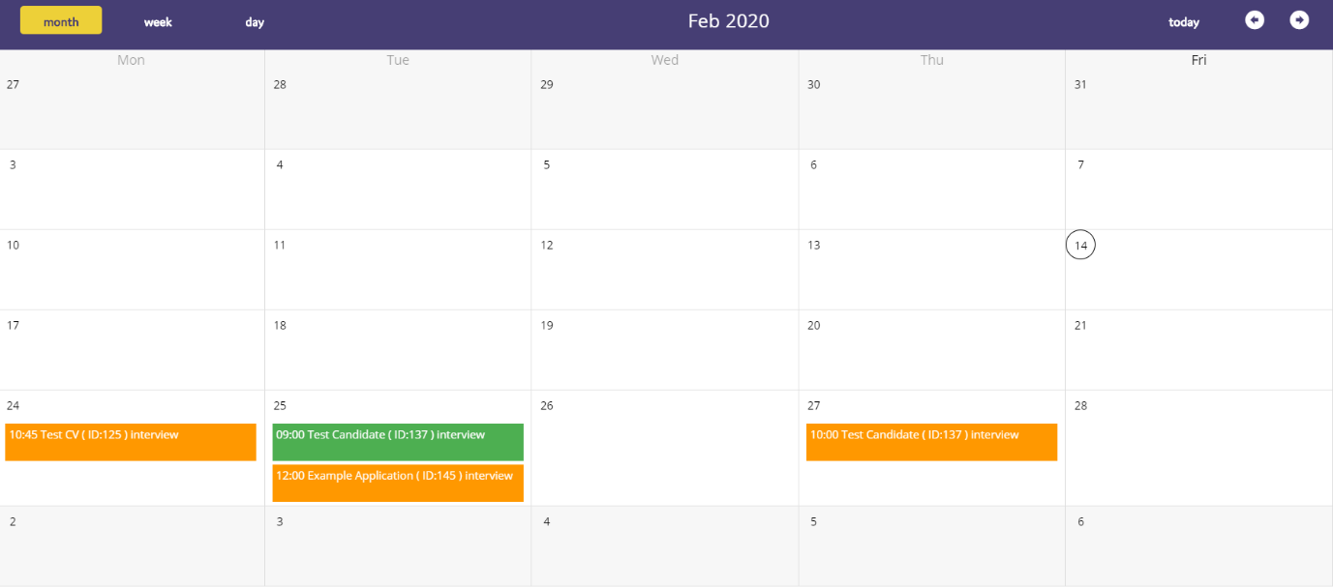
Please note: The self-interview feature works as an independent feature. The slots that are booked are just for that type of interview for that role, they are not shared between different instances of interviews.

vacancy approval module.
Depending on the configuration of your system, you may have the vacancy approval module enabled within your login. This allows you to request a vacancy through the Hiring Manager portal that can then be put through your organisation’s approval process to then create the role on the ATS to go live.
If the vacancy approval module is enabled within your system, on the jobs page there will be a vacancy approval button visible.
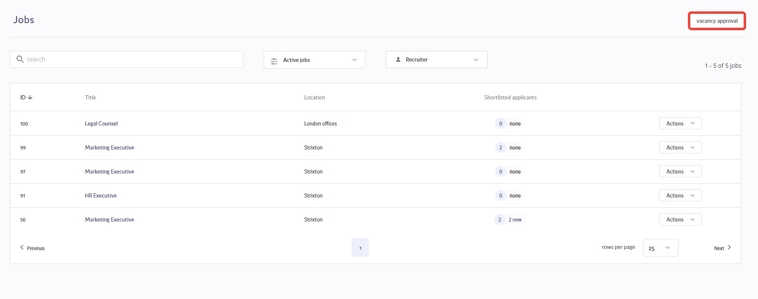
You will then be taken through to a form to be completed providing details of the role you are requesting for approval. Below is an example of a basic Vacancy Approval Form. This is likely to vary from the form that you may be required to complete, depending on the requirements that were requested when the ATS and the Vacancy Approval Form were completed.
Fields with a * are mandatory to complete.
Once you have completed all of the required fields, click Submit and the form will be emailed across to the approver for the role, who will be able to decide to accept or reject the request.
Depending on the outcome of the role being approved or rejected, you will receive an email notification to update you on the decision by the approver.
