



Getting Started
Logging In
Resetting your password

Jobs
Adding a Job – Overview
- Adding general details
- Adding a description
- Adding additional vacancy specific questions
- Adding Files
- Marketing/publishing your new job
Viewing your jobs
Editing the details of a job
Cloning a job
Closing a job off to new applicants

Processing Applicants
Reviewing an application
Rejecting applicants
Shortlisting applicants
The Activity Log
Adding comments against an applicant
Viewing emails sent within the Activity Log
Viewing an applicant’s notes from other applied roles
Updating/replacing files for an applicant
Replacing an applicant’s CV
Bulk status updates

Managing Applicants
Choosing the applicant(s) you want to schedule for interview
Selecting to book an interview with a batch of applicants
Why you should schedule interviews on the ATS
Confirming the interviewers
Confirming the date/time and location
Interview communication
Viewing interviews in the interview calendar
Rescheduling interviews
Self-Service Interviews
Video Conference Interviews
Candidate Database
Manually adding a candidate to the database
Assigning candidates to a role
Searching for candidates in the database
Tagging candidates
Emailing applicants from talent pools

Recruitment Agency Management
Adding a new recruitment agency
Releasing a job to an agency user
How an agency submits and applicant
How to withdraw a job from an agency

User Management
Adding a new user

Reports
Accessing Reports
D&I Reports

Email Templates
Creating and using email templates

Getting Started.
logging in.
When your ATS is setup, you should receive an email similar to the below with link to your Recruiter portal (this is where you login) and your username and password.
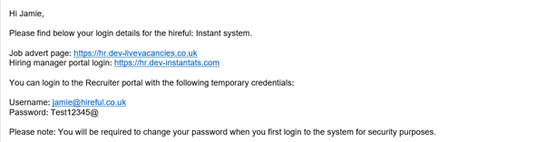
If you have been sent these details but cannot locate the email, please check your spam/junk/clutter folders to see if it has landed in there. If you still cannot find this email, please contact the support team who will be able to assist you (support@hireful.co.uk / 09133 667164).

Resetting Your Password.
If you cannot login to the ATS you will probably want to reset your password as this is the most likely issue, as your username will be your work email address and you are unlikely to forget this.
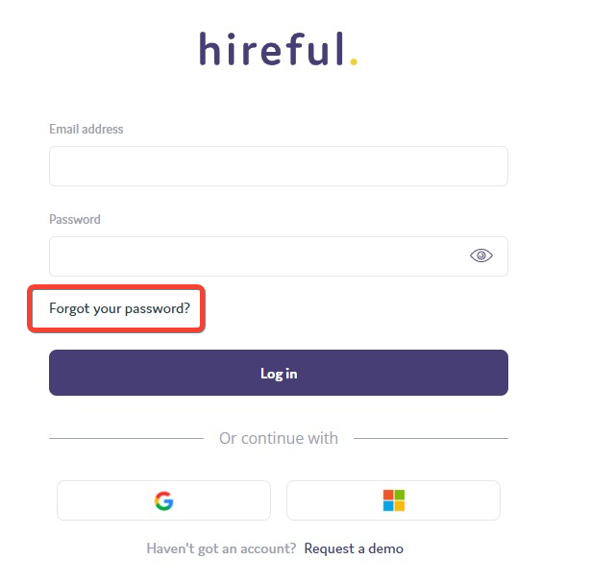
If you have forgotten your password, you can reset it yourself by clicking on the "Forgot Password?" link (see highlighted section below).
This will bring up the "Get Password" window where you will need to add in your username (this is your work email address) and a reset email will be sent.
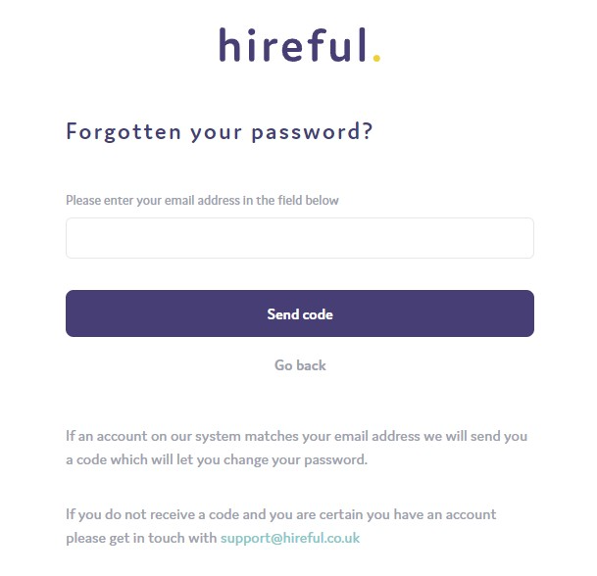
Once you add in your email address you will then be sent an email with a verification code that you need to enter along with setting your new password.
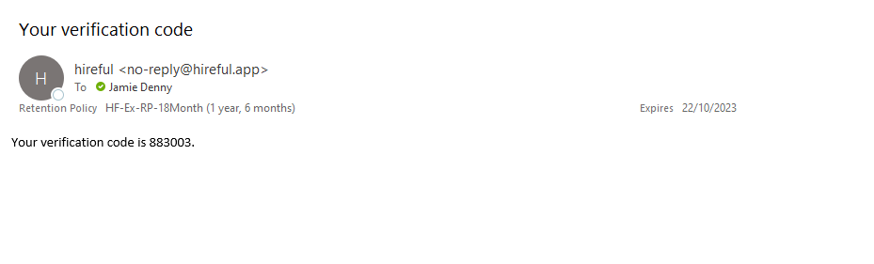
With this code you can now setup your new password. Enter the code and your new password and then click “update password” to save these changes.
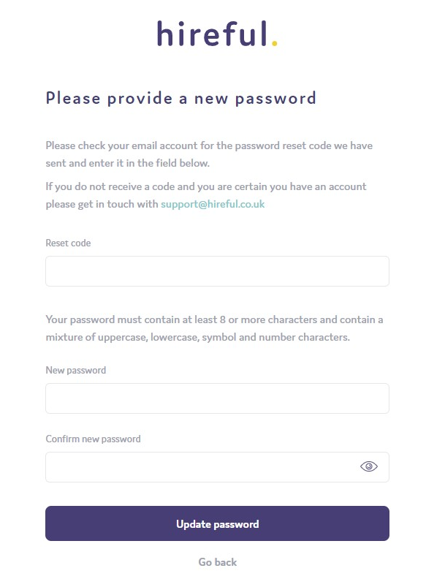
Please note: Your username and password are case sensitive when logging into the system.

Multi-factor authentication.
Depending on your company/organisation’s IT security policies, you may find when you log in you have the multi factor authentication (sometimes called two factor authentication) feature enabled on your login. This is an extra level of security when logging into the system.
If multi factor authentication is enabled by your company/organisation, after entering your username and password, you will be asked to enter the mobile number that you wish to register your account against.
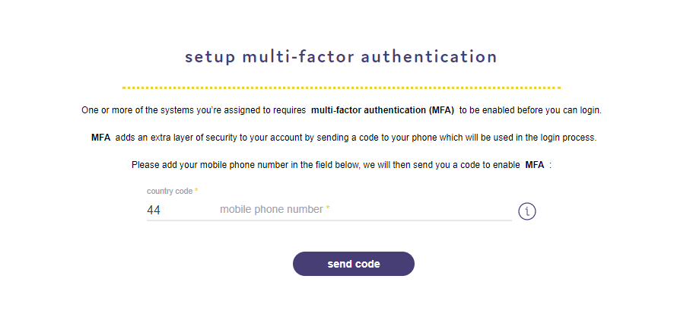Please note when entering the mobile phone number, make sure you remove the first digit of your mobile phone number in line with international dialling standards e.g., for +44 region number, please remove the "0" digit at the start of your number.
You will then be sent an SMS message with your sign in code. Enter that and then press submit.
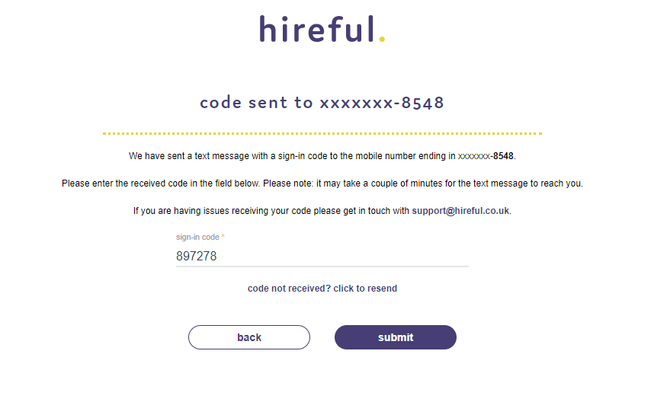
You will then get a confirmation message appearing to say that MFA has been enabled on your login.
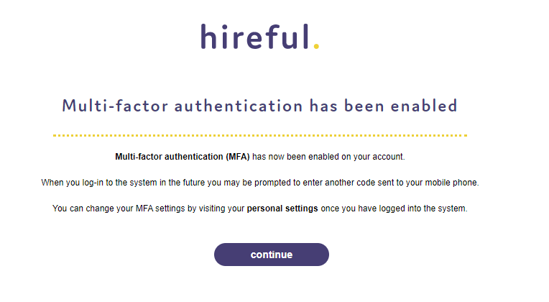
Click continue to login to the ATS.
You can update your MFA settings at any point should you need to. For example, if you wanted to change the phone number where the sign in codes are sent. In your settings section, under the My Profile tab there is a section called multi-factor authentication.

Jobs.
Adding a Job - Overview.
From the jobs list page, you can add a new job by clicking the Add Job button.
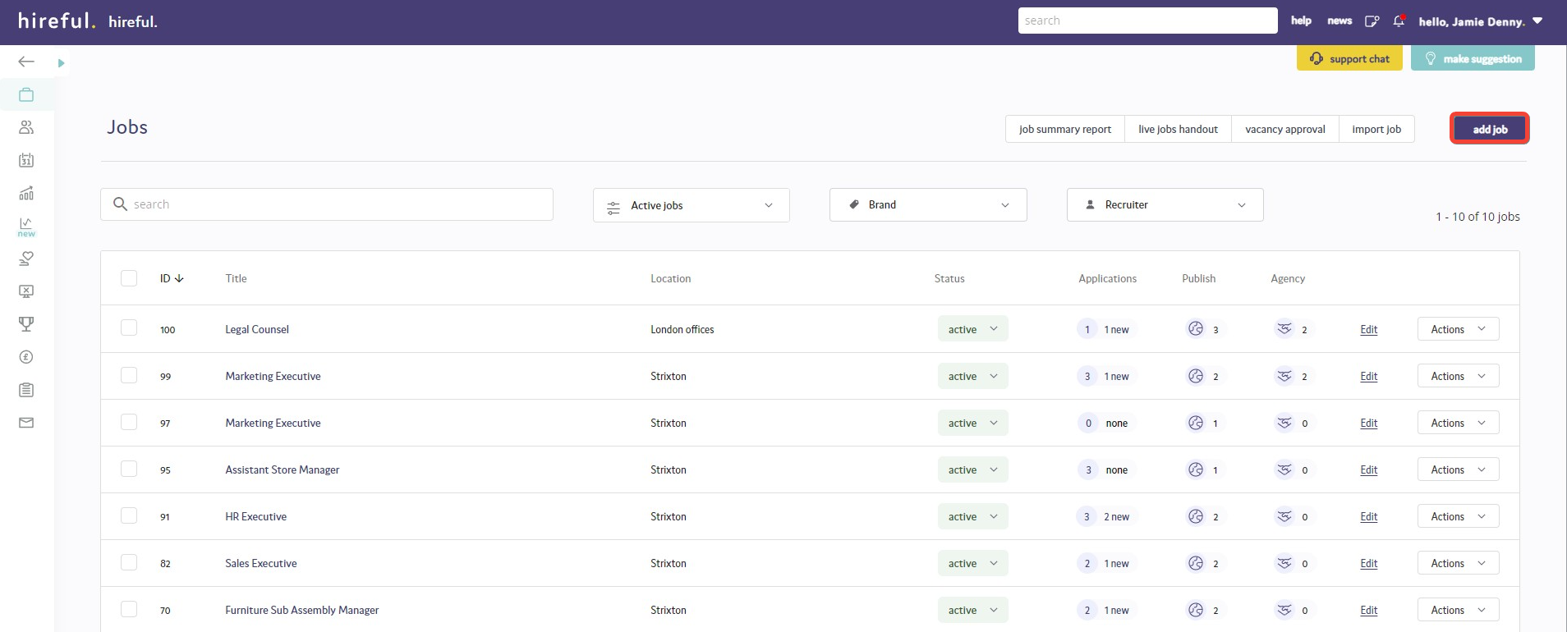
There are 4-5 steps to complete to create a new job to the system, two of which are mandatory (1 & 2).
- General: This step asks the recruiter user to provide the general information about the job e.g., job title, location etc
- Description: This step requires the user to provide the main content for the job advert e.g., role overview, essential skills, etc
- Questions: On this page you can assign additional vacancy specific questions to the very start of your application form. This step is not essential but is recommended.
- Files (this step will not appear in your ATS unless you have requested it): At this stage you can add additional files to your job e.g., Person Specification. These files will normally be published to the job advert and available for download by jobseekers.
- Marketing: This is the final stage where you get to confirm where you want to advertise the new job and any other additional marketing steps.

Adding general details.
The first step in adding a job is to provide some general details about the job. Your add job page might have some bespoke fields added to it, but for 90% of customers the following fields listed below will all apply.
All fields marked with an asterisk* are mandatory and must be completed before continuing to the next step. Once all mandatory fields have been filled click the save button in the bottom right-hand corner to continue.

Most of the above fields listed in the general details page are self-explanatory. If you have drop down fields such as Contract type, Job type and Department that do not have the correct options within them, then contact our support team support@hireful.co.uk and they will be able to update these lists for you.
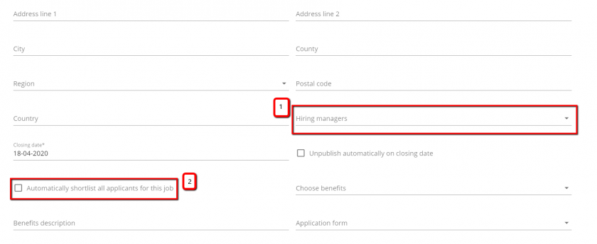
Assigning Hiring Managers (1): You can assign one or more hiring managers to your job (1). There are two main ways of working with this ATS and hiring managers. You can invite them to login and review applications OR you can email them the details of applicants.
Regardless of which option you choose it is a good idea to have your hiring managers listed in the ATS as this will help you when scheduling interviews and for reporting purposes.
Please note: The hiring managers name is not published to your job advert. It is only available to view on an internal basis.

Automatically shortlisting applicants for hiring managers to review (2): If you would like applicants for a specific job to be automatically shortlisted for hiring managers to review then click this option (2). Once applicants apply for this role, assuming they successfully answer any killer questions they will be immediately updated to a status of “Shortlist”. The system runs a daily check to see if any new applicants have been shortlisted for hiring managers to review. If there are then they will then receive an email every morning at 8am with the details of newly shortlisted applicants for them to view.
You should tick this option if the recruiter for this job is not planning to screen the applicants in advance of providing a shortlist to the hiring manager AND you also want to invite the hiring manager to login and view applicants within the ATS.
Closing Date / Automatically Unpublish: If you add a closing date and time to your job, it will be automatically published in your job advert. In addition to this, if you select to “unpublish automatically” then the advert will be unpublished from the jobs page once the closing date and time has been exceeded. This means no further applicants can apply for this job unless you decide to republish it. Once a job has been unpublished the assigned recruiter for that job will receive an email to remind them that this action has been taken by the system.

Choose benefits: If your benefits have been added to the ATS then you will be able to choose the relevant benefit name from the list and the text to display the full details will appear in benefits description. These full details will be displayed to jobseekers viewing the job advert.

Application form: The ATS can support multiple application forms. If you have requested an additional application form to be developed, then you will be able to choose to deploy this alternative application form to this specific job.
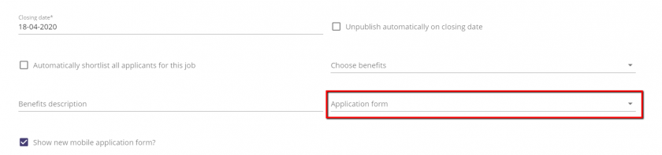

Adding a job advert.
This section is where you add the main content for you job advert.
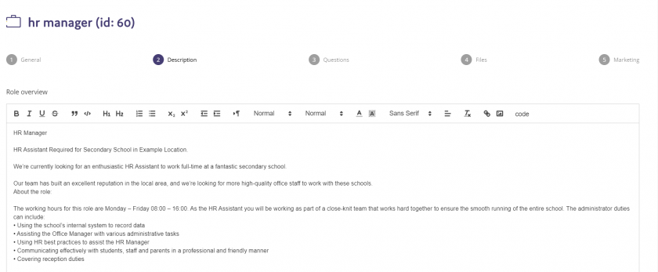
By default, you have one main field here called “Role overview”. You can decide to type or cut and paste your main advert content into this one field and then add section headings within your role overview by using the BOLD option on your text as shown in the above example.
Our description field can support all the standard formatting options you might expect including:
- Font style such as Bold, Italics & Underline
- Font size/colour/type
- Text alignment
- Bullet points
- Numbering

In addition to this our description field can also support raw html so you can add images, videos, hyperlinks etc. to your description.

Adding additional vacancy specific questions.

The ATS allows the user to create additional questions that are asked only to applicants applying for this specific job. We are able to position these questions in the main application form, but as standard your system will be setup to add these questions to the pre-application form, see example below.
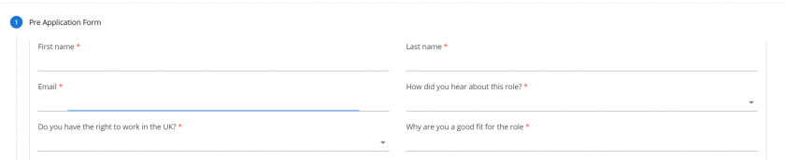
Pre-application questions.
There are currently two types of pre-application questions you can add these are “free text” and “drop down” questions.
Adding a free text question.
Free text questions are typically used to gather more information about an applicant so you can make a better resourcing decision. Example questions could be:
“What is the largest team you have managed?”
“How strong would you describe your Excel skills?”
Adding a free text question requires you to add the question text (1), assign the question as free text (2) and deciding whether you want the question to be mandatory (3). Once you have updated these options you need to remember to select to “ADD QUESTION” (4).
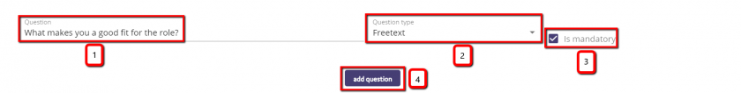
Once a question has been added it will appear as shown below. You can choose to edit this question or delete it if you decide you do not need it anymore.
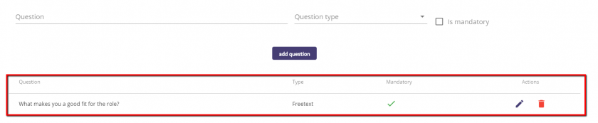
Adding a drop-down question.
Drop down questions provide the applicant with several options they can choose from. They are normally mandatory, and you can also decide to choose to have certain options marked as killer answers. To add a drop down question you need to add your question text (1), select the question type as “drop down” (2), confirm whether the question will be mandatory for all applicants to answer (3), type each option into the answer text field (4) and confirm whether the option you are adding is an auto reject answer (5). Then and then select to add each option (6). Once options are added you will see them listed below (7) with auto reject answers listed in red.
Once you have added the question text and all the options you need for your drop-down list, remember to choose to “ADD QUESTION” (8) otherwise this question will not be added to the application form.
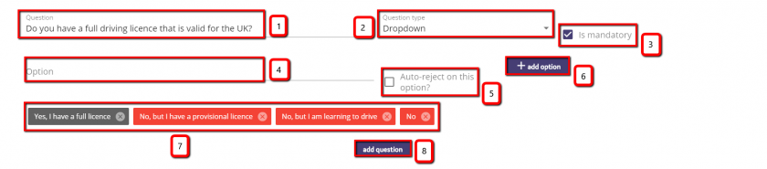
What happens if an applicant selects an auto reject answer?
If an applicant selects an auto reject answer, then when they try to move to the next stage, they will see an onscreen message informing them that they have not been successful in applying for this role. See an example screenshot of this below:
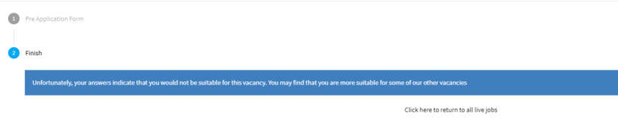
They will be logged in the ATS as a failed application for this job. However, you will typically not see these applicants as they have been rejected and the system defaults to show you only active applicants. You can view these applicants by changing the drop down on the applicant list page to view "All applicants". See an example screenshot of this below:
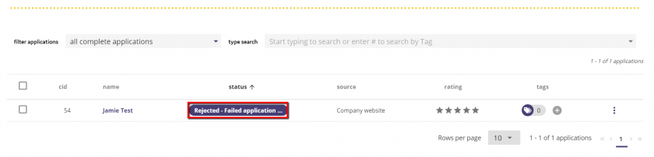
Re-applying after you have failed an auto reject answer.
The ATS treats each candidate’s email address as the key piece of information by which to establish their identity. This means if an applicant applies for a second job using the same email address, both applications will be linked to the one candidate record. This also allows us to stop candidates from reapplying for a job for which they have already applied. If an applicant who has failed an auto reject question tries to reapply, assuming they use the same email address they would see a warning message informing them that they have already applied for this role.
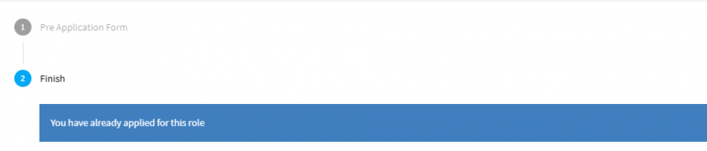

Adding Files.

Please note: As most of our customers choose not to attach files to their job, we have removed this step from being included in your ATS as standard. If you wish to attach files to your job, then contact our support team (support@hireful.co.uk) and then can enable this feature for you.
You can add files to your job record and choose to publish these files to the job advert.
All files that you attach to a job record are published to the job advert page so it you are saving a document that you do not wish to publish then click on the globe icon (see below image) and once this is black then the document is not available to be viewed in the job advert.
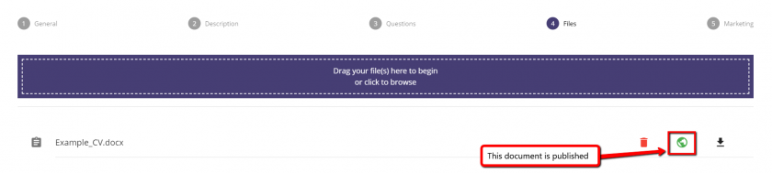

Examples of documents you might want to attach to a job record

- Job description/person specifications
These are the most common type of documents added to a job record and they are normally published.
- Request for vacancy approval documents
If your organisation has an internal document that is completed to authorise the recruitment for a new vacancy, then it might make sense to save this document against the relevant job record but not publish them.
- Notes for interviewees to review prior to interview
If a job has a specific set of instructions, test, presentation or similar then these can be saved against the job but not publish them. You can see in the image below that when you are booking an interview for this job these notes will be available to be shared to the interviewee.
- Travel Instructions/Maps that interviewees might need prior to interview
Similar to the above notes example, if the job is based in a specific location that is likely to be the interview location, then you might choose to add these documents to the job record but not publish them. You can see in the image below that when you are booking an interview for this job these travel instructions will be available to be shared to the interviewee.
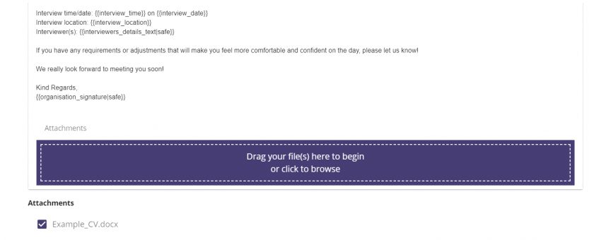
Marketing/Publishing Your New Job.

In this final step you can choose the job publishing and marketing options that are relevant to your job. This is an area that is customisable so you may not see all the options below. If any of the options below are missing but you would like them enabled for your system, please contact the support team (support@hireful.co.uk).

Publishing Options
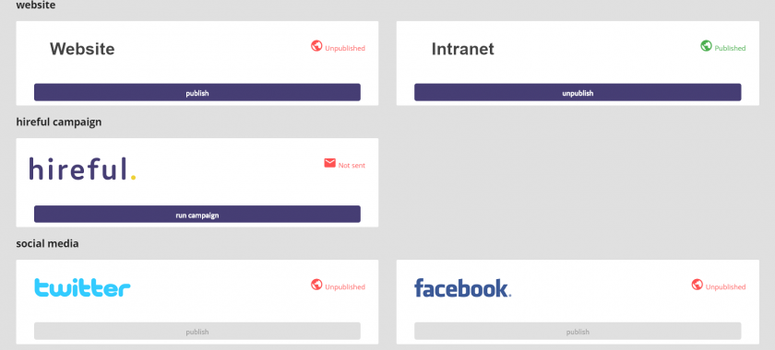
Options include:

Your websites.

- Website: This will publish the job to you jobs page or jobs table that is either linked to your website (jobs page) or embedded in your website (jobs table).
- Intranet: We can provide an additional jobs table that can be embedded in your intranet, so you can publish jobs only for internal applicants to see. This feature also comes with a free additional internal application form, as the application process for internal applicants is likely to differ from what you expect of external applicants (for Professional & Premium edition customers only).

hireful.

- hireful offer managed online recruitment campaigns (see www.hireful.co.uk for more info). These are integrated with your ATS so that applicants will view your adverts and be redirected to apply back into your ATS. If you select this option here, a pop-up box will appear allowing you to confirm which type of campaign you would like to run (depending on the credits that you have purchased with hireful) and place comments/notes to alert us about more information on the job.
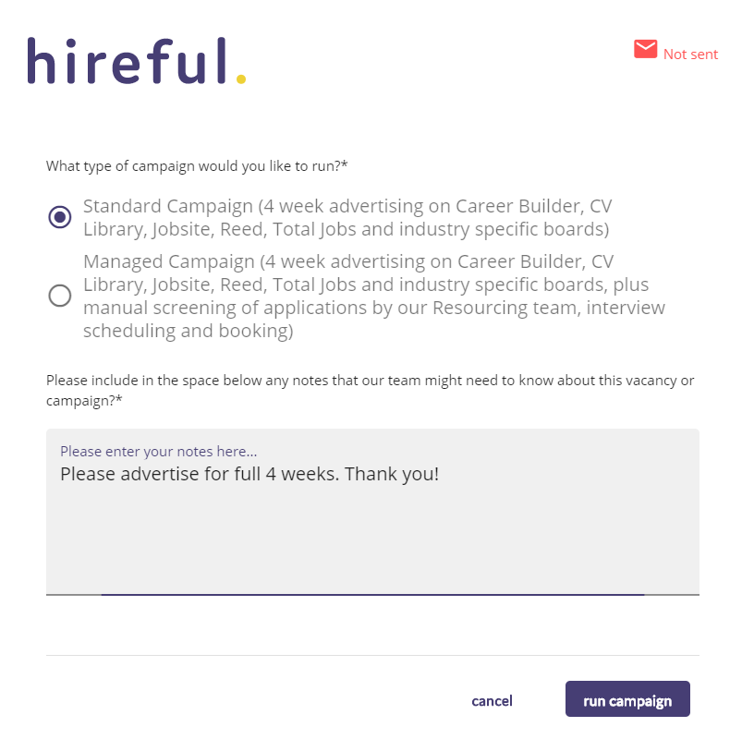
Clicking the Run Campaign button will trigger an email to our recruitment team who will draft an advert and posting proposal for you to review and then confirm if you would like to proceed.

Social media.

All the below social media options require the customer to have integrated their social media accounts with our service. If you’re interested in doing this, then contact our support team who will be able to provide you further details (support@hireful.co.uk).

- Twitter: When you select this option you can publish a tweet about this new job to your twitter page.
- Facebook: When you select this option you can publish an update about this new job to your Facebook page.
- LinkedIn: When you select this option you can publish an update about this new job to your LinkedIn company page.

Job boards.
The options below allow you to automatically publish to a selection of job boards. With hundreds of job boards available in the UK, our focus has been to enable publishing to the most universally relevant job boards, including the free to use job boards that we suspect a large majority of our customer base will want to use. If there’s a job board that you would like to post to that is not included below, please contact our support team (01933 667164 or support@hireful.co.uk) and they’ll be able to log your request for the Product team to review.

Each of these job board options needs to be enabled for you, so if you see an option below that is not enabled, please contact our support team.
When you select the option to publish to job boards you might be asked to provide some additional information about your job. This is because the job board has some additional fields that will help further categorise your job. It’s always a good idea to complete as many of these fields as possible to ensure your job is correctly categorised on the job board.

- Indeed: When you select this option your job will be published to Indeed. If you request for Indeed to be enabled, then all jobs that you publish to your website will be published to Indeed. See www.indeed.co.uk for more information.
- Glassdoor: When you select this option your job will be published to Glassdoor. See www.glassdoor.co.uk for more information.
- Publish to Jobcentre/Find a job: When you select this option your job will be published to Find a job. See https://www.gov.uk/jobsearch for more information.

Job alerts.

If you have job alerts enabled in your ATS then all applicants who register for job alerts can be notified via email about this new job. All you need to do is select "email details of this job to job alert registrants?" and then choose the relevant salary range and region that would apply to this job.

When you select "Get Count" the system will run a search and let you know how many applicants meet these criteria and will receive the email alert.

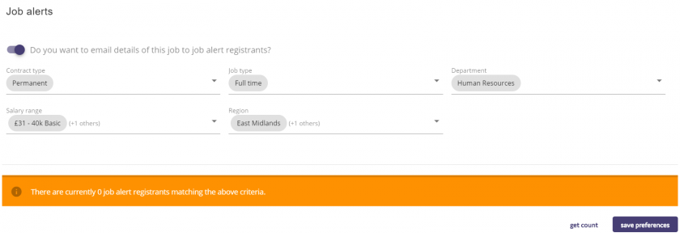
This is how the email to a job alert registrant will look:
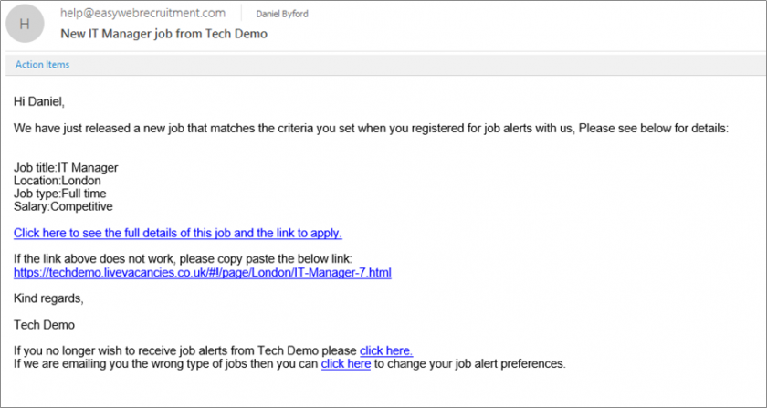

Automated tracking.
All the above options will post a specific link to each different website/social media site. This individual link will contain some tracking code which will allow the system to automatically track where the applicant came from. So, applicants will see the question "How did you hear about this role?" on the pre-application page, but they will not be able to change it as it is set. See below for a visual example:

This allows us to produce more accurate reports on which sources are producing you relevant applicants as we are not relying on the applicant choosing the right option.

Viewing your jobs.

You can view your published jobs by opening your jobs page. If you are not sure the location of your jobs page, then you can find the link within your ATS.
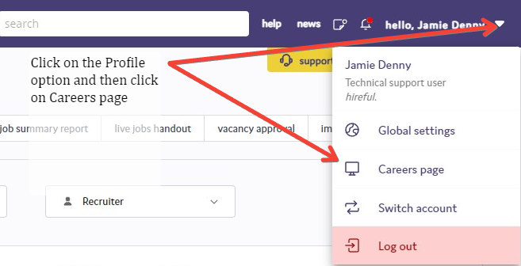
Jobs page or Job table.
For most customers you will either have a standalone jobs page or a jobs table.
1. Standalone Jobs Page.
If you have a standalone jobs page, then you will need to ask whoever manages your website to add one or several links to your new jobs page. On every page on the jobs page there is also a link back to your website. This allows for website visitors to easily travel between the two websites. See below for an example:

Main website links to jobs page:

Jobs page links back to main website:


2. Jobs Table.
The jobs table works by adding a small piece of code (called an iFrame) to your website. Your website manager will need to add this code and ensure there is enough space to display the jobs table. Once added when your web page loads it calls into the ATS to find all the jobs that are available to be published into the table and displays them.
The jobs table is designed to match the fonts/colours used in your normal website, see below for an example.
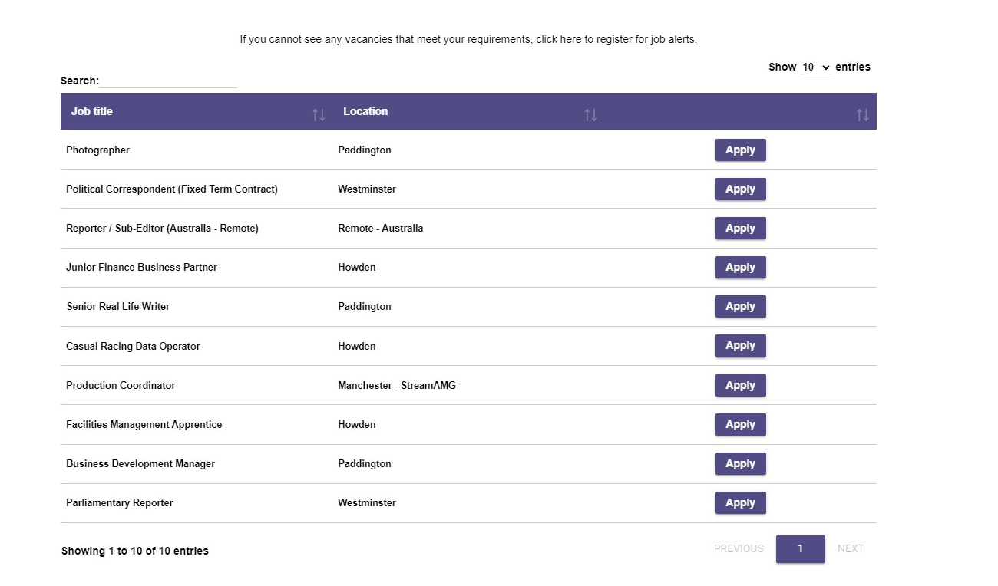

3. RSS Feed.
The RSS feed allows you to post data from the ATS onto your careers page, giving you the option of defining the layout and format of your job listings and adverts. Our support team can provide you with feed details and documentation for your Marketing/IT team to work on setting up the feed.

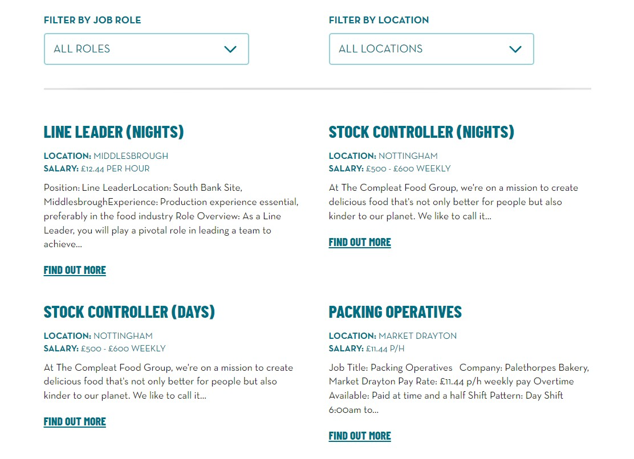
Editing the details of a job.

You can edit your jobs details at any time by clicking on the edit button. Any edits you make to this job record will be instantly updated to your website.

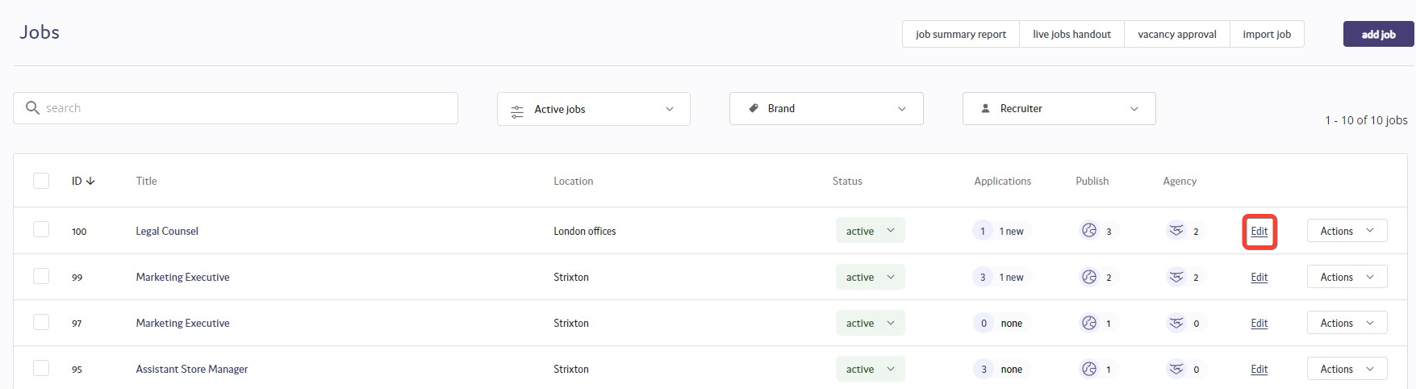
Cloning a job.

The ATS allows you to clone any previously created job, meaning you can make an exact copy of this role. This can be extremely useful if you are running very similar roles and wish to speed up the process of adding these roles to the ATS to be published out.
To clone a job, from the jobs page click on the Actions button on the right-hand side of the role that you wish to clone.
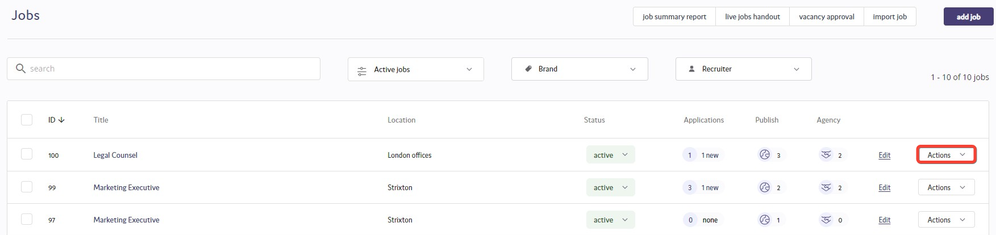
A dropdown list will then appear, and from this list select Clone.
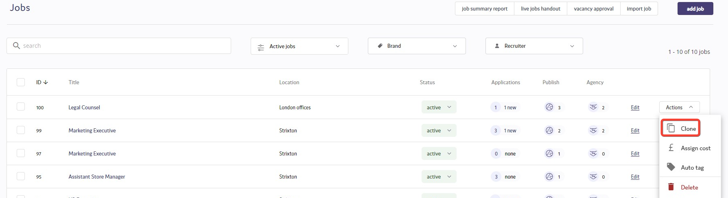

You will then be taken to the edit job section, which allows you edit any aspect of the role if you need to. To edit, click on the field that needs to be amended.
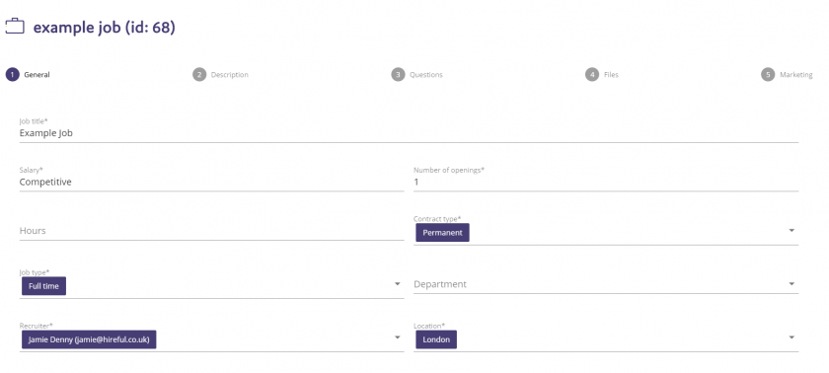
You can then edit the sections of the role that you wish to. Any questions that were on the original role will have been copied across, along with the job description, so it is best practice to check that these details are correct before moving to the Marketing section and publishing the role. For example, if the location is different, checking that this new location shows in the description.
Closing a job off to new applicants.

There will come a point when a job that you currently have as active on the ATS will need to be closed off. This could be that you have successfully hired for the role, or that you need to place to role on hold or cancel it so that you do not receive any further applications.
To close a job off on the ATS on the jobs page, click on the drop-down list under the Status heading.
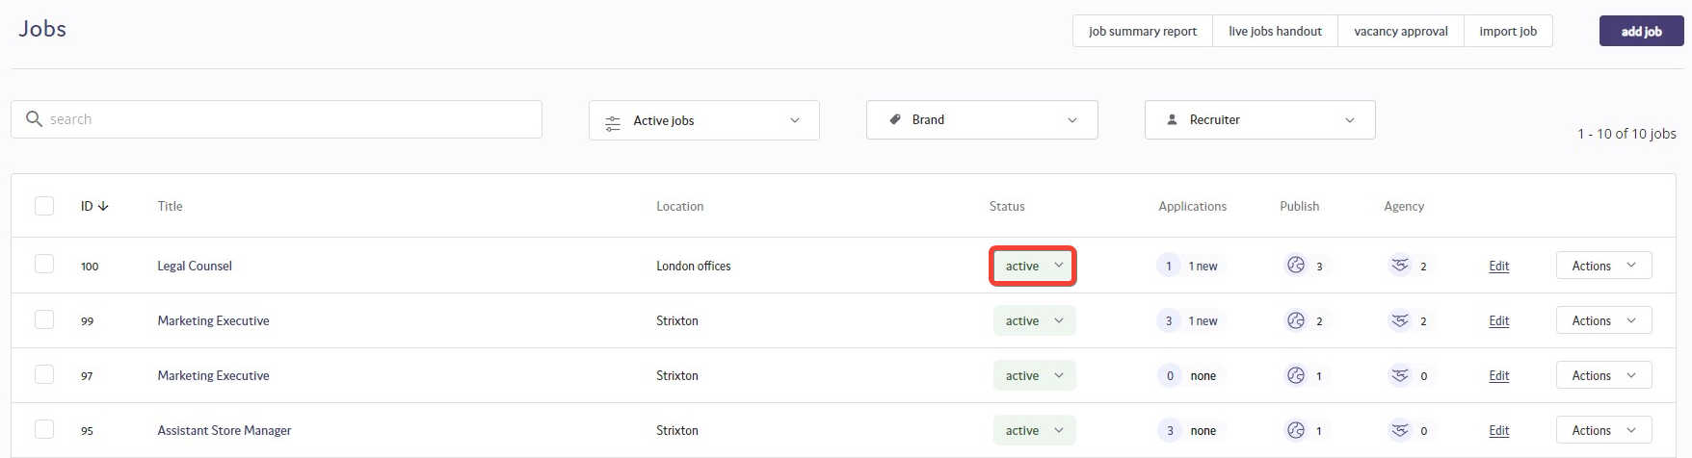
The following list of status options will then appear for you to change the role to:

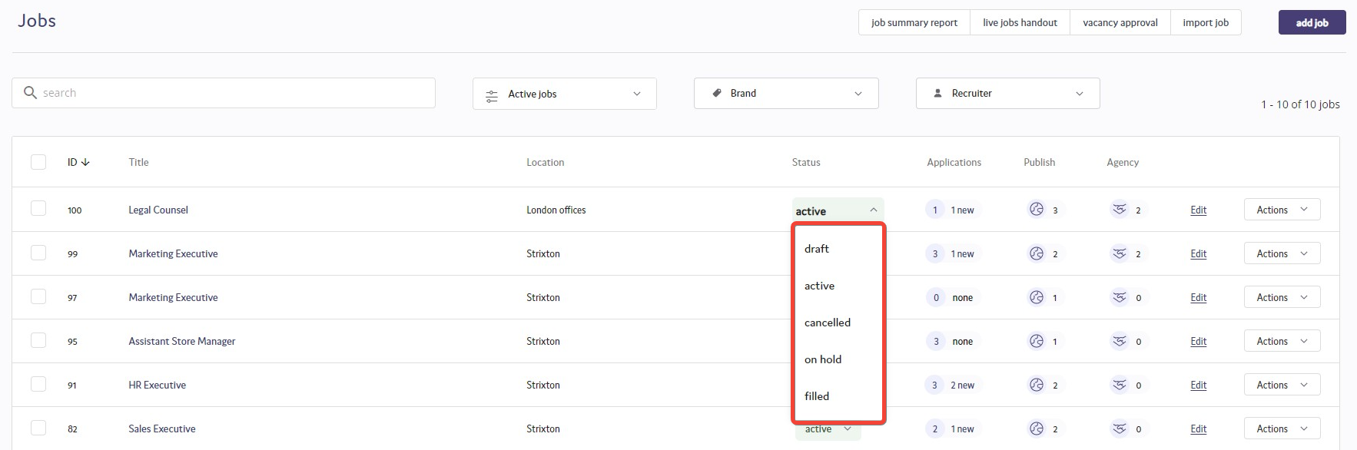
The list of statuses that you can change the role to are:
- Cancelled
- Draft
- Filled
- On Hold

Select the status that you wish to change the role to, and the following confirmation box will appear.
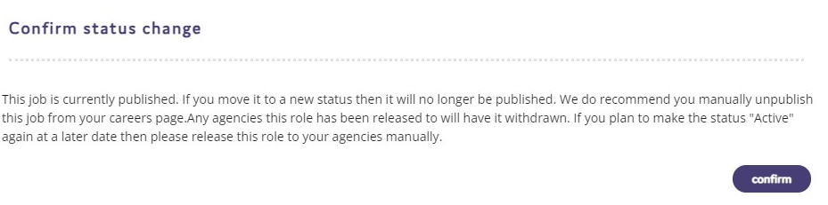

The role will then be unpublished, meaning no new candidates can apply for the role. It will also withdraw the role from any agencies that you have released the role to.

Processing Applicants.
Reviewing an application.
When you login to the system, you will see the page we call the "Jobs list". You can see all your active jobs and you can easily see which jobs have new applicants that you need to review.
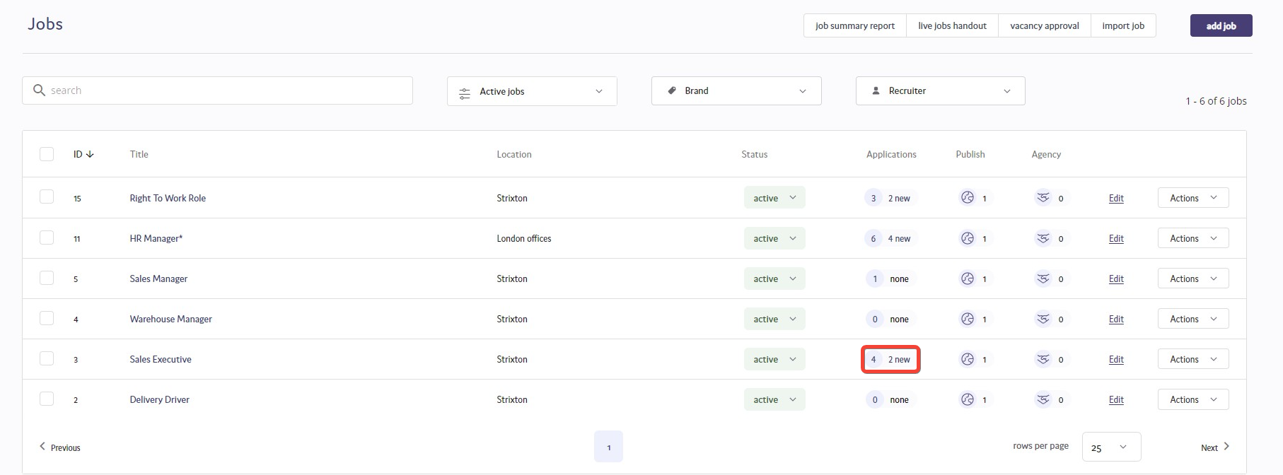
Applicant list.
When you click into the list of applicants for one of these jobs you will see there are applicant(s) that have a status of "Applied". Technically, the labelling you see highlighted in the image of "new" is not correct. It would be more technically correct to say that these applicants are "not yet processed" as any applicant who is listed on a status of "Applied" will be counted as a "new" in the jobs list.
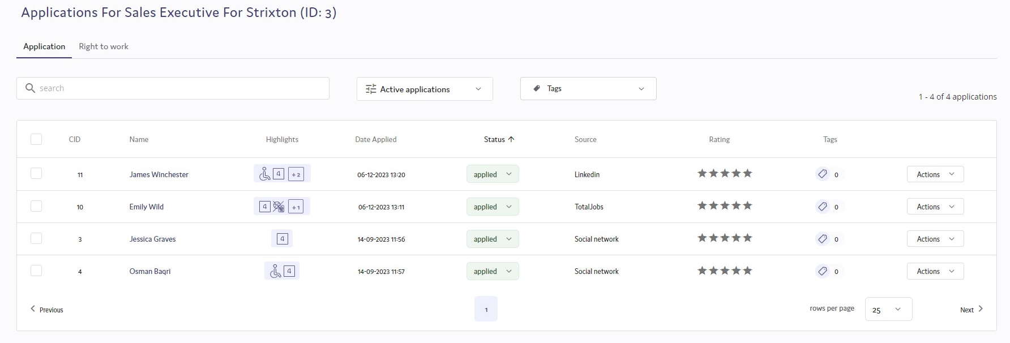
Applicant record.
If you click on an applicant in the applicant list view, you will open the applicant record. This applicant record is really important. For most recruiters, this page view is where they do most of their work, reviewing the relevant information and deciding on whether to progress or reject the applicant.
The applicant record has been designed to show the user all the information they need to make the correct resourcing decision on this applicant. The design is based on two windows with the left-hand window showing the applicant's answers to the application form, the job details and the activity log.
The image below shows the application form view in the left-hand window and the CV document in the right-hand window. You can choose to change the view in either window by choosing from the heading options in the left hand window (options include: App form, Job details & Activity log) and in the right hand window you can change the view of the document shown by selecting from the list of available documents in the highlighted drop down list that currently shows "CV".
Please note: If your organisation does not accept CVs as part of their application process then you will see the application form in the right-hand window.
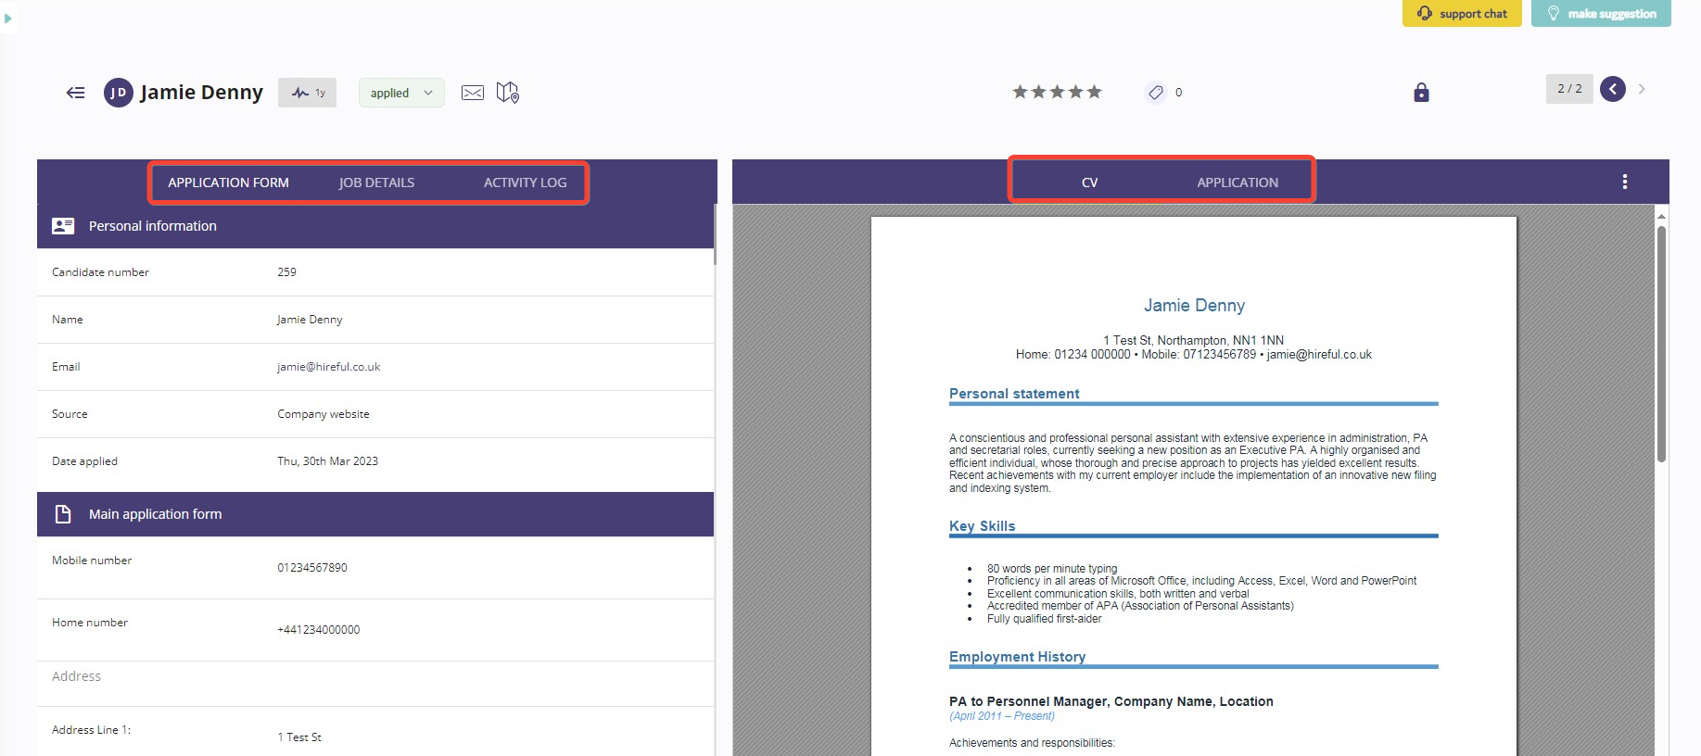
You can also expand on the view of the document held in the right-hand window by clicking on the white dots just above the CV and selecting "Open in New Window".
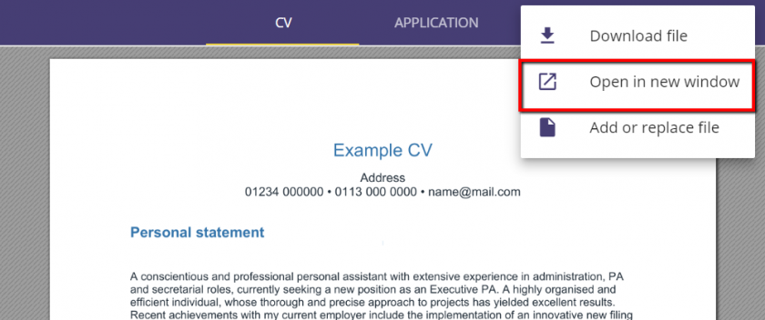
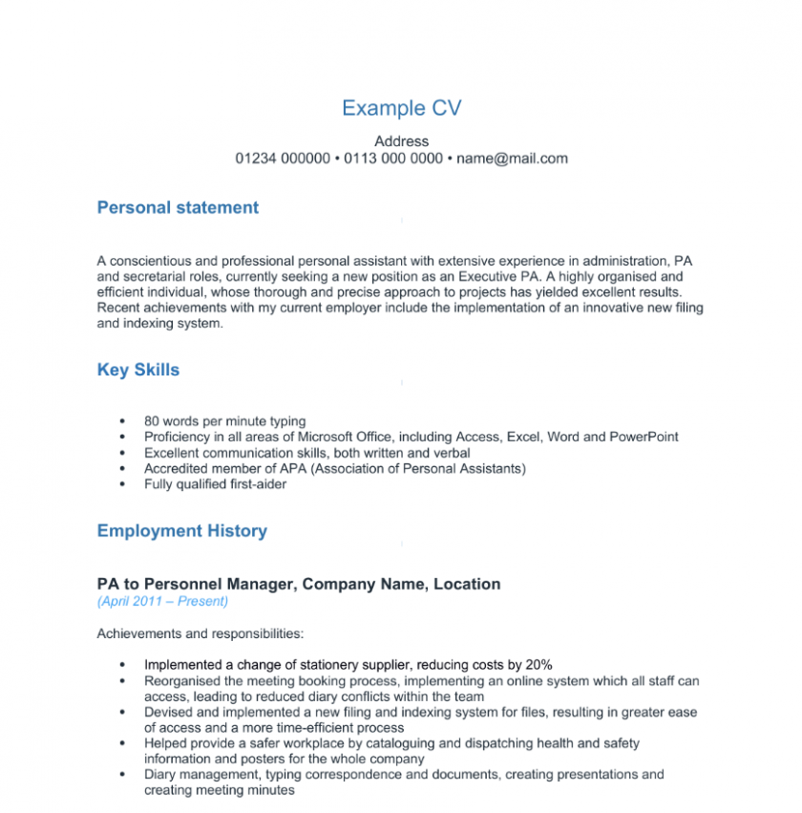
When you have reviewed the relevant information, you can choose to update the applicant's status or rate them (see below).
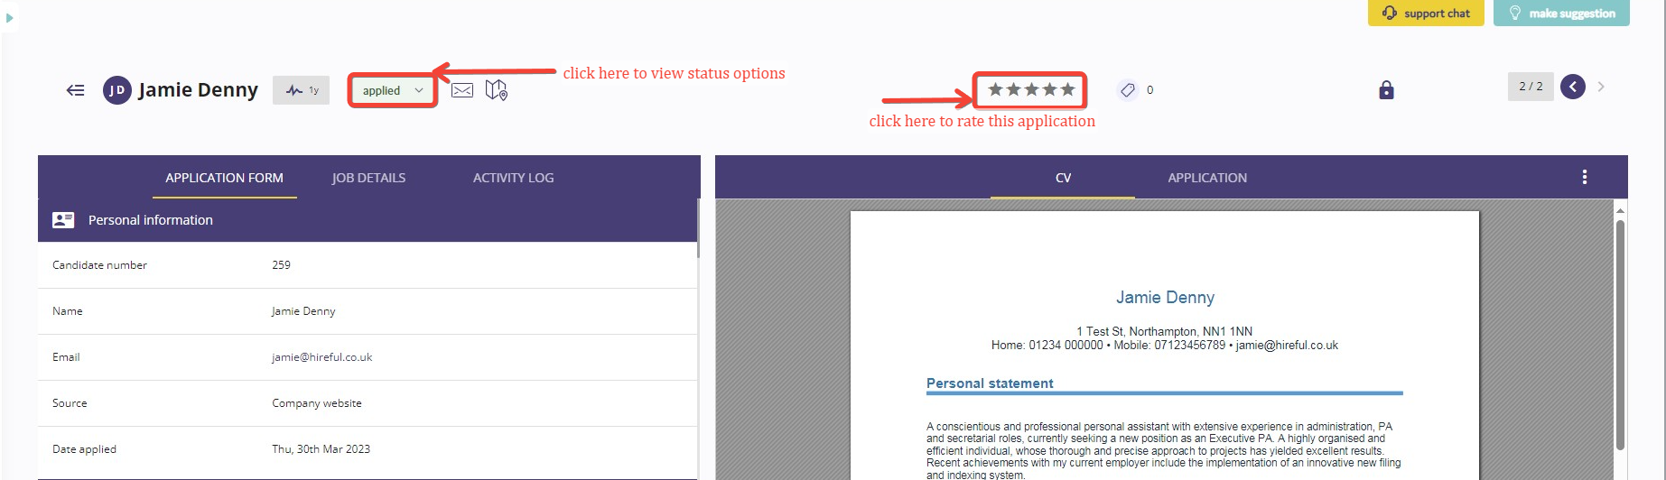
Once you have updated the applicant record you can choose to either go back to the list of all applicants or stay in the applicant record view but progress to the next applicant.
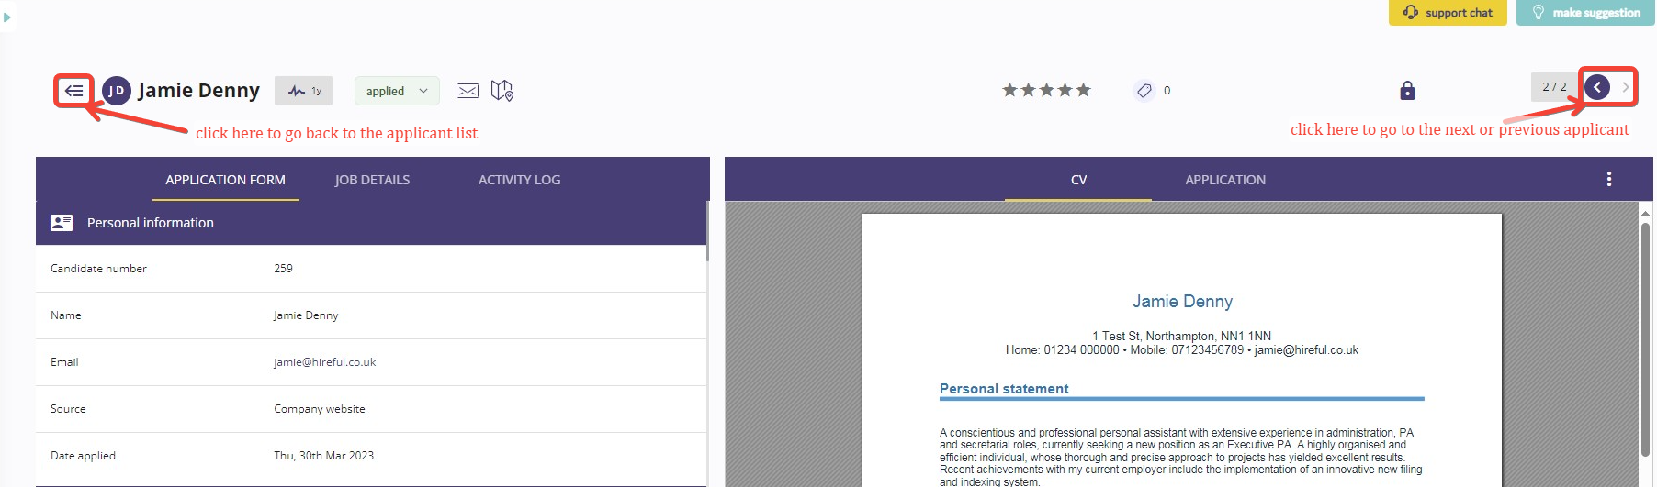
Rejecting Applicants.
You can update applicants to a rejected status from the applicant list page or the applicant record page. Most systems have an option to send an automatic email to the applicant as well as updating the status.
Rejecting applicants from the applicant list page.
The image below shows you how you can select multiple applicants in the applicant list view and then choose to update their status to a reject status. The user would then choose either "Rejected (auto-email)" or "Rejected no email" based on whether they wished to also send an email confirmation to the applicant.
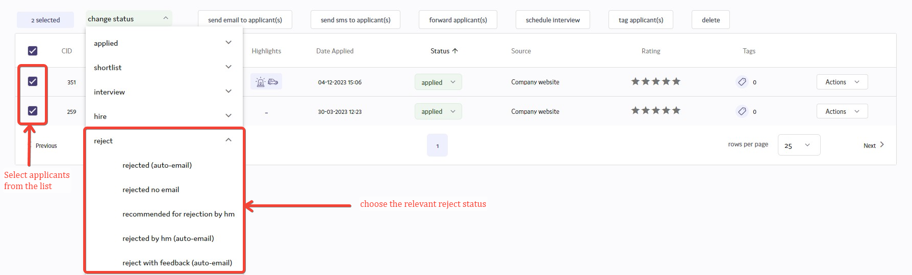
Rejecting applicants from the applicant record page.
Most users will reject applicants from the applicant record page, as from here you can see all the key information that relates to their application. The applicant's status is listed at the top of the page, just to the left of centre (see image below).
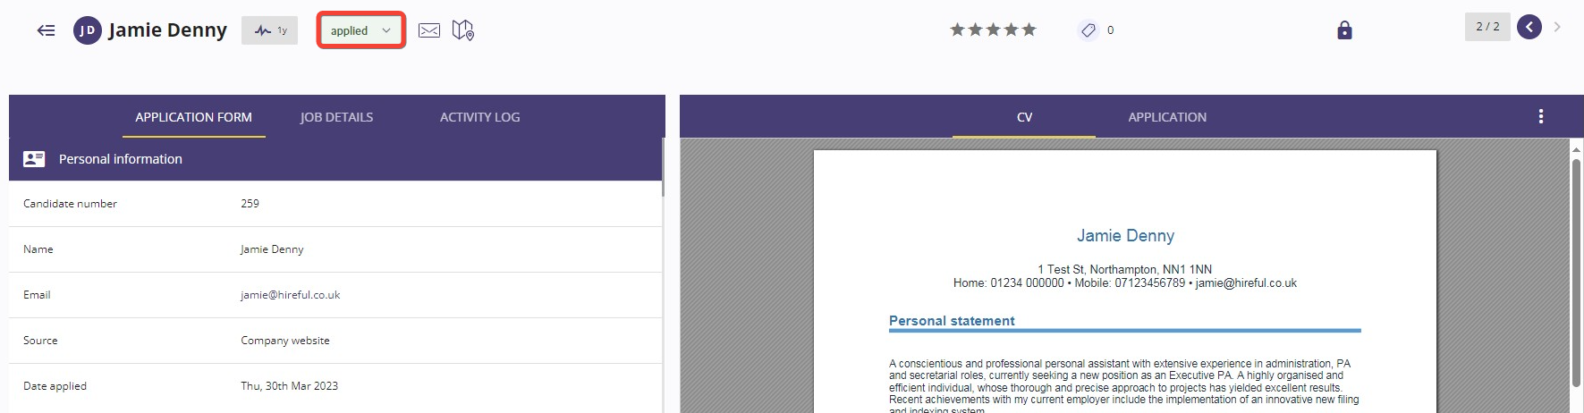
When you click on this status the dropdown list of all statuses will appear. From here you will need to select the relevant reject status.
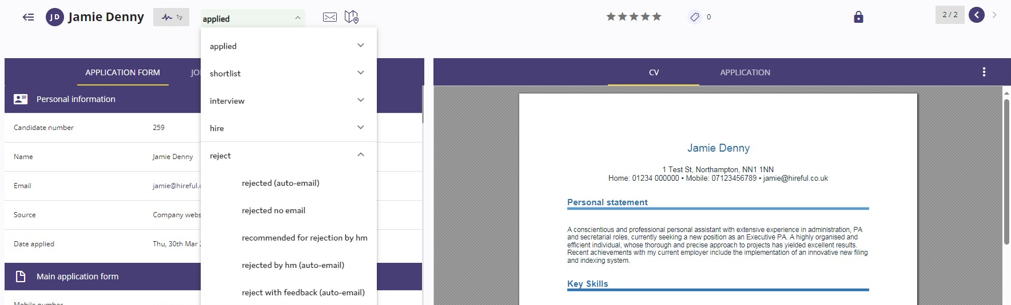
Standard reject email.
All reject emails come from a generic email address (e.g., careers@examplecompany.com) rather than an individual user’s email. The reject email in your ATS will look similar to the example below. If you are using hireful ATS Professional or Premium edition, then all email communications can be updated to your specific requirements.

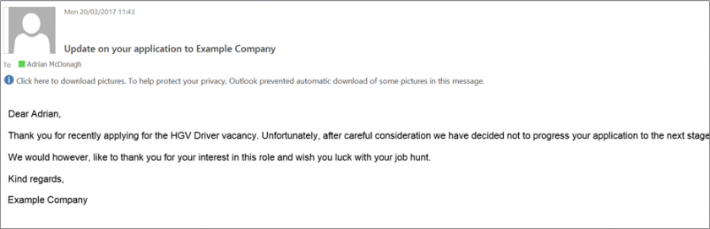
Shortlisting Applicants.
Shortlisting applicants has several potential uses:
- You are highlighting that an applicant is a potential fit for your vacancy.
- You are triggering the sharing of this applicant with the hiring manager(s) for this job (this only happens if you have the hiring manager portal enabled - see below for more information).
- The system can report on shortlisted applicants, including those that were later rejected. For example, instead of reviewing which sources your applicants came from you can see which sources your good (shortlisted) applicants came from.

Shortlisting applicants from the applicant list page.
If you prefer to rate your applicants using the 5-star scoring method (see below) ....
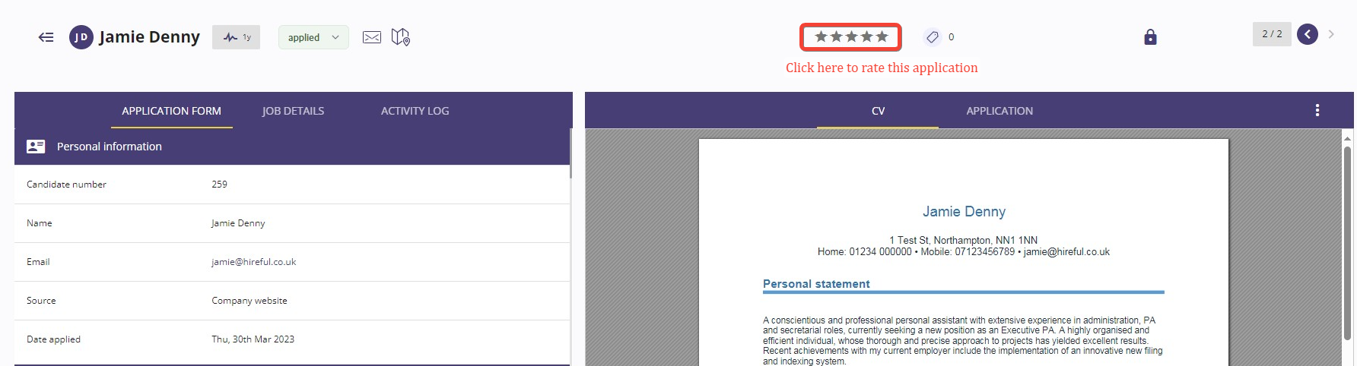
...then you might decide to review all the applicants and their rating in the applicant list page.
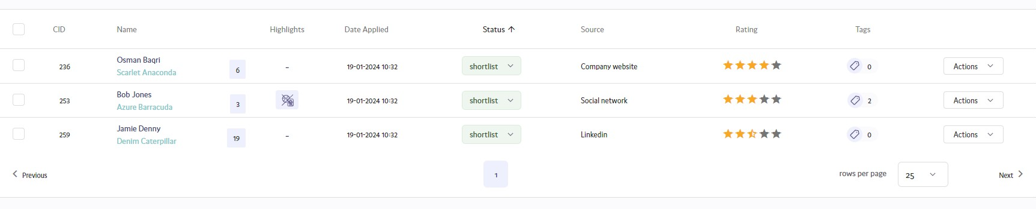
From here you can select multiple applicants and shortlist (or reject) them in one process.
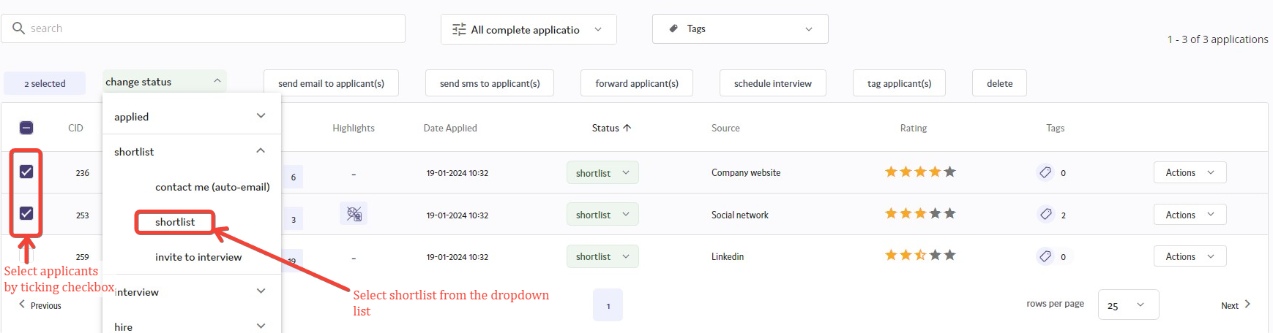
Shortlisting applicants from the applicant record page.
Most users will decide to shortlist applicants from the applicant record page, as from here you can see all the key information that relates to their application. The applicant's status is listed at the top of the page, just to the left of centre (see image below).
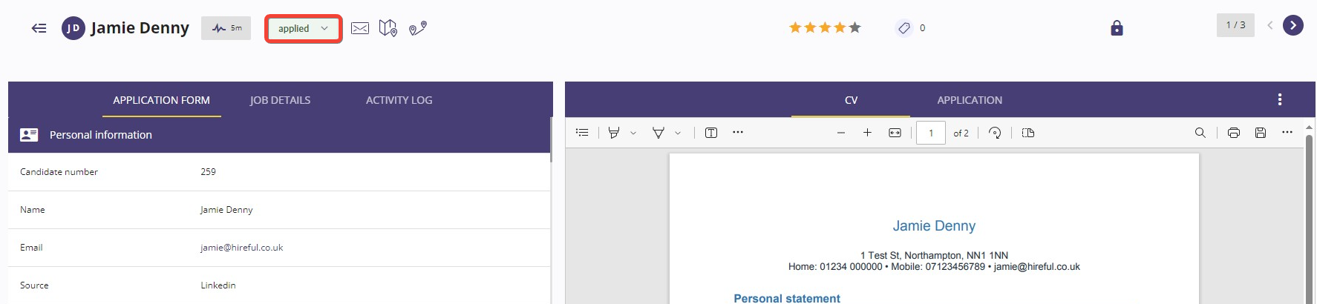
When you click on this status the dropdown list of all statuses will appear. From here you will see the option for "Shortlist".
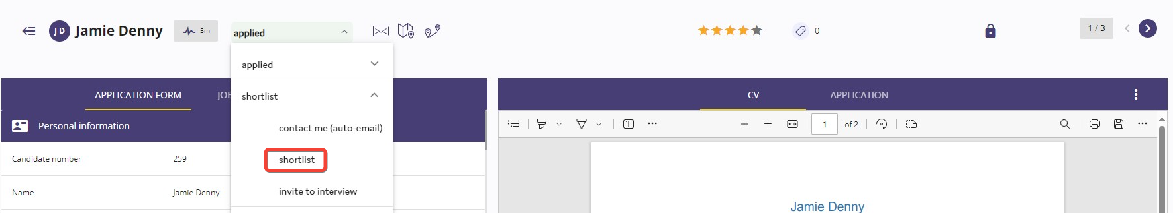

Shortlisting applicants for hiring managers to view.
Once you move applicant(s) to the status of "Shortlisted" then if you have the hiring manager portal enabled, the assigned hiring manager(s) for this job will be alerted to these new shortlisted applicants via email.
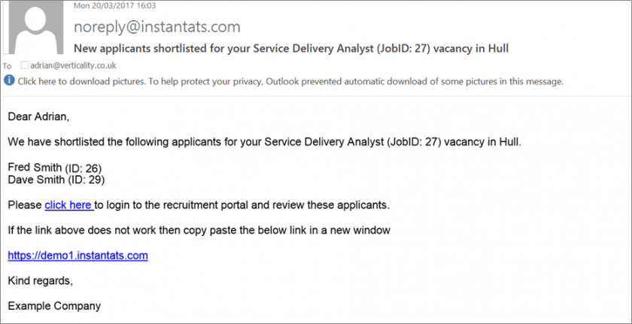
The Activity Log.
The Activity Log provides an audit trail for applicants from when they initially complete their application, to status updates, ratings applied to the applicant, comments placed against the applicant and any emails that are sent to them during the application / screening process. If an applicant has applied for more than one role within the ATS, the Activity Log will allow you to see the actions that have occurred to the applicant for those other applied roles.
To view the Activity Log for an applicant, when in the applicant viewer screen (for more information on this, click "The Applicant Viewer") , click on the "Activity Log" tab.
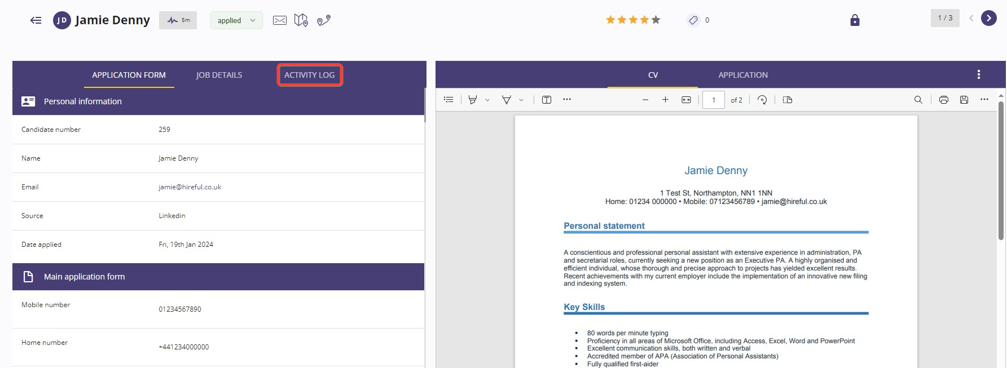
The Activity Log date and time stamps all activity that has occurred with the applicant. Any status changes are recorded and by which user.
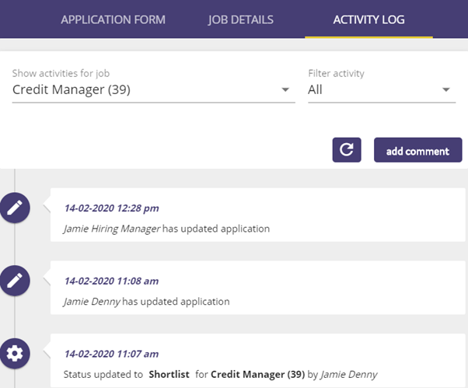
Adding comments against an applicant.
The Activity Log allows you to add comments against an applicant. This is useful in giving you the opportunity to note down any conversations that you have had with the applicant and thoughts and screening notes about the applicant's CV and application form that can be provided to the applicant as part of feedback on their application.
To add a comment against an applicant, click on the Add Comment button.
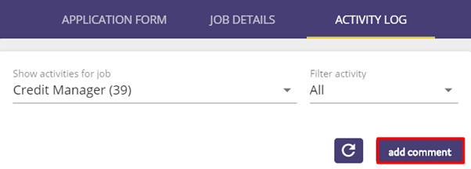
A box will then appear allowing you to add your comments. Once you have finished adding your comments click "Save".
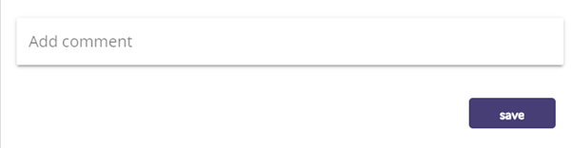
The comments will then appear in the log.
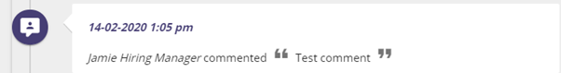

Viewing emails sent within the activity log.
Within the Activity Log, you can view the emails that have been sent with regards to the applicant. This could either be a direct email to the applicant about their application, or if you have sent an email to the Hiring Manger passing over the applicant’s details.
Where an email has been sent about the applicant, the Activity Log will show the subject message of the email:
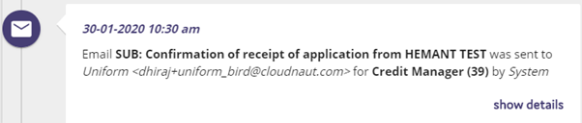
Click on the "Show Details" button, and the email that has been sent will be displayed:
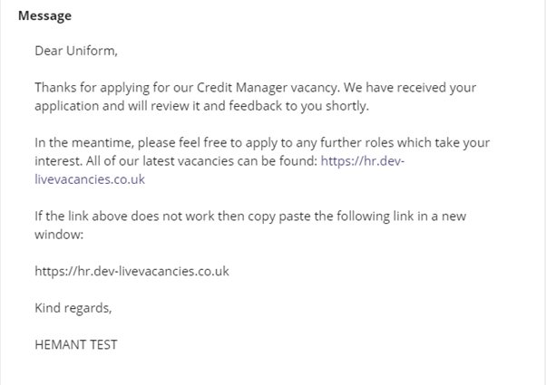
Viewing an applicant's notes from other applied roles.
The system also allows you to view the activity status of an applicant if they have applied for more than one role in the system. The system will show the role that they have applied for and there will be orange drop down arrow:
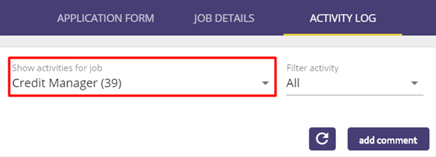
Clicking on the drop-down arrow to see the other roles that the applicant has applied for:
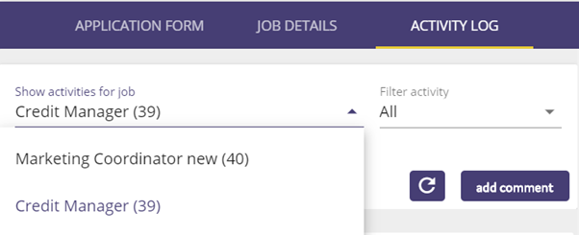
Select the other role(s) that the applicant has applied for, and their activity notes will be shown:

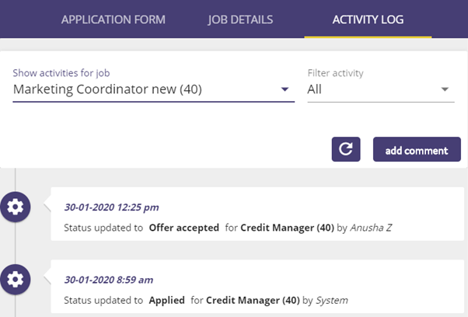
Uploading/replacing files for an applicant.
The ATS allows you to upload additional files / documents against an applicant. This could be files such as a telephone interview script, or a task that the applicant may have been required to complete as part of the application process.
To upload a file against an applicant, from the Applicant Viewer screen, click on the 3 white dots on the right-hand side of the screen and then choose "Add or replace file".
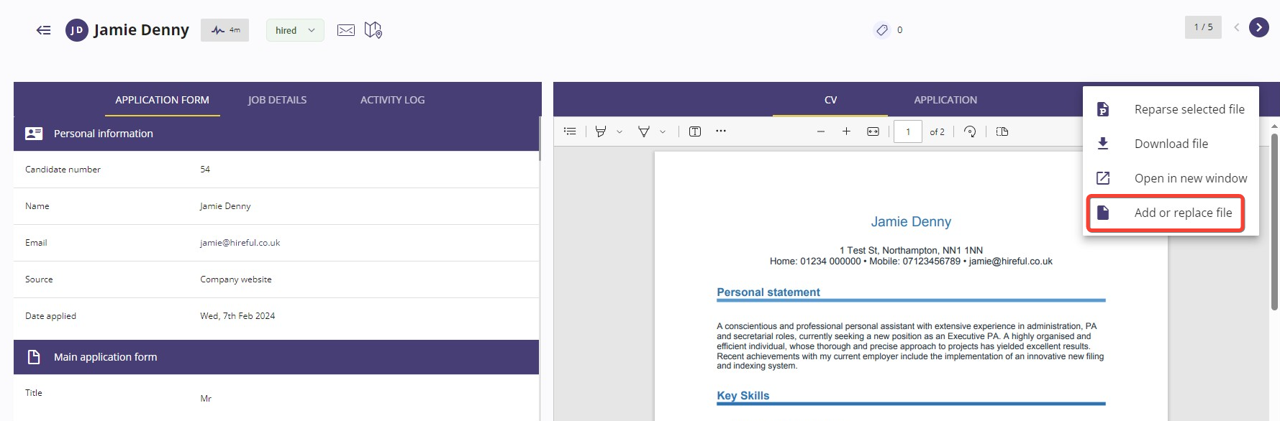
The following box will appear where you can choose to upload a new file against the applicant or replace an existing file.
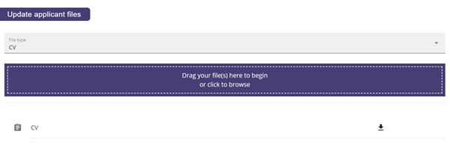
To upload a new file against the candidate, from the dropdown list select "Additional File".
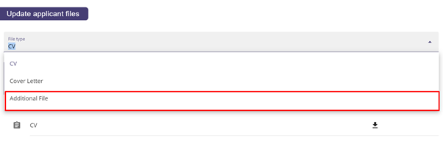
Click on the blue box to upload the file.
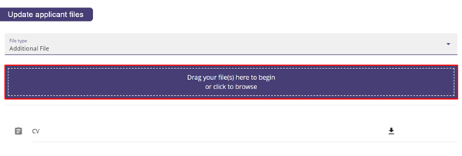
The uploaded file will then appear at the bottom of the page.
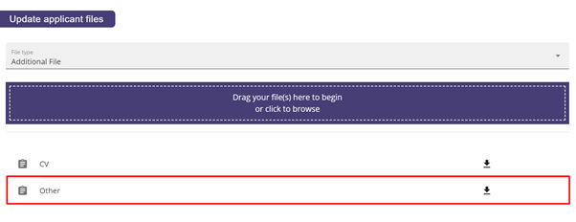
Replacing an applicant's CV.
The ATS allows you to replace an applicant's CV with a more up-to-date copy should you wish. From the pop-up screen after clicking on the white dots and selecting "Add or replace file" select the CV option from the dropdown list.
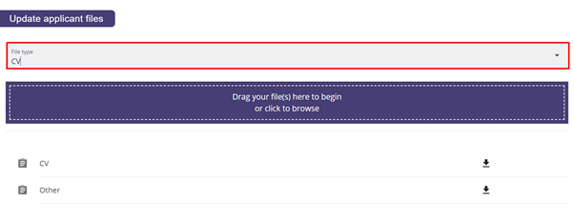
Once CV is selected, click on the blue box, and upload the file. This will then replace the CV against the applicant's record.
Select the file that you wish to upload, and the CV will then be updated with this new file.
Bulk status updates.

The ATS allows for the bulk updating of applicant's statuses, allowing you to update multiple applicants’ statuses at once.
From the applicant list select the checkbox on the left-hand side of the applicant's name and then choose the option to "Change status" will appear at the top of the screen.
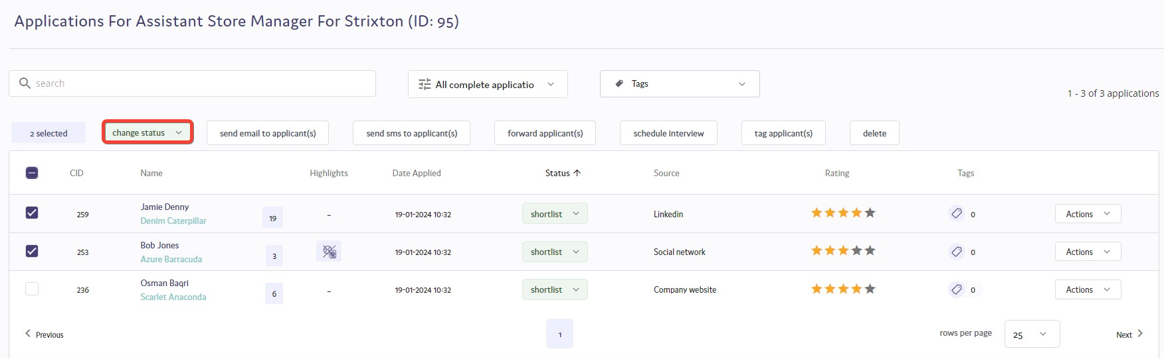
Click on the "Change status" button to bring up the list of status options:
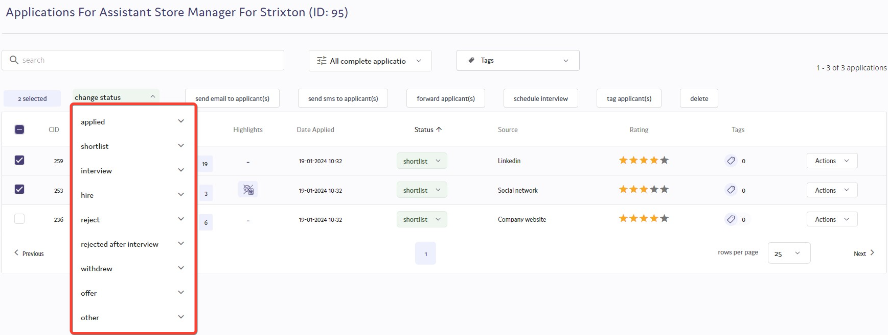
Select the status that you wish to change the applicants to and then click "Confirm" when prompted.
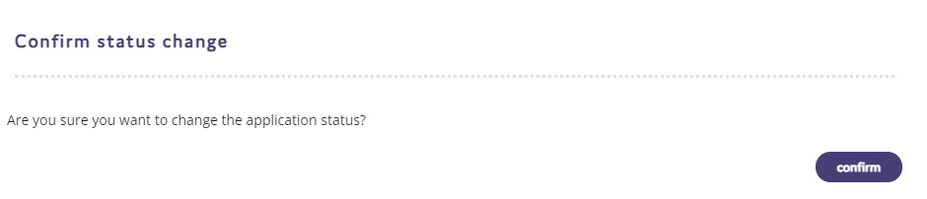
The applicants will then be changed to the selected status.

Managing Applicants.

Choosing the applicant(s) you want to schedule for interview.
The ATS offers you the option to choose to schedule interviews for individual applicants or a batch of applicants. This is assuming the batch of applicants are all interviewing for the same job and will all have the same interviewers.
Selecting to book an interview with an individual applicant.
The system will offer you the option to schedule an interview when you move an applicant to any of your interview statuses.
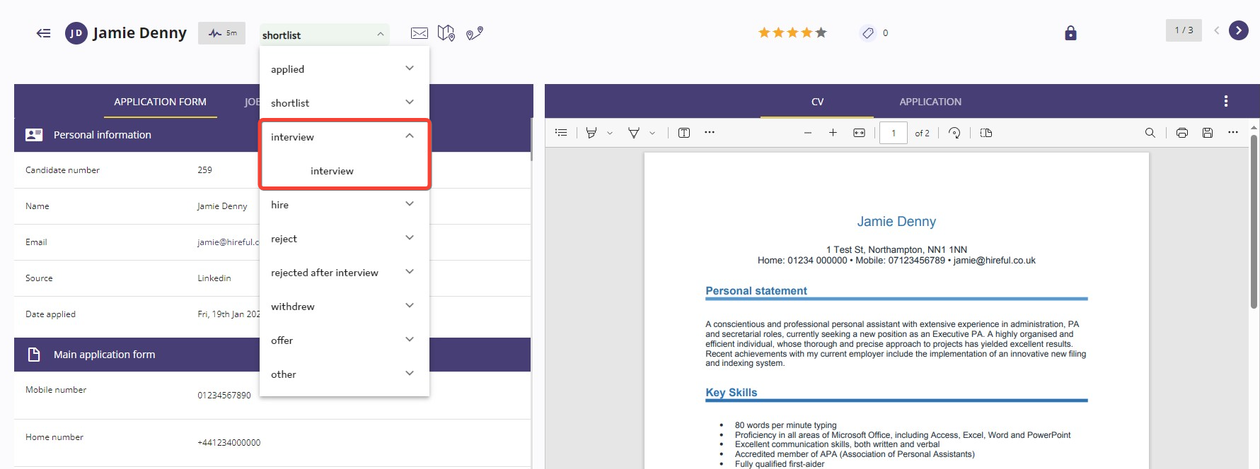
This is the question offering you the option to schedule the interview via the ATS.
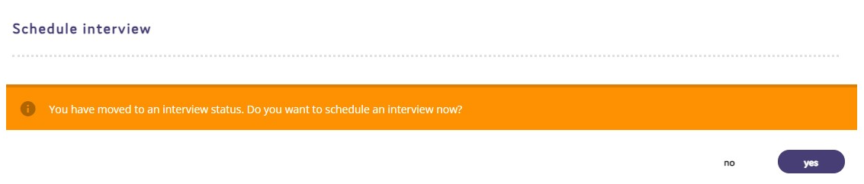
Selecting to book an interview with a batch of applicants.
You can schedule multiple applicants to interview with the same interviewers for the same job by selecting them from the applicant list and then choosing the option to "Schedule interview"
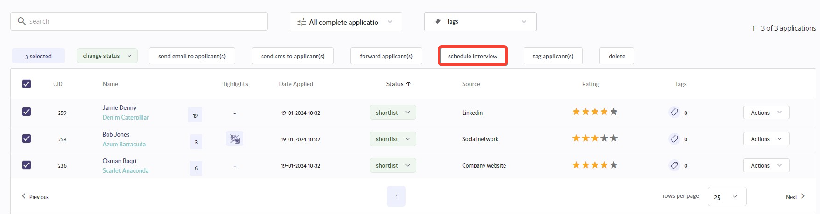
Why you should schedule interviews on the ATS.
It is a good idea to schedule interviews via the ATS as this offers the following benefits:
- Use of email templates by all users scheduling interviews will see a more professional and consistent approach to communicating with interviewees and interviewers.
- Interviewers and interviewees can easily add interviews as appointments into their calendar.
- Interviews that need to be changed can be rescheduled within a few clicks and new confirmation details emailed to relevant parties.
- The ATS can report on which applicants went to interview and also measure the time taken to get applicants to this important stage in the recruitment process.

Confirming the interviewers.

Scheduling interviews is a 3-step process. You can see in the image below we are at step 1 "Interviewers/Candidates". The candidates for interview have already been confirmed we only need to confirm the interviewers at this step.
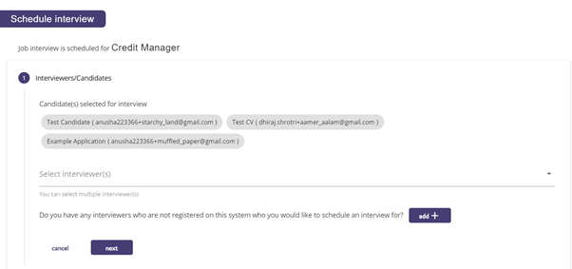
Most users will only need to select the relevant interviewer(s) from the dropdown list called "Select interviewer(s)". Check the box next to the interviewer(s) that you wish to include in the email confirmation.

If you do not see an interviewer who is part of this interview process, then you can choose the option to add them see example image below.
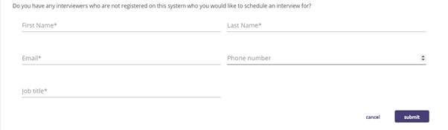
When you are happy you have selected all the relevant interviewers then select NEXT in the bottom right-hand corner to proceed to the next step.

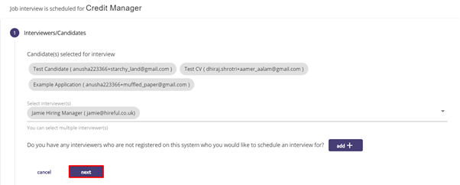
Confirming the date/time and location.
The next step in the process is to confirm the date/time and the location of the interview(s). If you are booking more than one interview you will need to confirm if the interviews are happening at the same date/time, for example if this is an assessment centre then you probably choose the option “Same date/time.” You will also need to confirm if the interviews are happening at the same location.
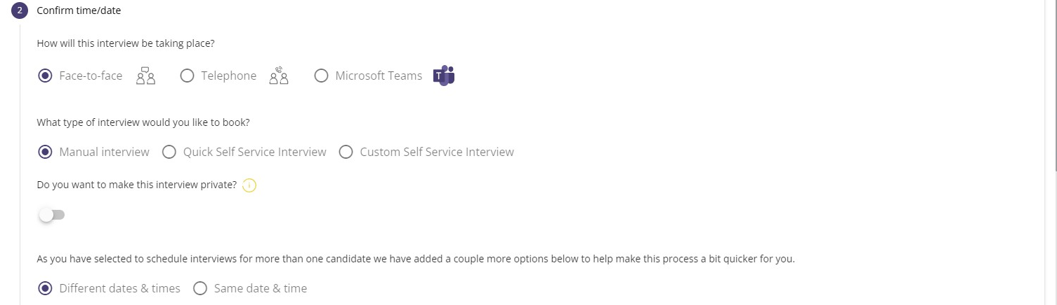
If you confirm that the interviews are not taking place at the same date/time, then you will need to confirm the individual date(s) and time(s) for the interviews. The same would apply if you need to confirm individual interview locations for each interview.
Once you have provided all the required date/time and location data select the NEXT button to proceed to the third and final step.
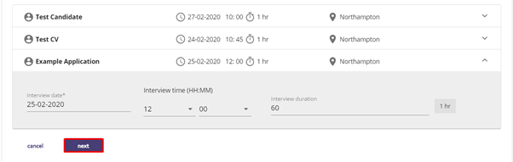
Interview communication.
In this step you will see options to assist you in sending the relevant email to interviewers and candidates. The first half of the communication section focuses on the options for sending the interview confirmation email to your interviewers. You will see options here for which user you want this email to appear to come from. It can come from the assigned recruiter for this job or the hiring manager or another option. You will also have options to cc you or any of your colleagues into this email.
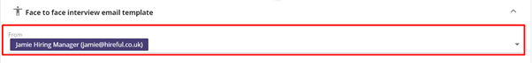
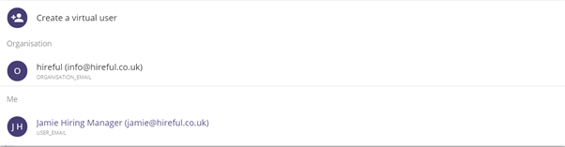
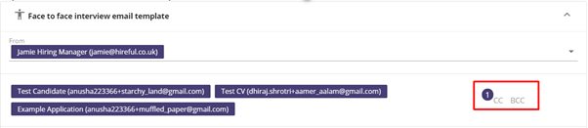
If you click on the email template area (highlighted in red below) you will be able to view and edit the email template that is due to be sent to your interviewers. Our ATS can support multiple face to face and telephone interview templates, so if you add additional interview email templates you will see these here.
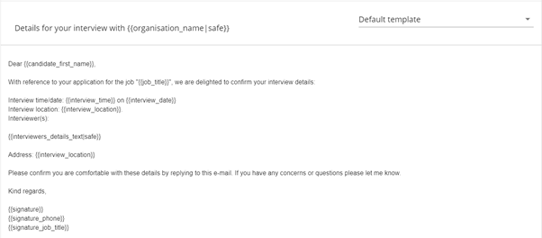
The default setting for emailing interviewers is to attach to the email all relevant documents relating to this candidate’s application. The image below shows that the candidates CV, Cover Letter and PDF Application Form is automatically attached. If you do not wish to include these documents, then you can click on the tick icon to not attach them. You can also attach additional files here.
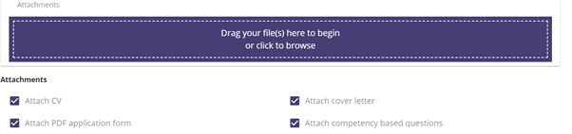
The same process applies to sending the email to your interviewee(s). Remember, if you require specific documents to be sent to the interviewee(s) then if you attach them, but do not publish them, to the job record, then they will be automatically attached at this stage. Here is the link to the page showing you how to do attach files to your job record.
When you are happy with the content and attachments for your email communication then click on the NEXT button to confirm these interviews.
You should see a small onscreen message in the bottom right corner confirming that these interviews have been confirmed.
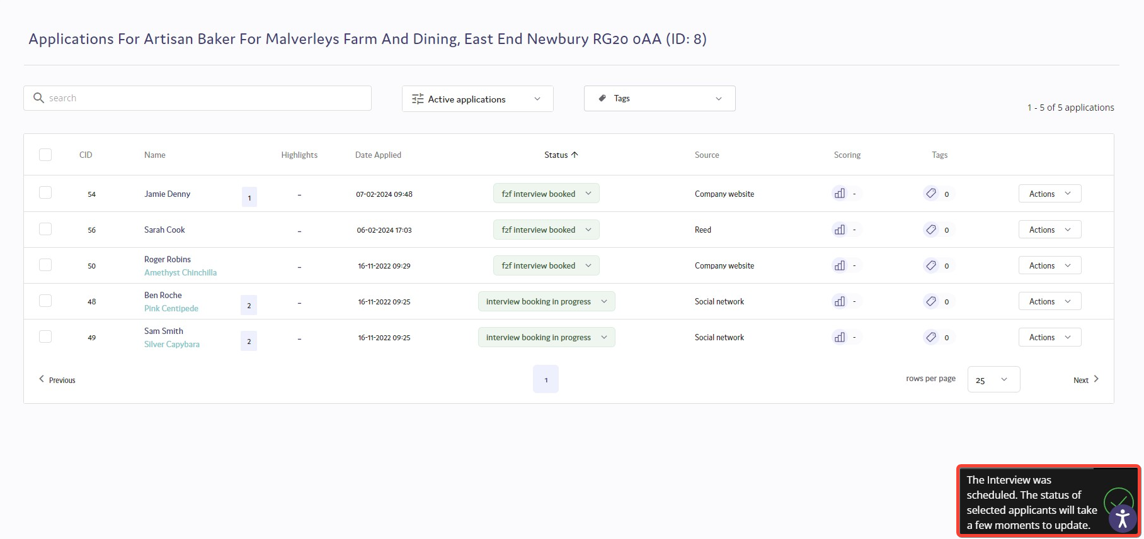
If you refresh the page on your applicant list, you will see that your applicants have had their status for this position updated to “F2F Interview Booked”. Within a couple of minutes your emails should arrive with your interviewers/interviewees.

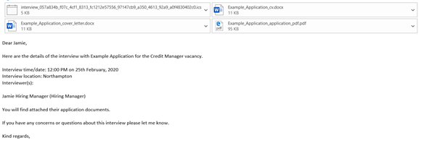
Your interviewers/interviewees will have an appointment file (it is called Interview.ics) attached to their email. We would encourage these users to open this attachment as it will open as an appointment.
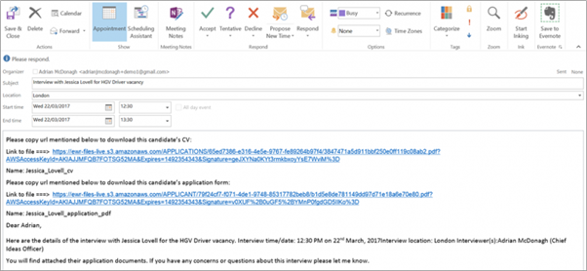
Once opened your interviewer/interviewees will be able to accept this appointment and have it saved as an appointment in their calendar. This attachment includes links to all the attachments in the original email, so your interviewers will no longer need to email you to ask for a CV on the day of an interview.
Viewing interviews in the interview calendar
You can access the interview calendar by clicking on the calendar icon on the left-hand side of the screen.
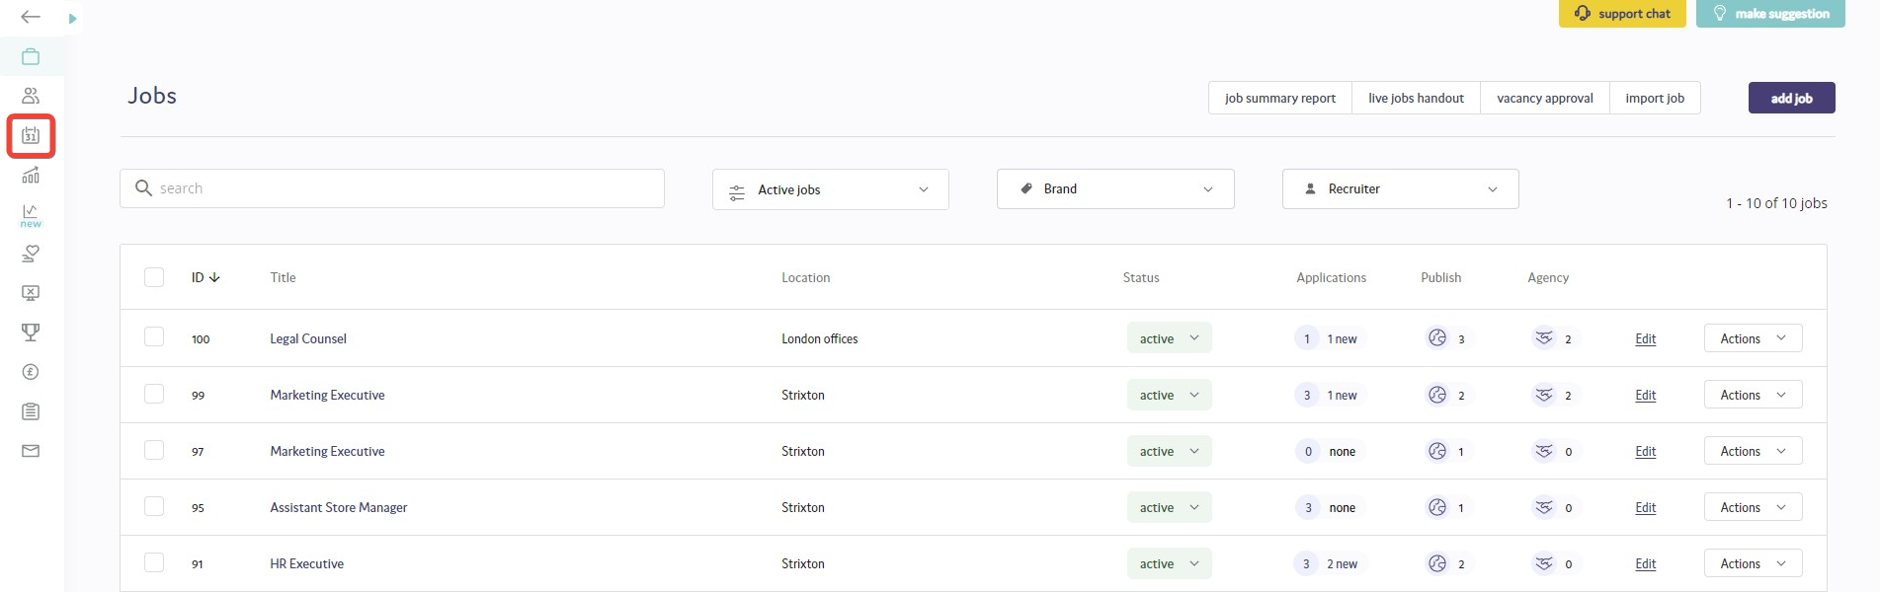
The interview calendar will show all past (grey) and upcoming (orange) interviews in the ATS. Hiring managers can also access their own interview calendar by logging into their hiring manager portal. However, hiring managers can only see interviews for jobs where they are the assigned hiring manager.
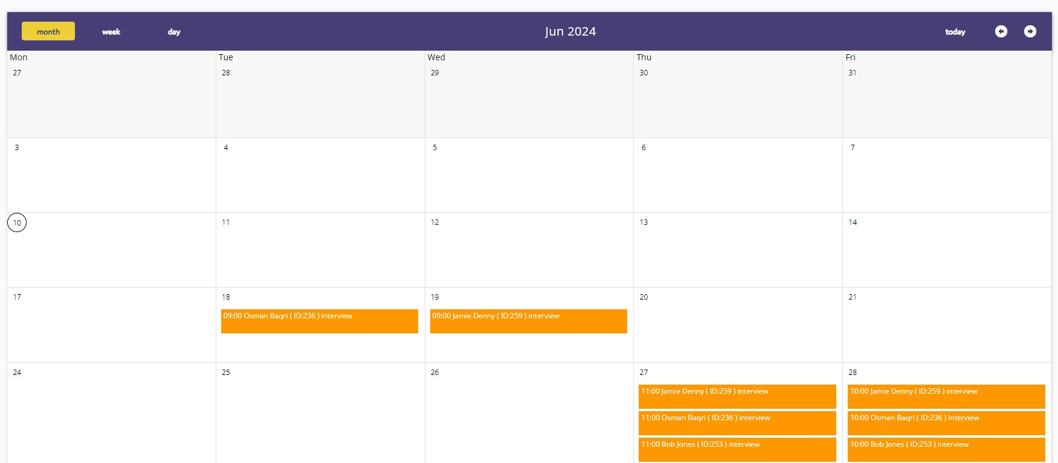
If a user needs to see the details of an interview they can click on the interview, and they will see the image below.

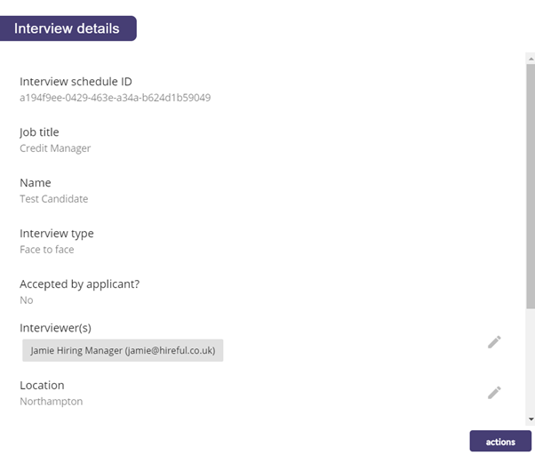
Rescheduling interviews.
You can reschedule interviews by clicking on the record in the calendar and then choosing to update the relevant details. Fields that have the pencil icon next to them can be edited, which are:
- Interviewers
- Location
- Interview date
- Interview time
- Interview duration
They can then save this record and choose if they wish to resend the new details of the interview via email to the interviewers and interviewees. To do this click on the "Actions" button and choose to desired option.
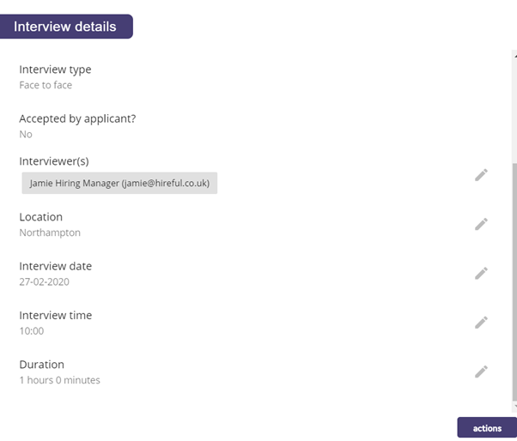

Self-servicing interviews.
There is the option to enable self-servicing interviews with your system. This feature allows for you to select specific date and time slots for candidates to select to attend their interview, and the confirmation emails are then sent once the candidate has selected their date and time slot.
To use the self-servicing interview feature:
Highlight the candidate(s) that you would like to proceed to interview stage:
Confirm and select the Interviewer(s) for the role and then press Next:
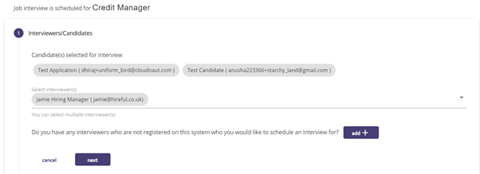
On the Confirm Time / Date tab, select Self Service Interviews
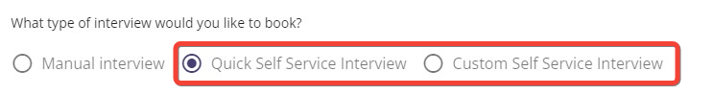
You will then have the option of picking quick time slots or custom time slots. Quick self service interview allows you to select times to follow on after each other, custom self service interview allows you to pick the start time for each individual slot.
To schedule quick time slots, enter the duration that you would like each slot to last.
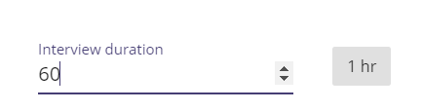
You can decide on what time the first interview slot can start at and the last interview slot can finish.
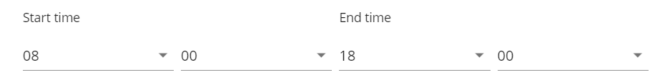
Confirm the date of interview which can be selected from the calendar:
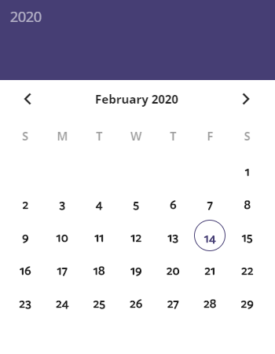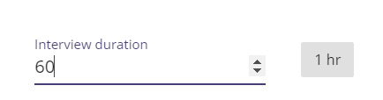

Select the time slots that you would like to make available for candidates to choose:
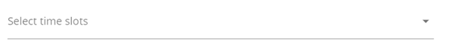
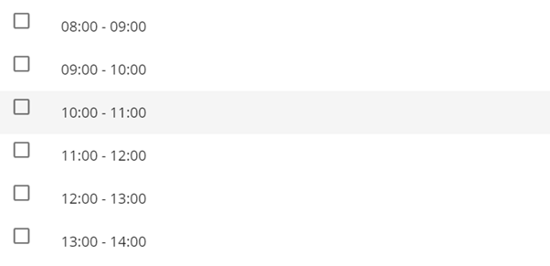
Click on the  button to add further date and time slots.

To book custom time slots, enter the duration in minutes that the slots will last.
​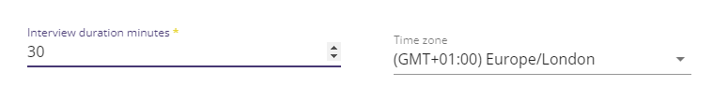​​
You can then select the interview date and then the start hour and minute for the first slot.
​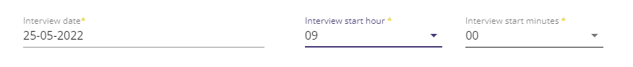​​
To add in a new slot, click the "add another slot" button. ​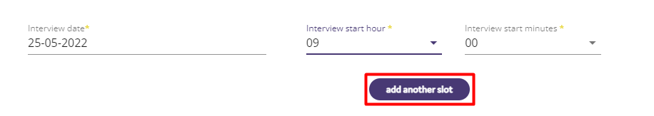​
Repeat the process by selecting the interview date and the start hour and minute for the second slot.
​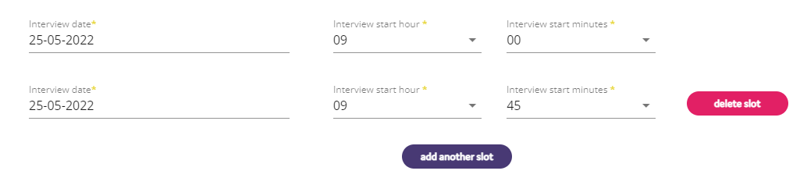​

You will then be asked to confirm if the same location is going to be used for all the interviews. If it is, then move the slider to Yes and confirm the interview location. Select if the interview is going to be a face to face or telephone interview and then if a telephone interview, confirm the number you will contact the candidate on, or if a face-to-face interview, confirm the location of the interview.
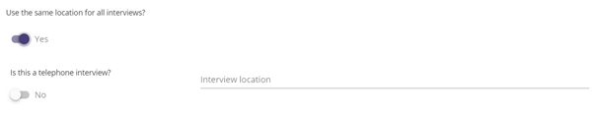
The Communication tab will then allow you to send confirmation emails to the interviewers and candidates. At the bottom of the page there will be an additional email option called “Self Service Notification Email to Your Candidate(s)”

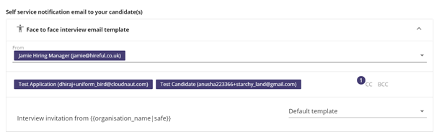

This email is sent to the candidate with a link for them to click on to select their interview slot:

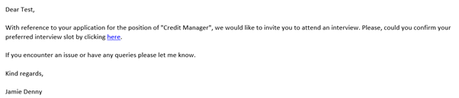

When the candidate clicks on the link, they are taken to a screen to select their date and time slot:

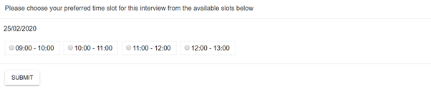

After the candidate has selected their date and time slot, they are informed that this has been successfully submitted, and the confirmation emails are then sent to the candidates and interviewers.

The confirmed interview slot will then show in the Interview Calendar, and the time slot will be highlighted green to show the candidate has confirmed this slot:

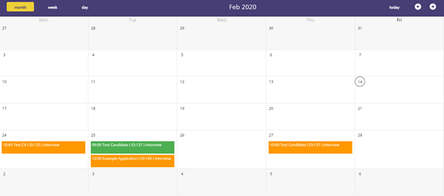

Please note: The self-interview feature works as an independent feature. The slots that are booked are just for that type of interview for that role, they are not shared between different instances of interviews.

Candidate database.

Manually adding a candidate to the database.

The ATS allows you to manually add a candidate to the database so that they are on your system. This could be because you wish to assign them to a role on the system or you wish to add them to a talent pool.

Clicking on the Candidates tab on the left-hand side of the screen will take you through to ATS candidate database.
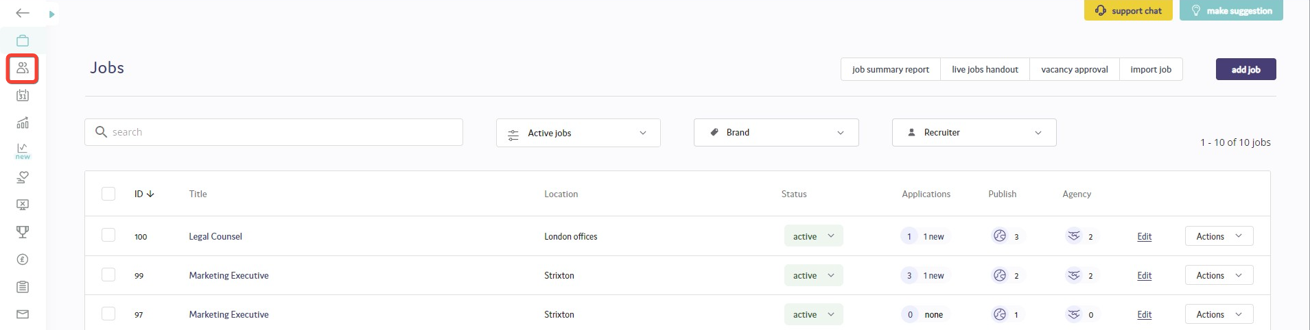
To add a candidate to the database, click on the Add button on the right-hand side of the screen.
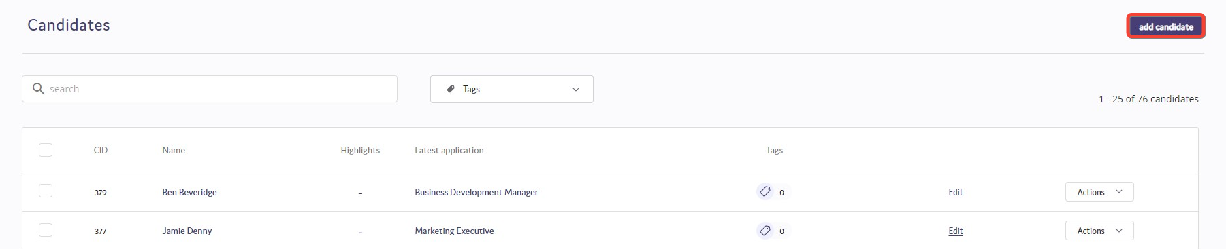
You will then be asked to enter details about the candidate. Fields marked with a * are mandatory fields to be completed.
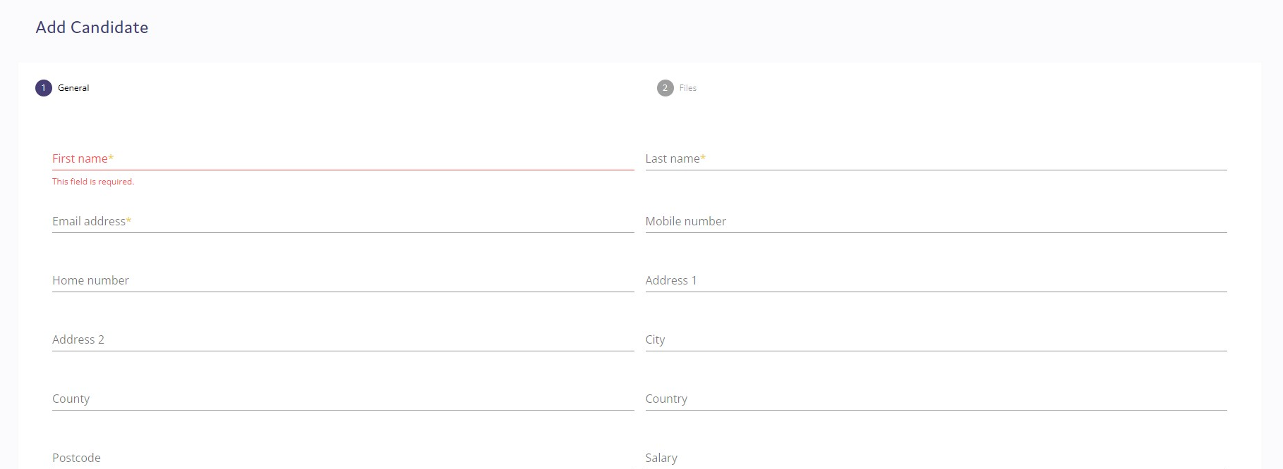
Once you have added the details, click the "Save" button. You will then move onto the Files tab. This will allow you to upload the candidate's CV and cover letter.
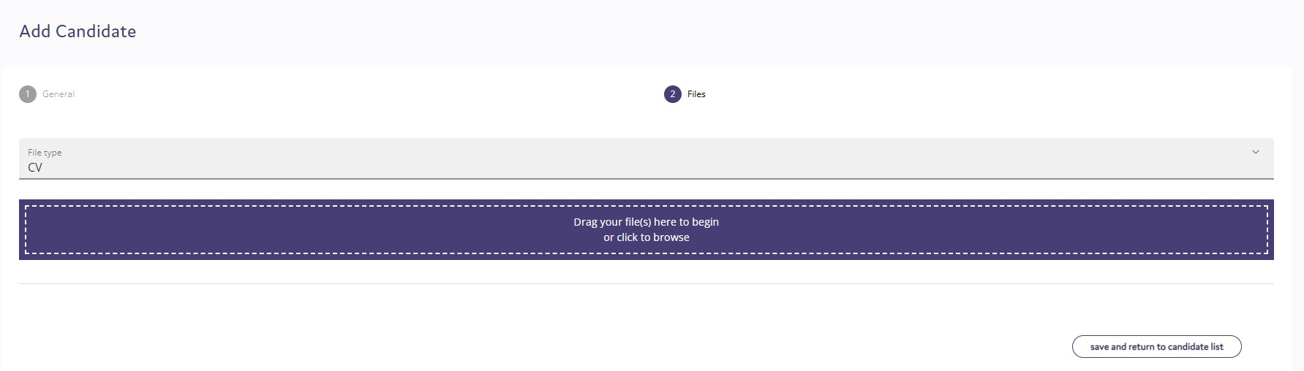
To upload the candidate's CV, click on the purple box and then select the file that you wish to upload or drag and drop the file onto the purple box. To upload a covering letter, click on the file type and select Cover Letter.
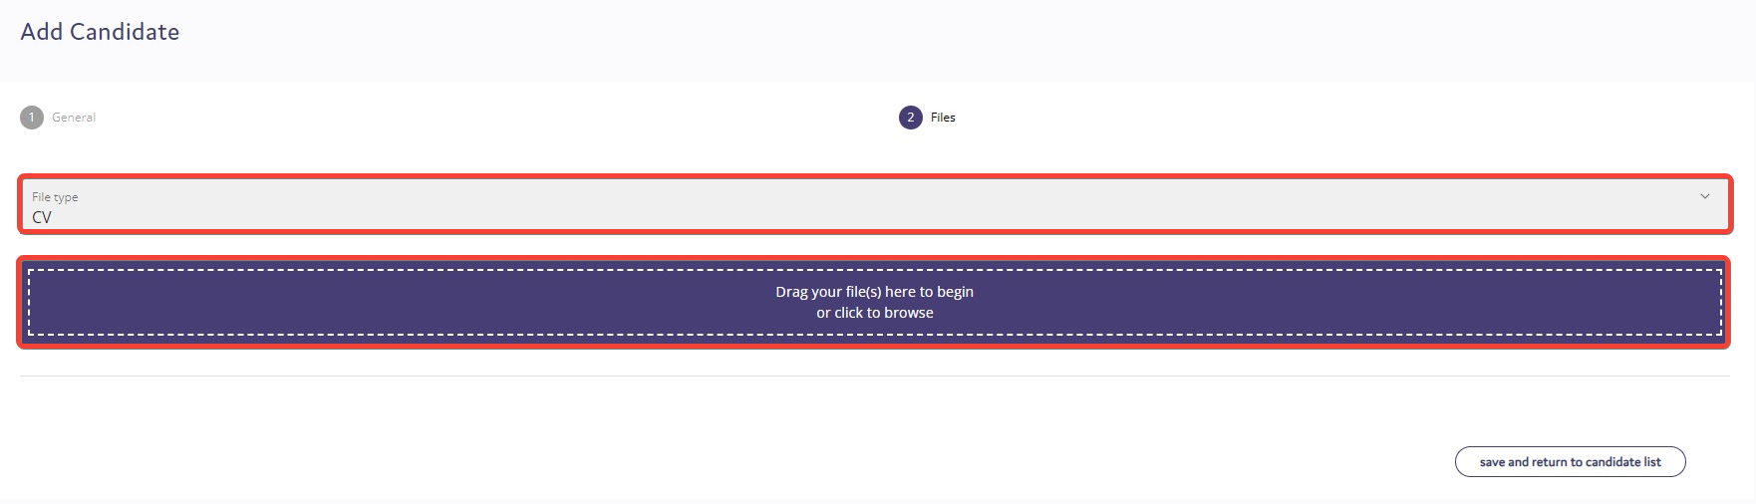
Please note: Only Word documents (.doc or .docx) or PDF files can be uploaded.

You can then choose to save the candidate to the database by clicking on "Save and return to candidate list".

Assigning candidates to a role.
The ATS allows you to assign candidates that you have added to the database to a role that is currently on the ATS. Alternatively, you may have a candidate that has applied for a role and you may wish to assign them to another role on the ATS as they could well be suitable for that vacancy.
Assigning a Newly Added Candidate to a Role
To assign a candidate that you have manually added to the ATS to a role, once you have added the candidate's details and click "Return to Candidate List" click on the checkbox next to their name and select "Assign to Job".
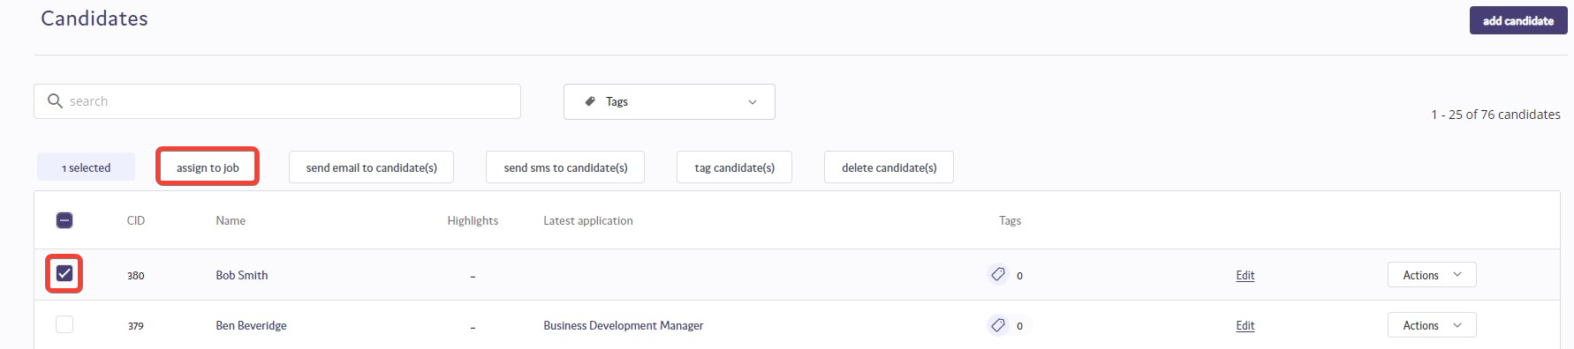
A pop-up box will then appear where you can choose which role you would like to assign the candidate to, and the source of where the application has come from.
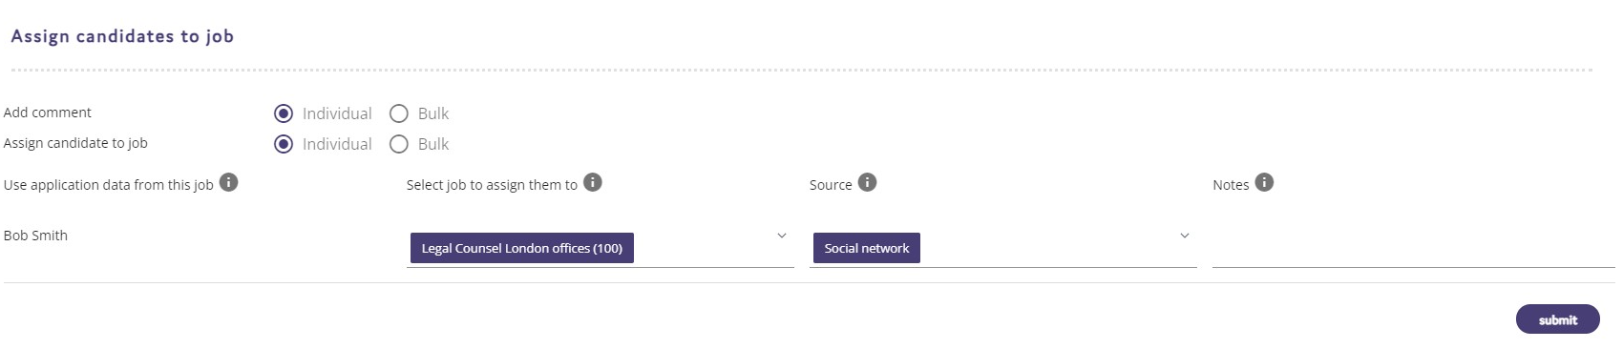
Once you have selected the job and the source of application, click Submit and the candidate will be assigned to that role.
Please note: You can only assign candidates to jobs that are active on the ATS.

Assigning a candidate that has already applied to a role in the ATS to another position.

If you have a candidate in your database that you would like to assign to another role in the ATS, first find the candidate that you are looking to assign to this role. Once you have found the candidate that you are looking for, click in the check box next to their name and then choose "Assign to Job".
As above the same pop-up box will appear where you can choose the role you would like to assign the candidate to, and the source that you would like to assign against the candidate.
Click Submit to confirm the role and source of application and the candidate will be assigned to that role, and on the applicant list for that role the candidate will show with a number next to their name.
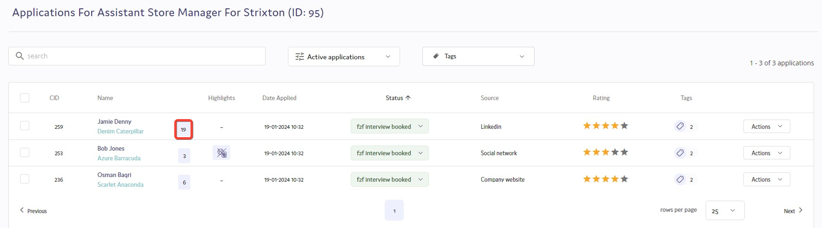
Searching for candidates in the database.

The candidate database has a search function built within it that will allow you to search for candidates by the following criteria:
- First Name
- Last Name
- Email Address
- Candidate ID
- Location Inputted in their Application Form
- Current Job Title Inputted in their Application Form
- Tag Applied to Them (see article on "Tagging Candidates" for further details)
To search for a candidate within the database, on the candidates tab, click into the filter candidates search bar to begin your search. You can then type the search word that you are looking for.
Searching for candidates by name / email address / candidate ID.
To search for a candidate by name (either first name or last name), email address, or candidate ID, enter the details you are searching for into the search bar and hit enter. A list will then appear to choose what criteria you want to search by.
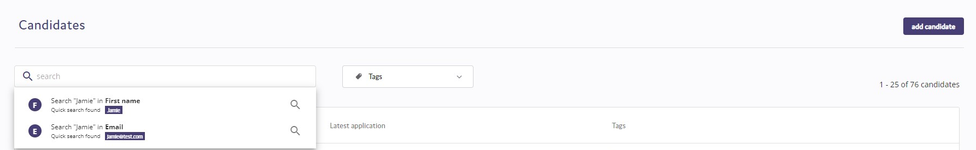
Select the criteria that you wish to search by, and the list of candidates will appear who have met that criteria.
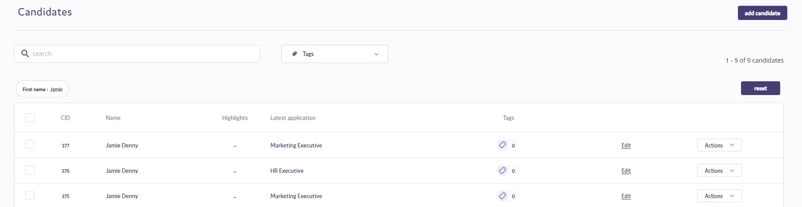
Searching for candidates by location / job title.
To search for candidates who are in a certain location or have indicated on their application form that they are currently working in a particular job, in the search bar enter either the location or job title and the dropdown list will appear for you to select the criteria to search by.
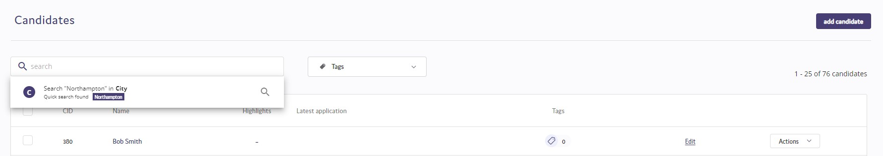
Select the location or job title, and all candidates that have indicated that they are in that location or currently doing that job will appear.
Searching for tagged candidates.
To search for tagged candidates within a talent pool, click on the tags option.
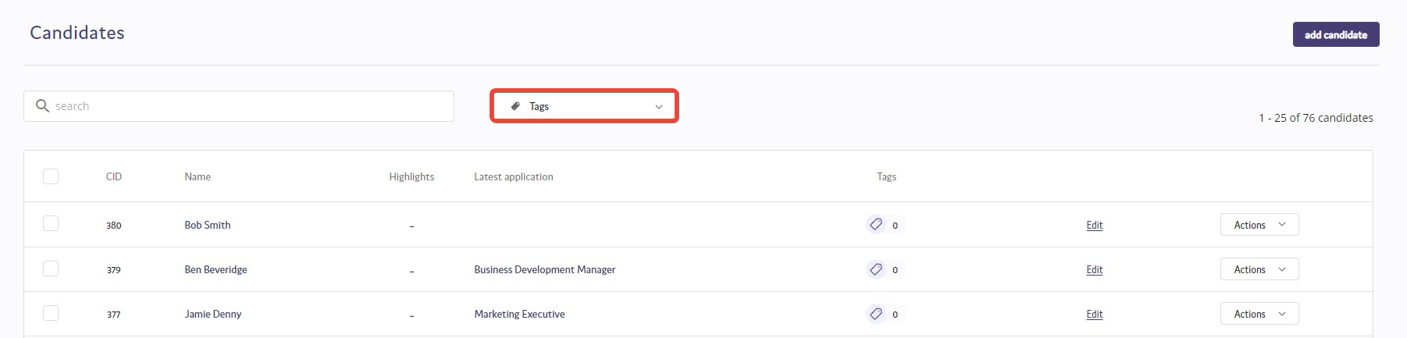
Click on the tag that you wish to search within and all candidates who have been tagged in that talent pool will appear.

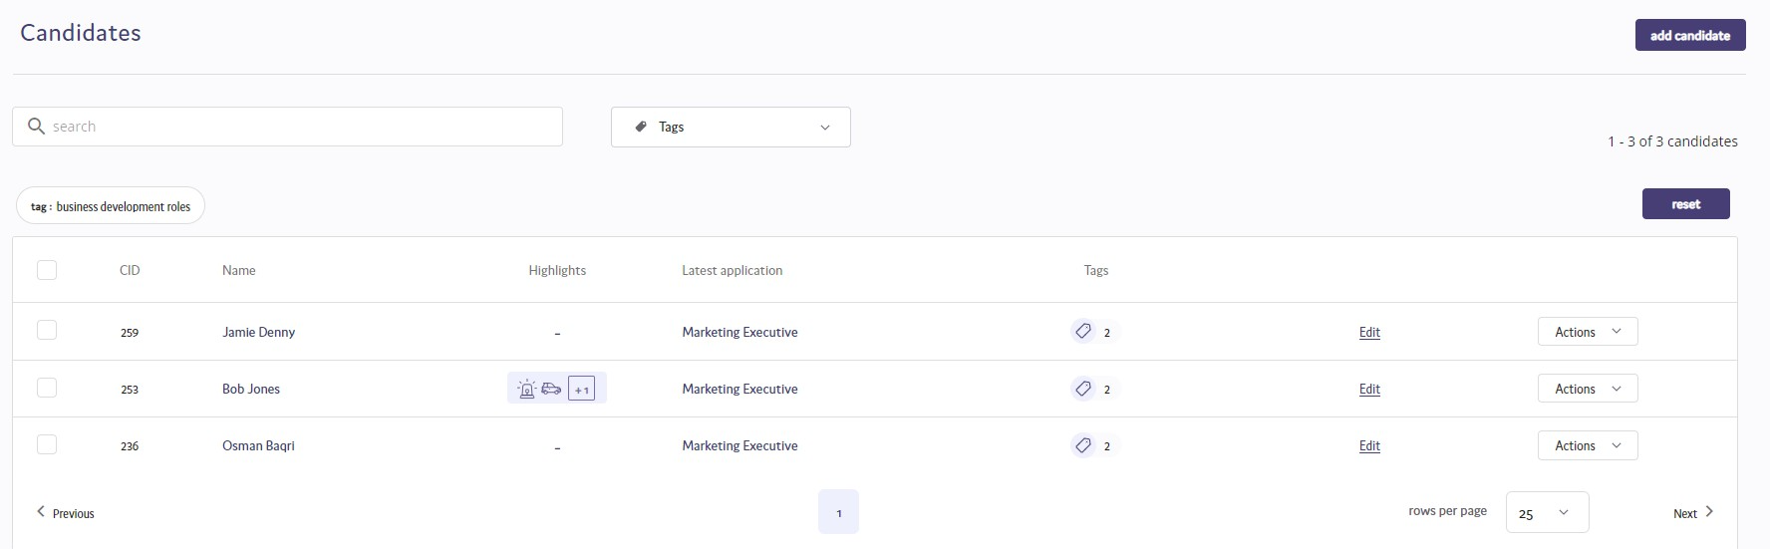
Tagging Candidates.
Within the candidate database you can "tag" candidates which allows you to add them to a talent pool that can be searched for future vacancies. Candidates can be "tagged" to multiple tags, allowing them to appear in multiple talent pools.
You can tag single or multiple candidates within the database.
Tagging a single candidate.
To tag a single candidate, search for the candidate that you are looking for and then click on the  icon. The following box will then appear on screen:
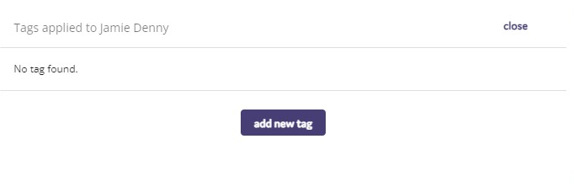

From here you can add a tag against a candidate. Click on the “add new tag” button and you can either type the name of the tag that you wish to assign to the candidate, or you can select from the dropdown list that will appear.
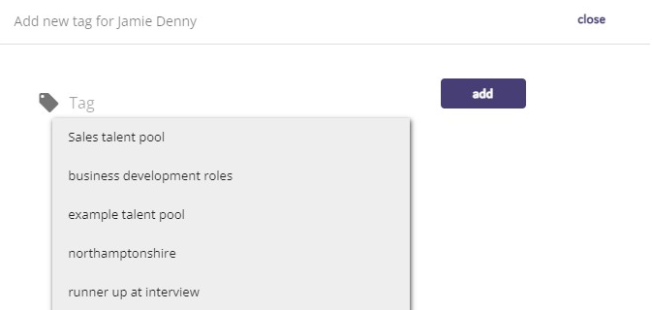

Tagging multiple candidates.
To tag multiple candidates within the candidate database, click on the check box next to the candidates’ names and then choose the "Tag applicant(s)" option at the top of the screen.
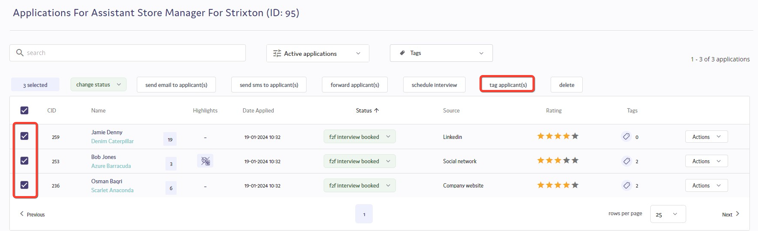

Emailing applicants from talent pools.
The ATS allows you to email applicants that you have added to talent pools to contact them about a new opportunity that you may wish to bring to their attention, thus allowing you to potentially make free hires through the ATS and reduce your recruitment spend.
To email applicants, search for the talent pool that you wish to email and then click in the box next to their name, or if you wish to email all applicants, check the box at the top of the applicant list and select "Send email to candidate(s)" from the top list of options.
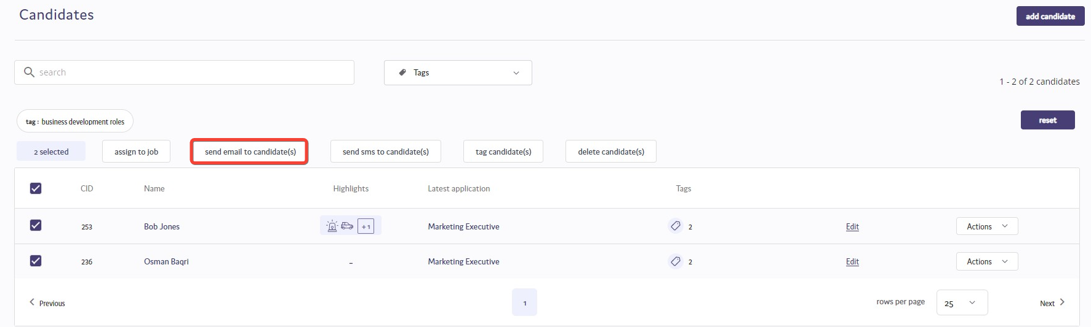
A new box will open where you can then send the email to the selected applicants (1). You can choose which email address you would like to email to be sent from (2) and choose to CC (3) or BCC (4) any other individuals into the email. You can then enter the subject of the email (5) and the content of the email (6) that you wish to send to the applicants, and have the option to attach any files that you may wish to include in the email (7). You can then send the email to the applicants (8).

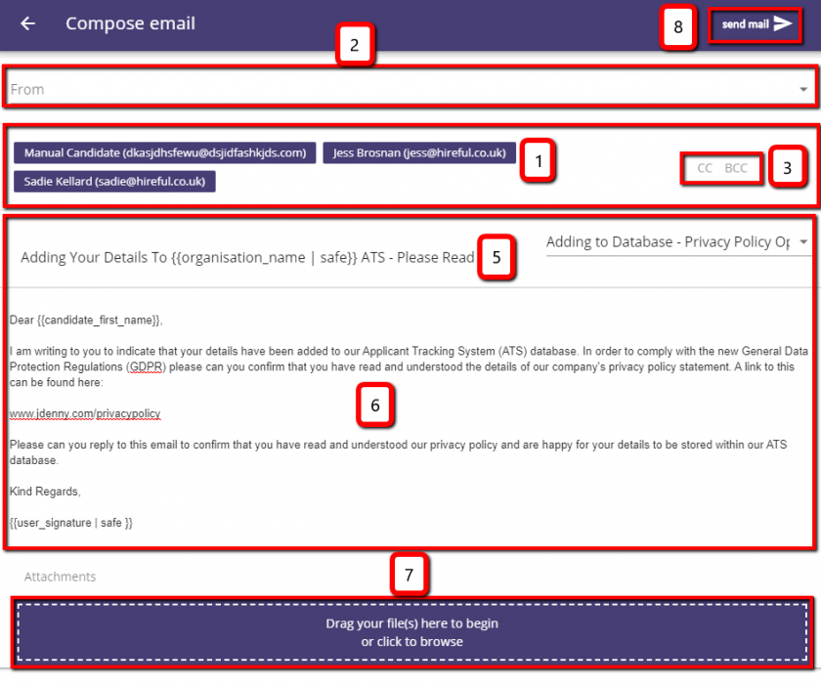

Recruitment Agency Management.

Adding a new recruitment agency.
If you are an admin user you will be able to add new recruitment agencies to your ATS. To do this you will need to click into the agency users page, see below:
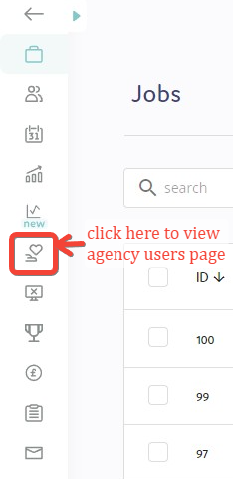
Then you will need to click on the “add agency” button in the right hand corner.
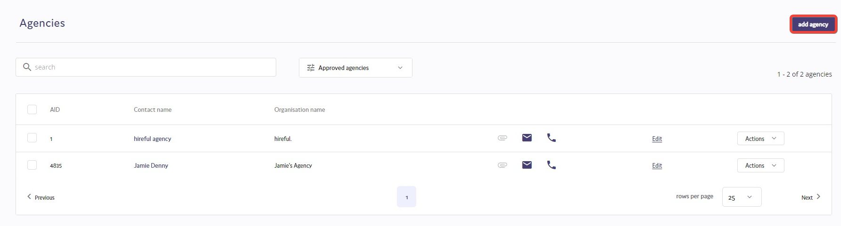
Then you will need to complete the "Add Agency" form. This requires you to first provide the agency contact’s email address. This is so the system can check to see if this agency user is already setup on our database (for example this agency works with another ATS client so will not need to have separate logins per system).
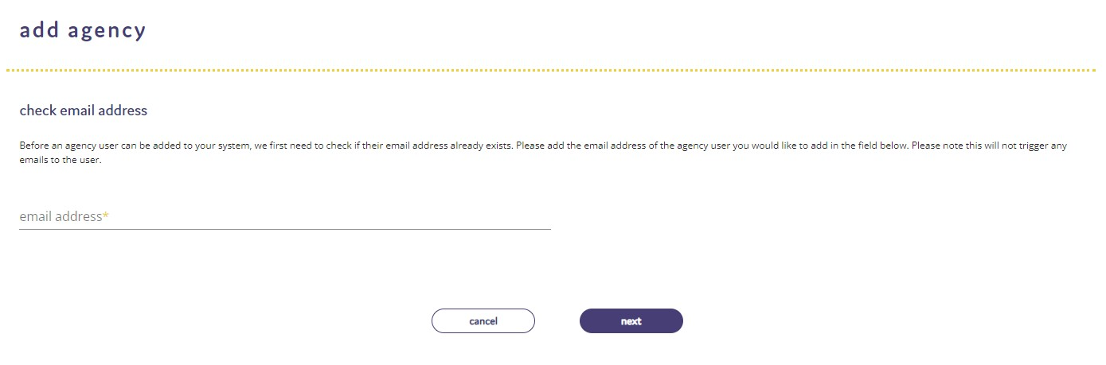
If the agency has not been setup already, you will then need to complete the form, asking you to provide the following:
- Contact first name
- Contact last name
- Office contact number
- Agency name - Our database is organised by users, so you can add multiple users from the same agency.
- Payment terms - This is an optional field where you can record the payment terms you agreed with this agency.
- Registered company number
- Website address
- Margin - This is an optional field where you can record the margin you agreed with this agency.
- Notes - Optional field to record any additional notes.
- Terms of business - You can upload a copy of their terms of business here in order to save it against their record.
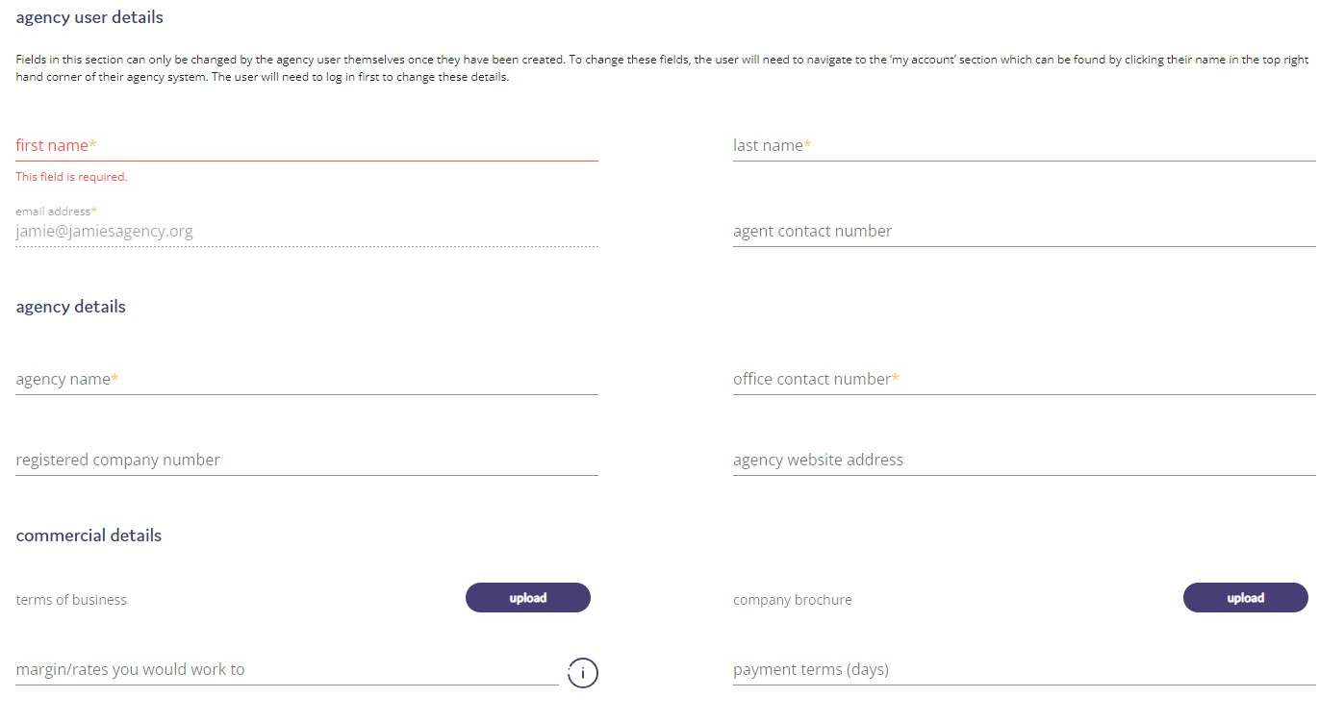
Importing a list of agency users.
If you are looking to set this up for the first time, you might prefer to email over an xls spreadsheet of your agency users to our support team for them to import for you (support@hireful.co.uk / 01933 667167). If you choose to ask the support team to import a list of recruitment agency contacts then please ensure that your list includes all of the following:

- First name
- Last name
- Agency name
- Contact email address
- Contact telephone number

Releasing a job to an agency user.
There are two ways to release a job to an agency user.
Releasing a job from the jobs page.
For most users this is their preferred method. You select the job(s) you want to release and you then select to "Release to agencies".
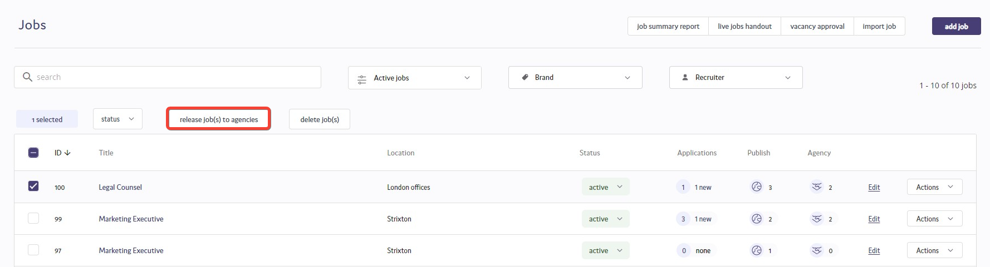
You will then see the "Release vacancies" page. From here you can select the agencies you want to release this job to, you can select more than one. You can also provide comments that are shared with the agency users. This is typically information not listed on the job advert such as salary/benefits details, information about the urgency of this job or any other key information.

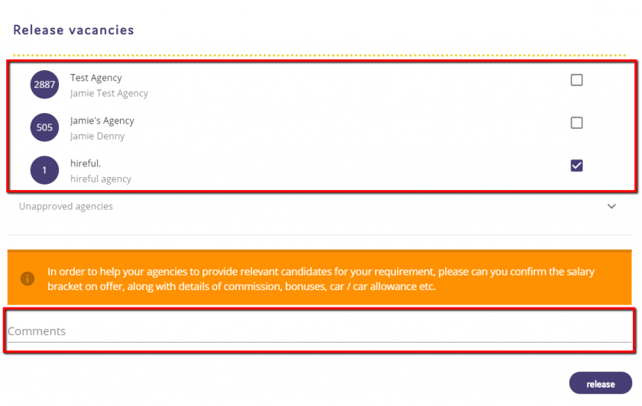
Releasing a job from the agency page.
You can also release a job from the agency page. Here you would start by selecting the agency users you wished to assist you with this vacancy. Then you would select "Release vacancies".
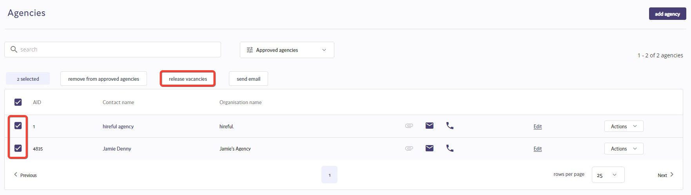
You would then see the same "Release vacancies" window. However, this time the agencies are listed at the top of the screen and are pre-selected. The user needs to confirm the job(s) they would like to release to the agencies.
Once again you should try to add some comments to assist your agencies in sourcing relevant applicants.
How an agency submits an applicant.
An agency user will be alerted that there is a new job for you to work on when they receive an email like the one below. Also note how the additional comments from the client are shown in this email (we have highlighted them in red below).
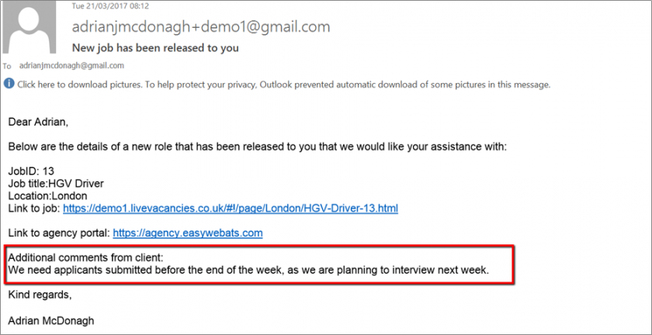
The agency user can view the details of the job and can login to the agency portal to submit any suitable applicants that they have.
Agency Portal.
When an agency logs in they will see a view like the one below, which highlights all the live jobs that they can submit applicants for.
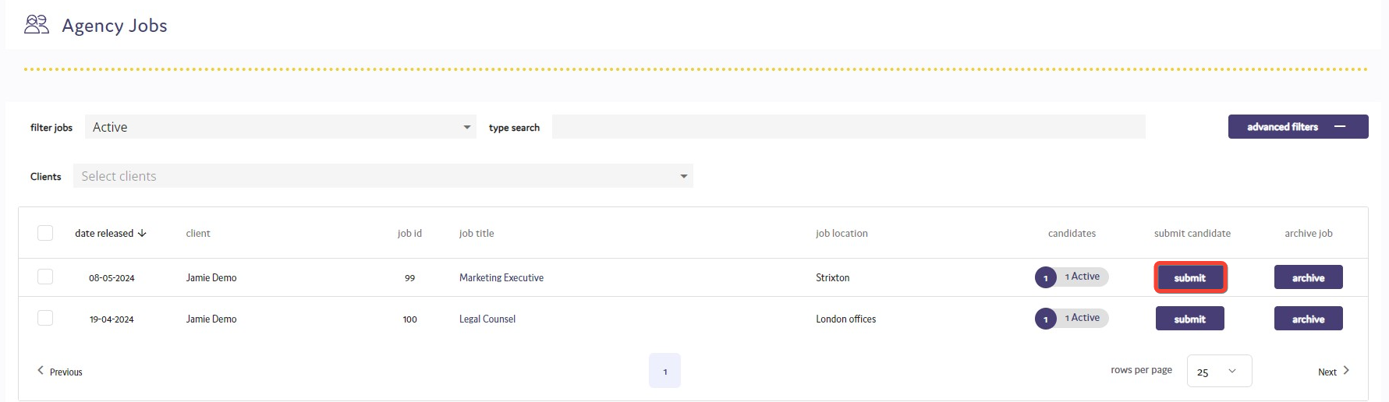
To submit an applicant the agency user should click on the Submit button. This will open a new page where they will be asked to validate the applicant's email address. This is to carry out a duplicate check on the candidate's email address submitted by the agency user. If an agency user tries to submit an applicant who has the same email address as an applicant already submitted for this job then they will not be able to submit this applicant and will see an onscreen warning.
If all the email address is okay then they will proceed to the next step in this submission process.
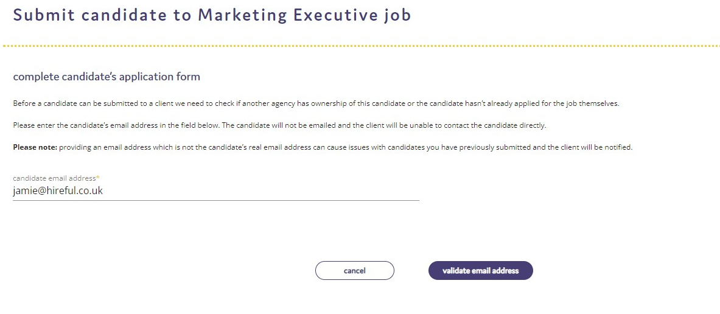
The next step in the process is for the agency user to provide additional information about this applicant and once the mandatory fields have all been completed the applicant can be submitted by the agency user.
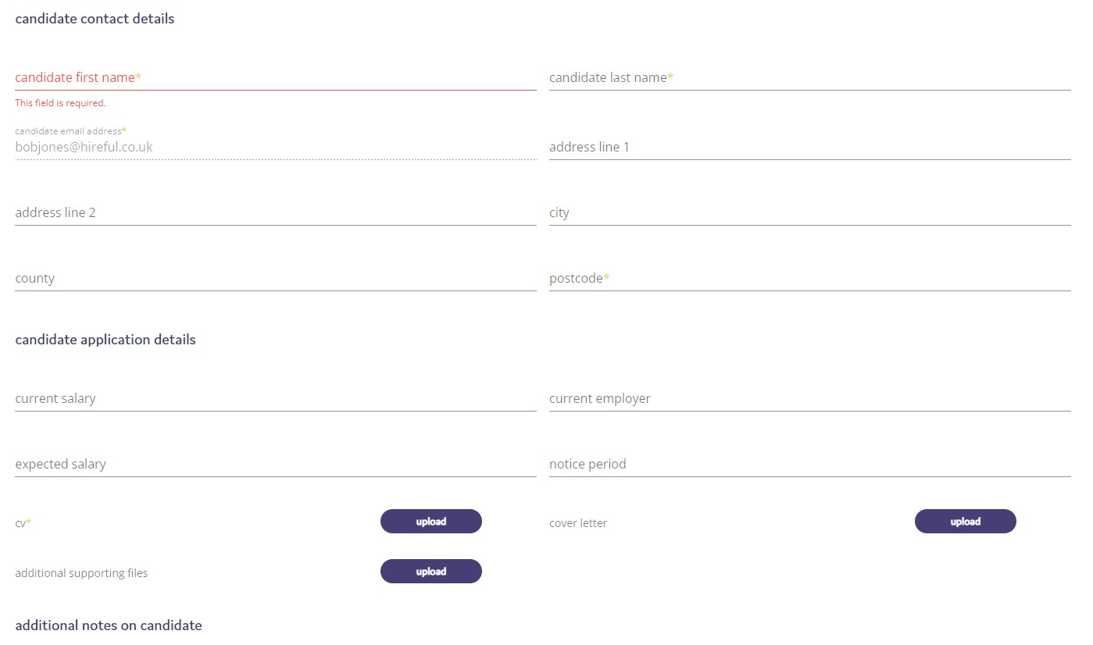
How to withdraw a job from an agency.
All recruiter users can see which jobs have been released to agencies from the jobs home page.
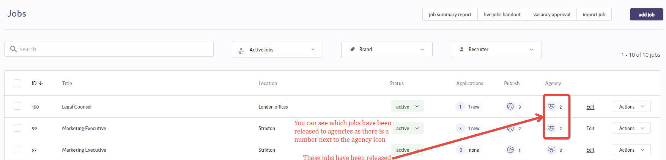
A recruiter user can withdraw a job from one or several agency users, by clicking on this highlighted icon in the agency column. This will open the "Withdraw job" window.
Here the user needs to choose which agencies to withdraw this job from. They can also choose to alert the agencies that you are withdrawing this job from by email and add comments to this email.
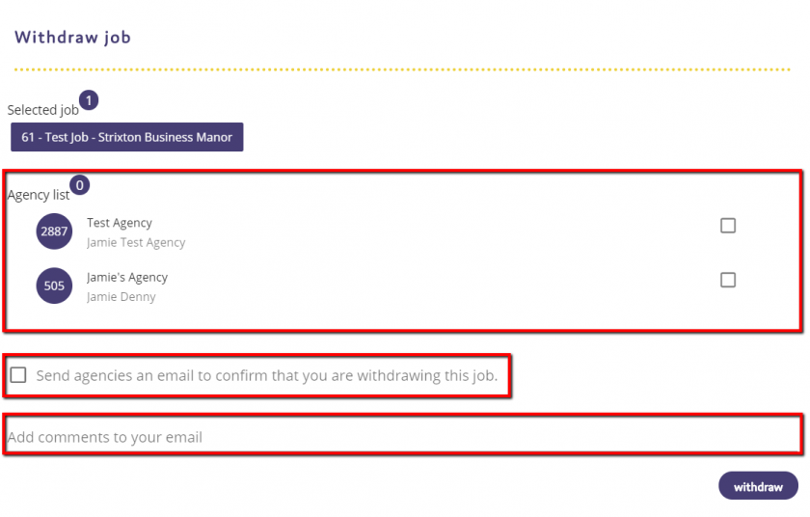
The agency user will receive an email that will look like the example below:

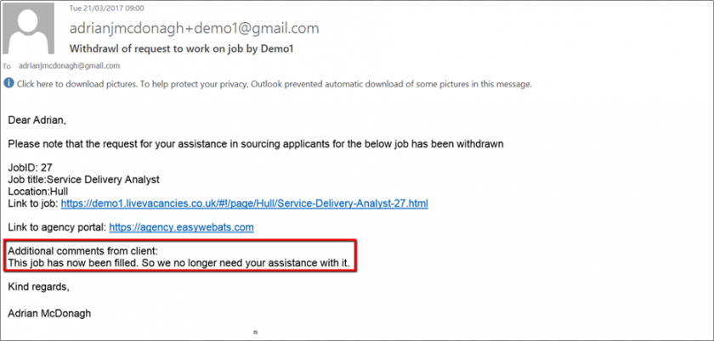

User Management.
Adding a new user.
If you are an admin user and there is sufficient user licenses allocated to your system you can add new users. You do this by clicking on the 3 dots in the top right hand corner of the page....
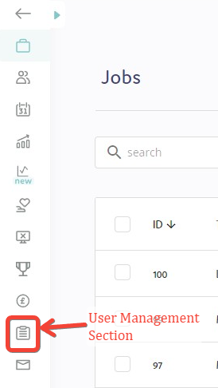

You will then see the User Management window and in the top right hand corner you will see a plus sign which will open the Add User window.
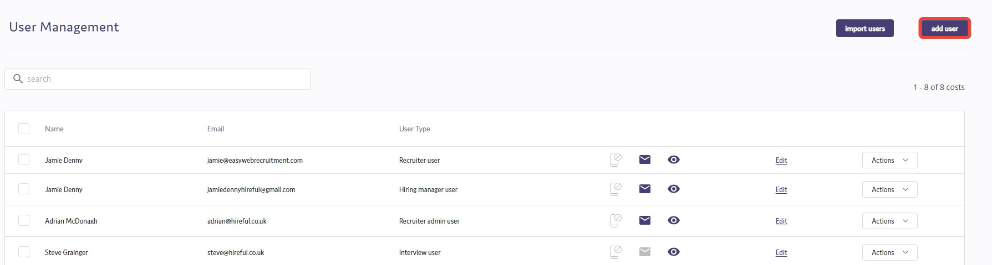
The first thing you will need to do is to add in the user’s email address to check that they haven’t already been setup.
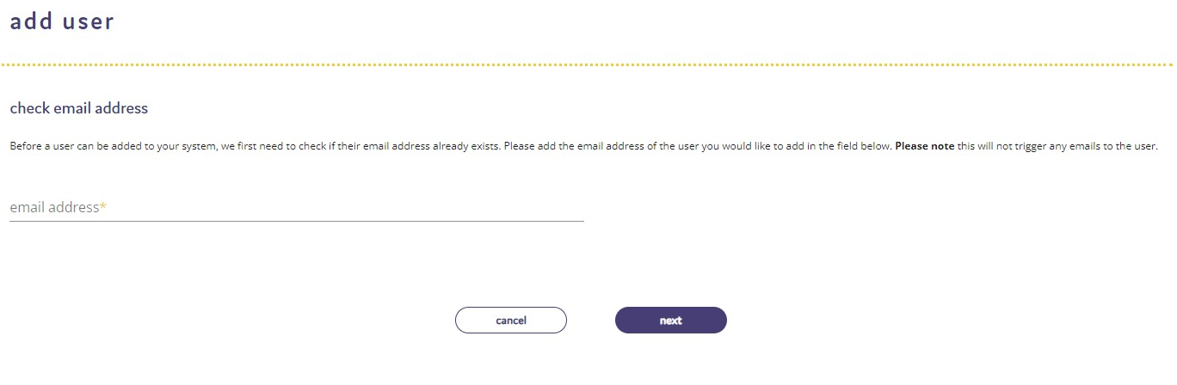
To add the user, you will then need to enter the following details:
- First name
- Last name
  - Job title - This is important to add as it is used in the default signature for this user and also in interview email templates.
- Contact number - Not required but useful, especially if this user might be involved in telephone interviews.
- Role type - Here you can select the relevant user type.
- Timezone – This will default to your computer’s standard timezone.
- Email signature - If you do not add an email signature a default email signature will be used when the system sends email from this user. We can support full html signatures (with organisation logos, social media icons etc - contact our support team for help with this - support@hireful.co.uk / 01933 667164).

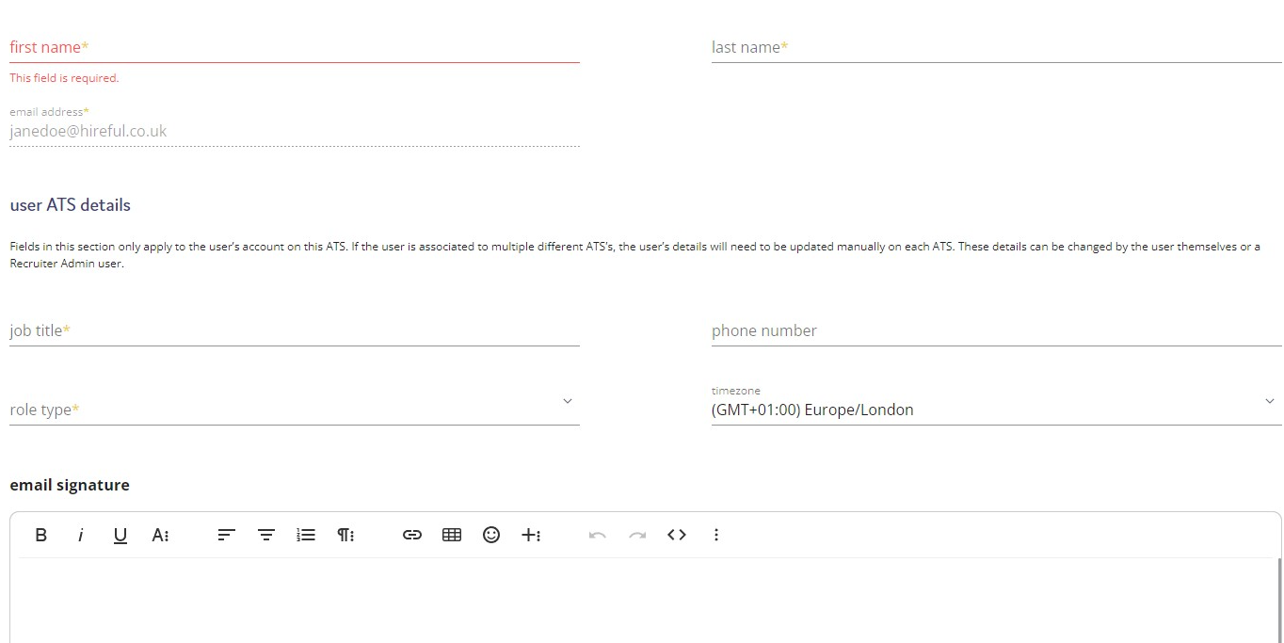

Reports.
Accessing reports.
The reporting suite cover a wide variety of areas that provide detailed information around your campaigns and candidates.
To access the reports, from the main screen, click on the reports icon on the left hand side.
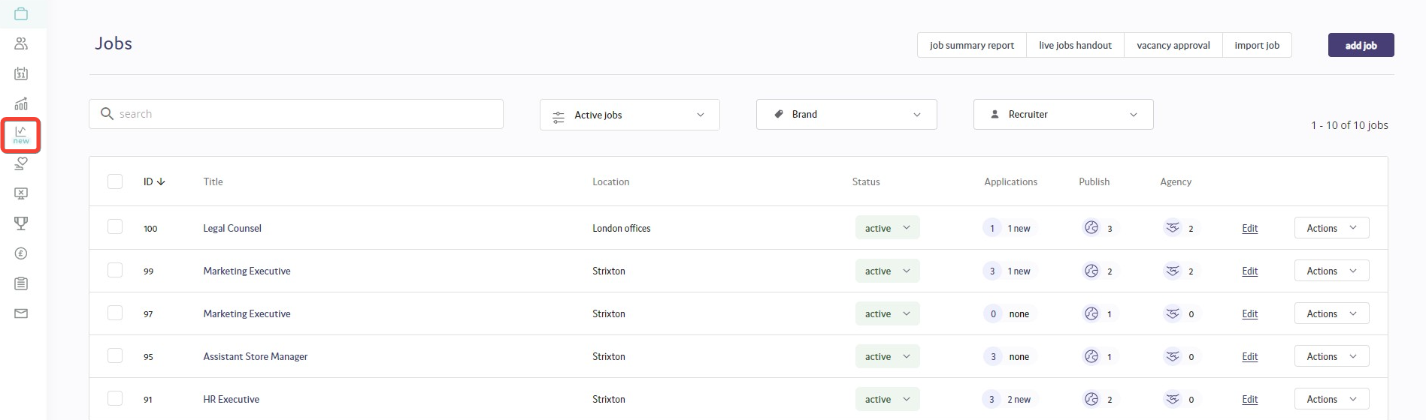
You will then be taken through to the reporting dashboard section. This dashboard provides real-time data around your current number of candidates at the Applied, Shortlist, Interviewed and Offered stages.
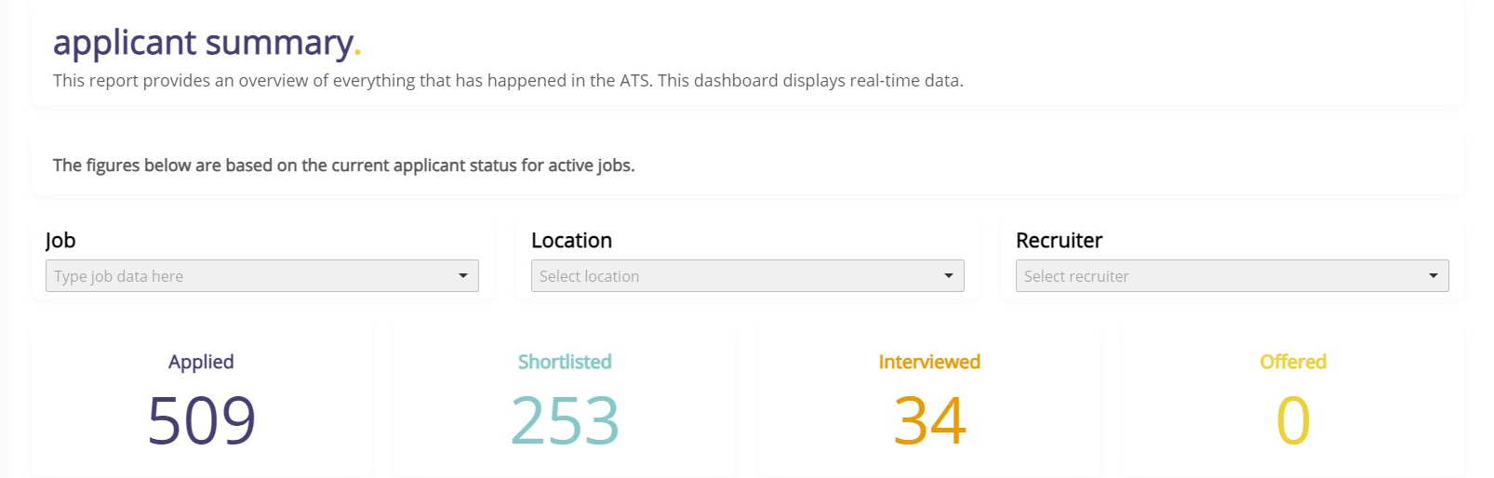
The applicant funnel is a graphical representation of the funnel of applicants as they apply and then shortlisted, interviewed, offered and hired over the previous 12 months. The funnel can be filtered by Department, Location and Recruiter.
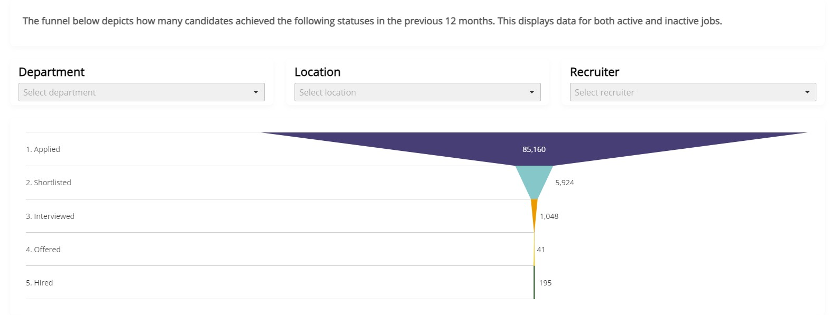

There is also a suite of standard reports, which go into further detail of the data that is available within the ATS. These reports are:
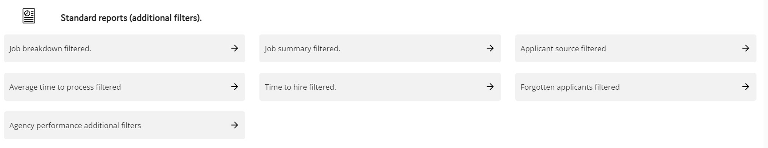
1. Job Breakdown - This report provides you with data around the different status that applicants have been updated to.
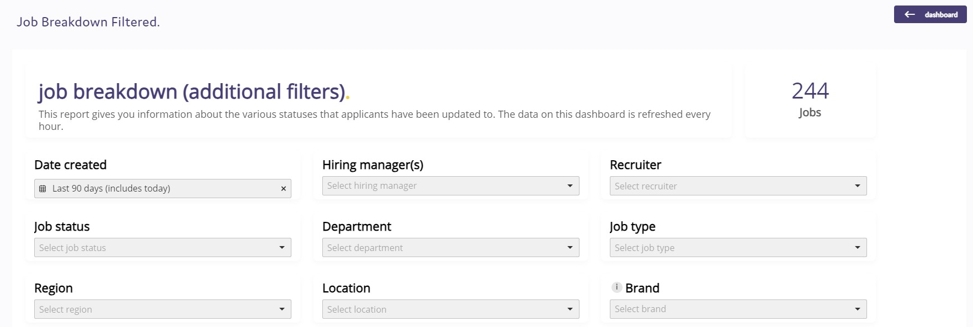

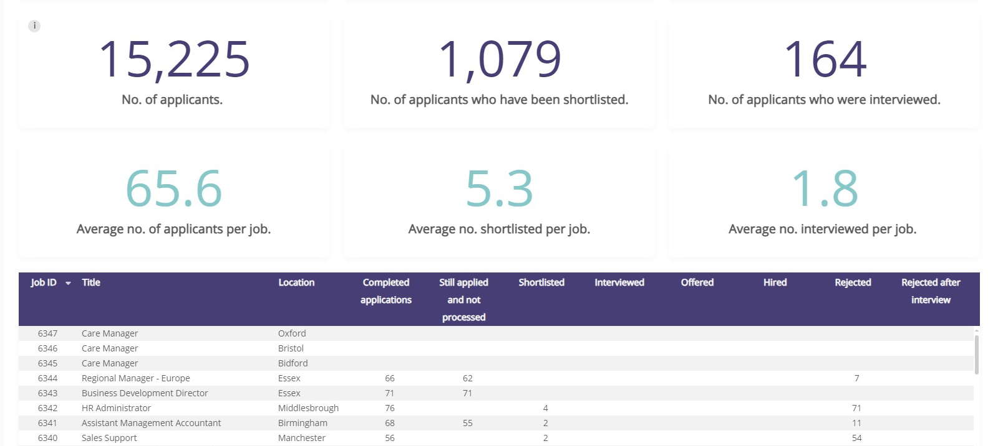
2. Job Summary - This report gives you a general overview of the details of each job and also states the dates the job was created on the ATS and then published.
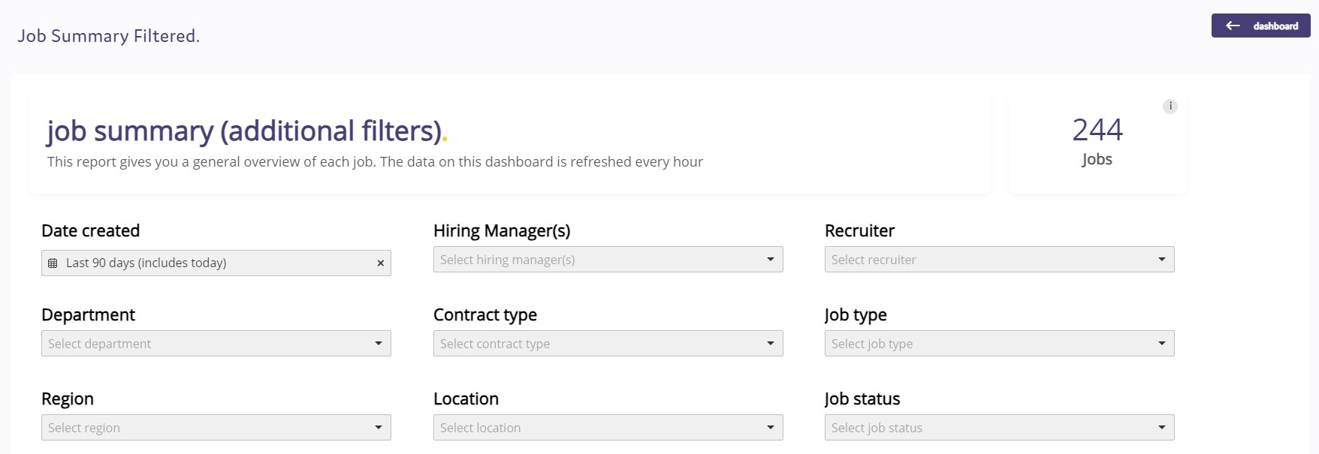
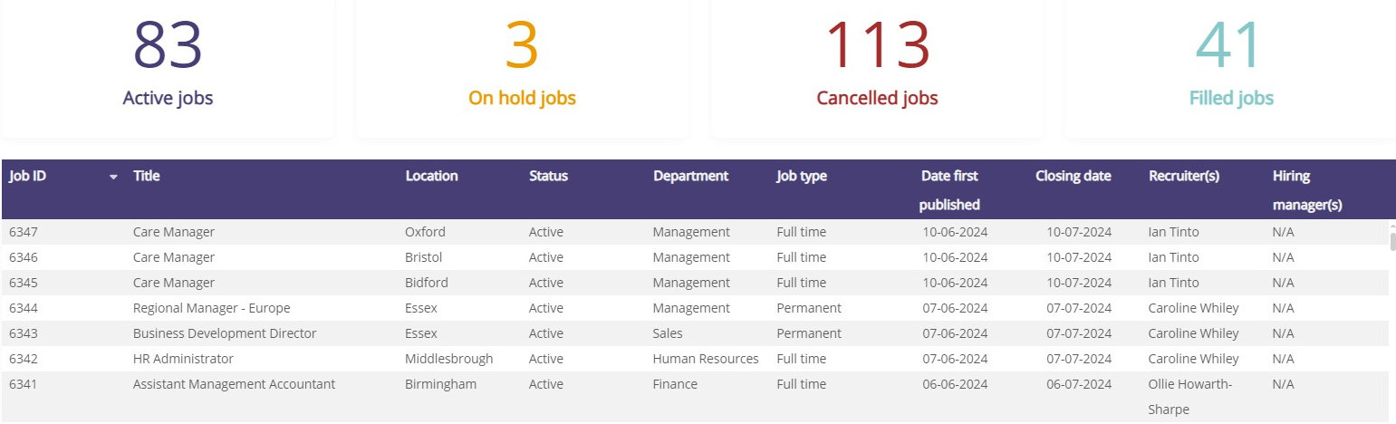
3. Application Source Breakdown - This report allows you to view the source of application for roles overall, and on a job by job basis. This report can be filtered by date range, Recruiter, Job Status type, Location, Region, Department, Brand, Hiring Manager, Contract type, Application progress (how far along the application stage candidates were progresses) and Job type.

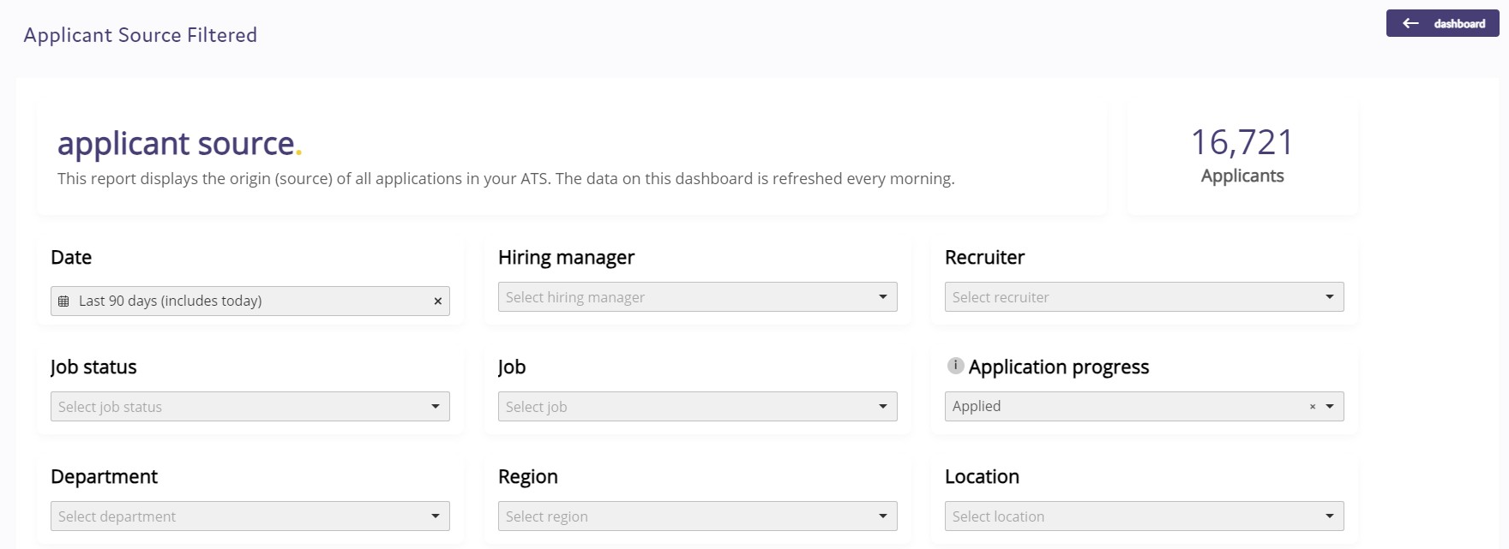

4. Average time to process - This report shows you the average time to process for each role, giving you in days the average time candidates spend at different statuses (applied, shortlist, interview, offer). This report can be filtered by date range, Recruiter, Job Status type, Location, Region, Department, Brand, Hiring Manager, Contract type and Job type.
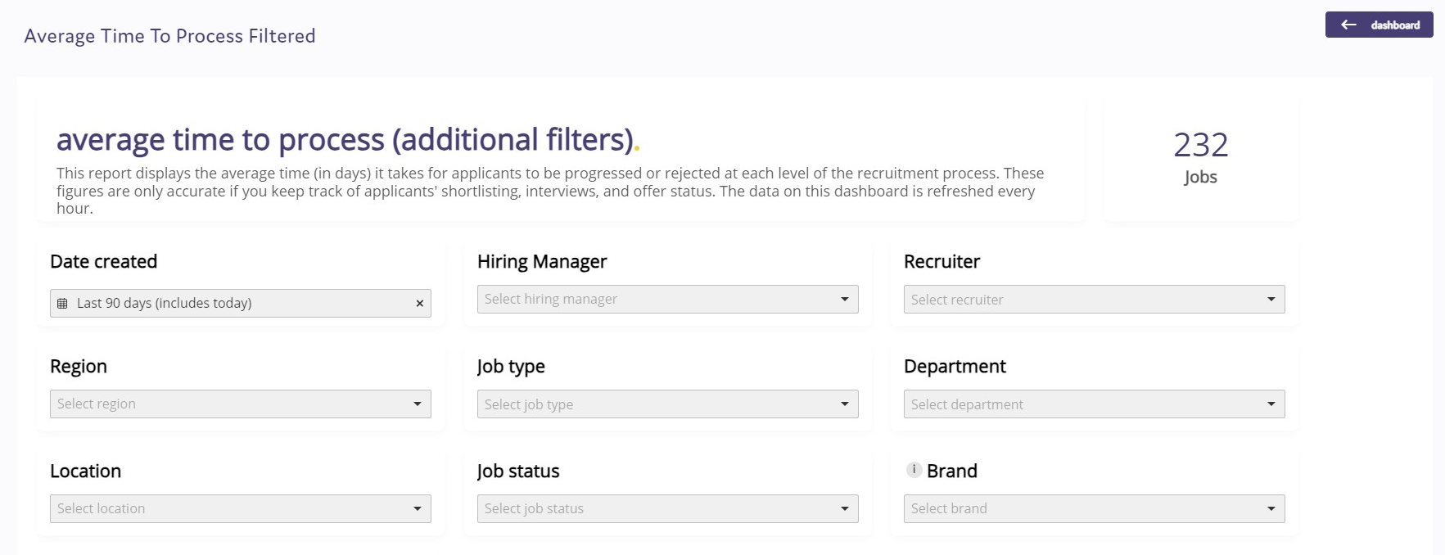
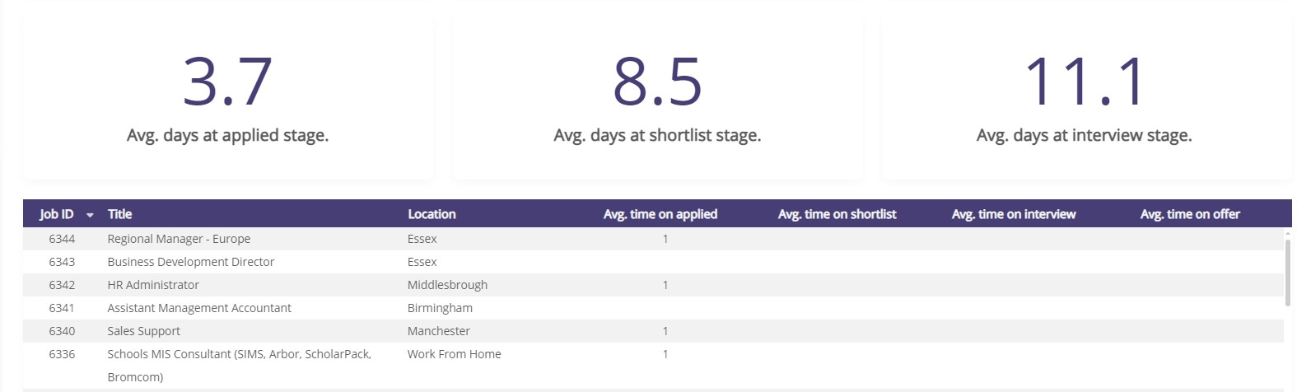
5. Time to Hire - This report provides you with details on your time to hire candidates. The report shows you the applicant time to hire (the time from the date the candidate applied for the vacancy to the date they were changed to hired on the system) and also the job time to hire (the time from the date the job was published out for candidate to begin to apply to the date the hired candidate was changed to hired on the system). Please note: this report will only show data if candidates are changed to the hired status on the ATS.
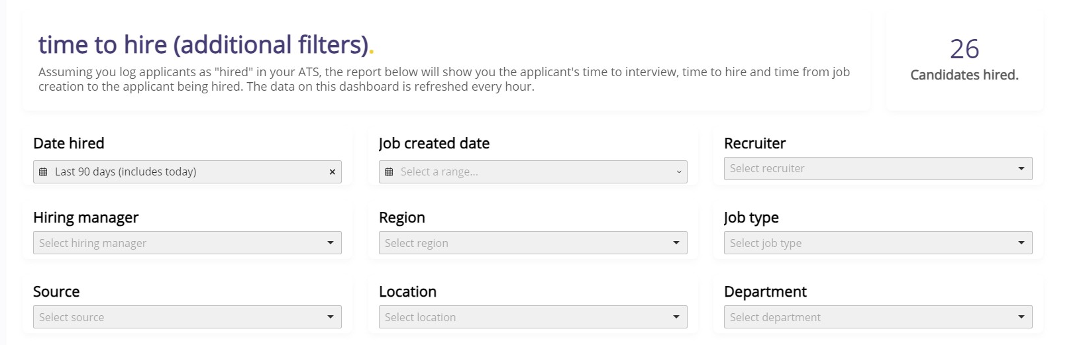
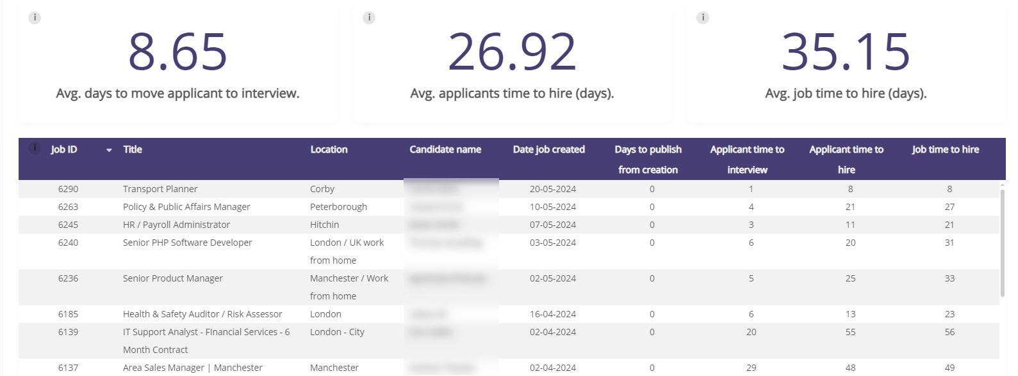
6. Forgotten applicants – This reports allows you to setup time ranges and see if any candidates have not had their status updated within that time period. For example, you can see how many candidates have been sitting at the status of applied for more than 5 days, and then work through the list to update their status.
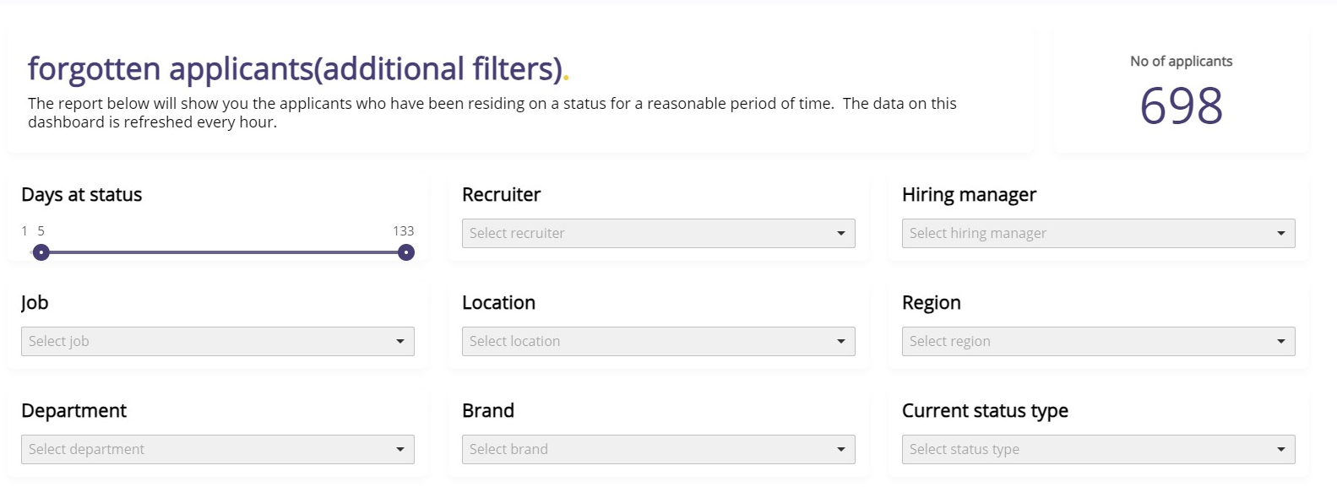
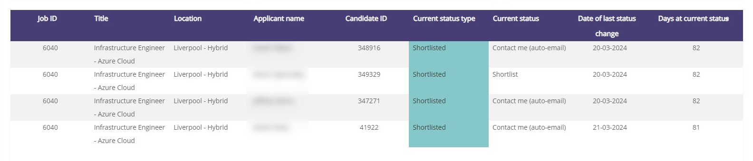
7. Agency performance – This report allows you to track how your recruitment agencies are performing in terms of number of applications submitted through to the number shortlisted, interviewed, offered and hired.
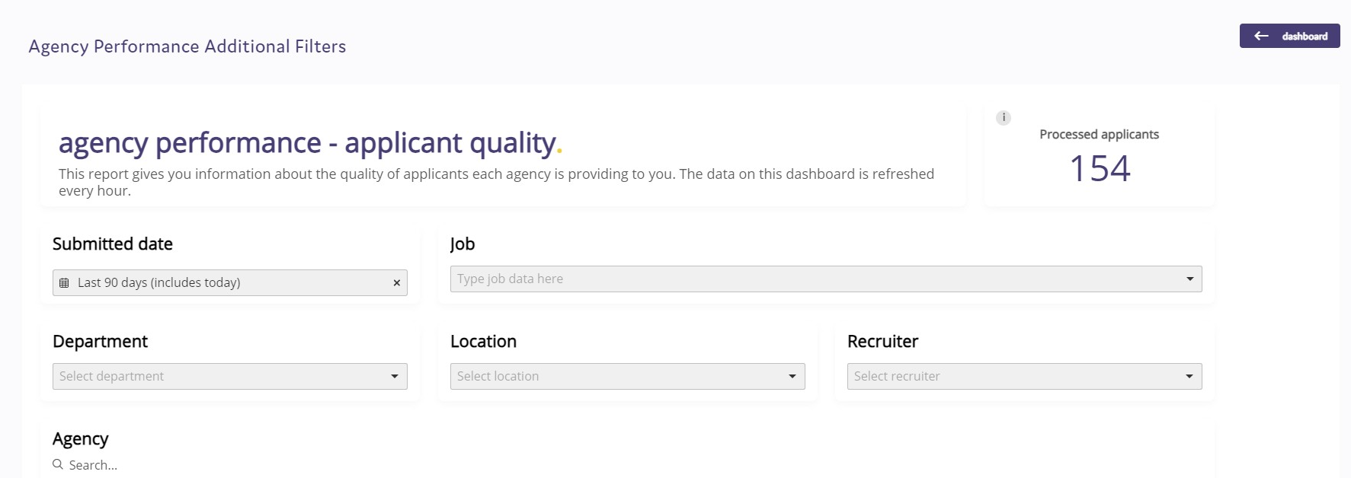
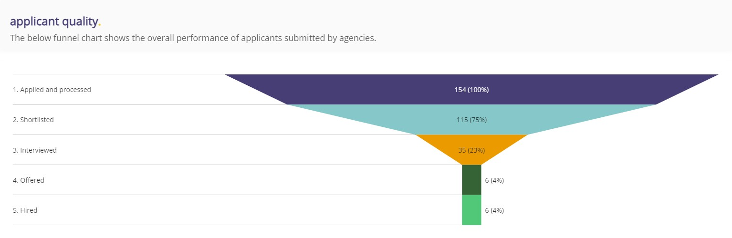
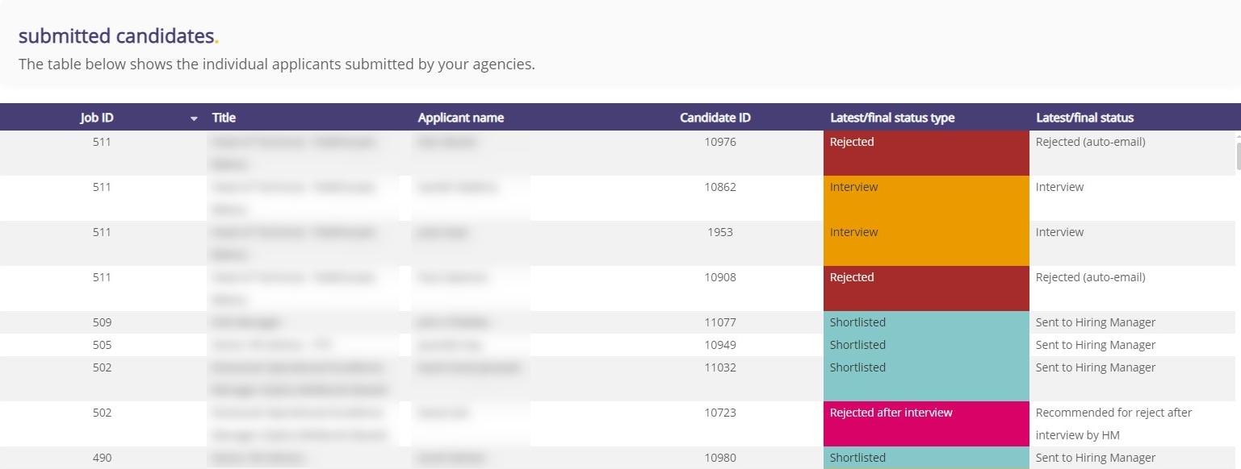

8. Application form performance – This report allow you to view your completion rate of application forms, and also the method of how candidates are applying for your vacancies (desktop, mobile or manually added). The report also allows you to see the percentage of applicants opting to provide their diversity data.
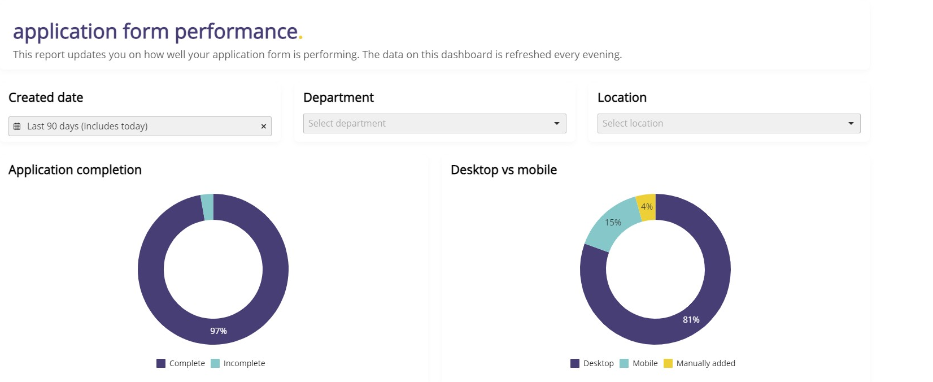
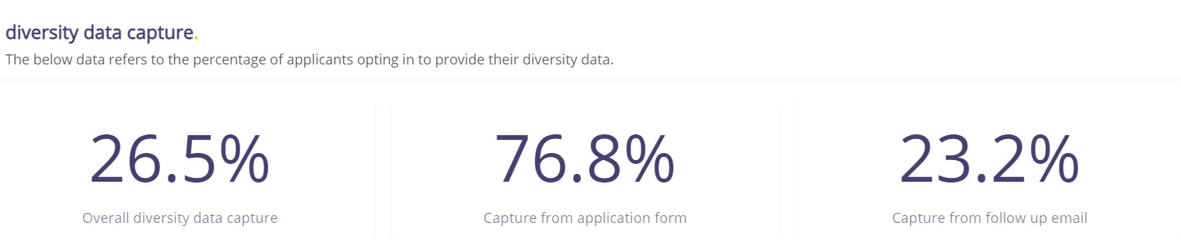
All of the standard reports allow you to export the data from the ATS to an Excel spreadsheet, or if any of the reports have a graph image, the image of that chart can be downloaded.
Please Note: If you are a Pro or Hero ATS customer, you have the option to have bespoke reports built for specifically for your ATS. If you would like further information around this, please speak to your Account Manager.
D&I reports.
The ATS comes with an extensive range of D&I reports that allow you to track your diversity data and how this changes as candidates move through the recruitment process. The ATS also has the 2021 Census data added to it, allowing you to benchmark your data against the latest census information.

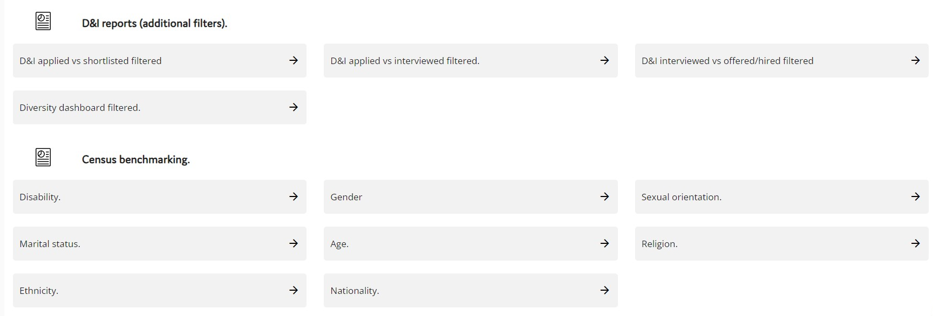

The D&I reports that are setup in the system are:

D&I applied vs shortlisted – This allows you to view the difference in your diversity data between your shortlisted candidates compared to the number of applications.

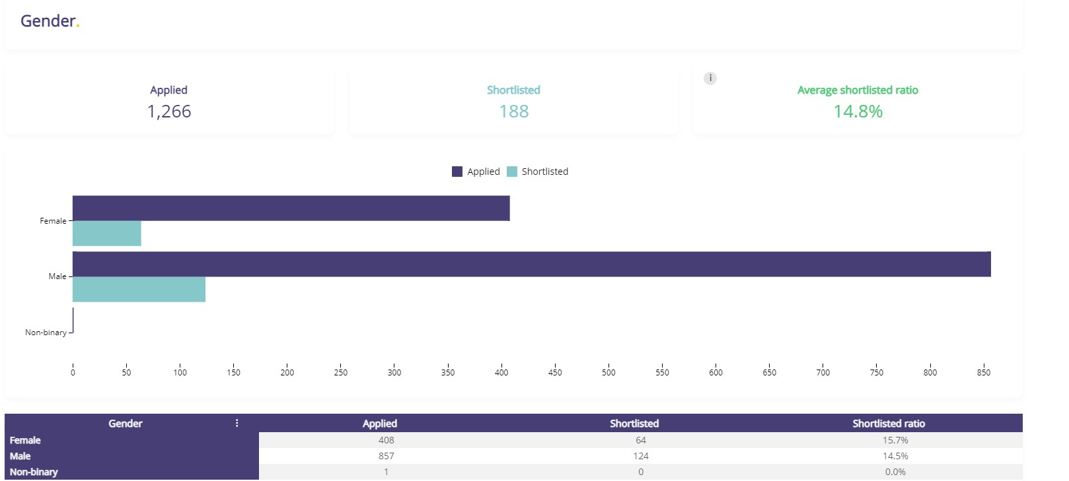

D&I applied vs interviewed – This allows you to view the difference in your diversity data between your interviewed candidates compared to the number of applications.
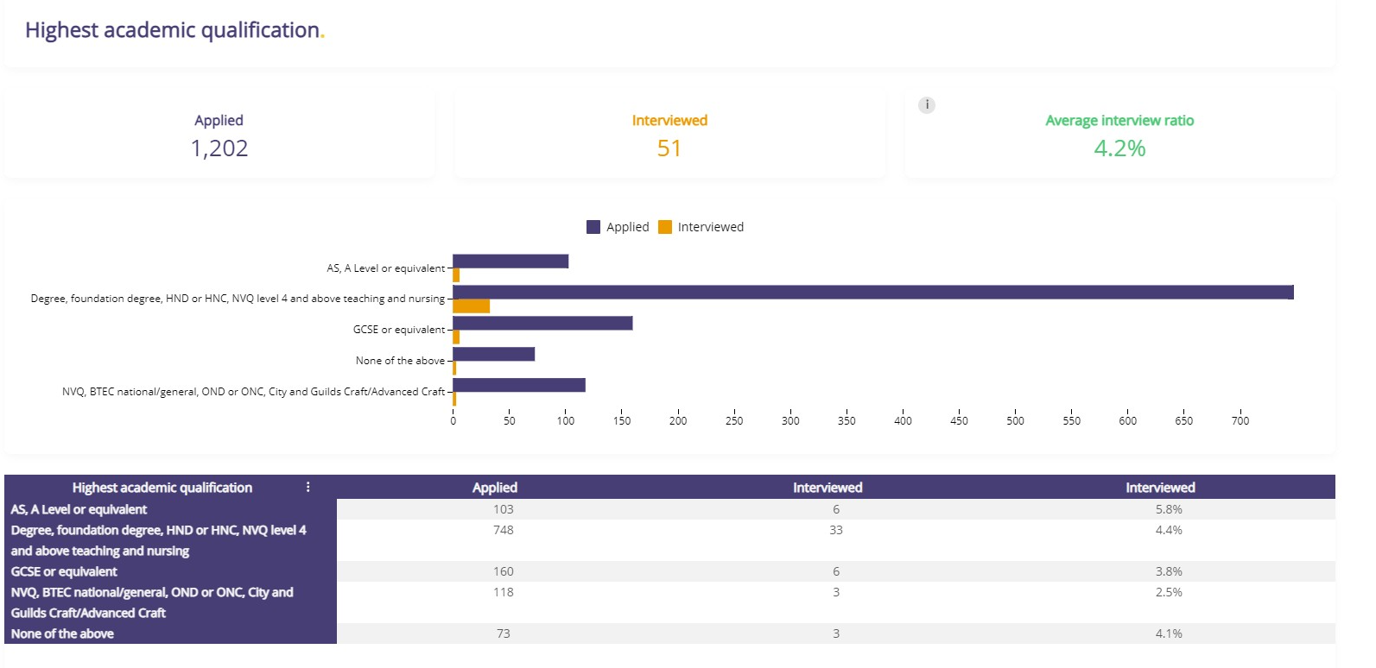

D&I interviewed vs offered/hired - This allows you to view the difference in your diversity data between your offered and hired candidates compared to your interviewed candidates.
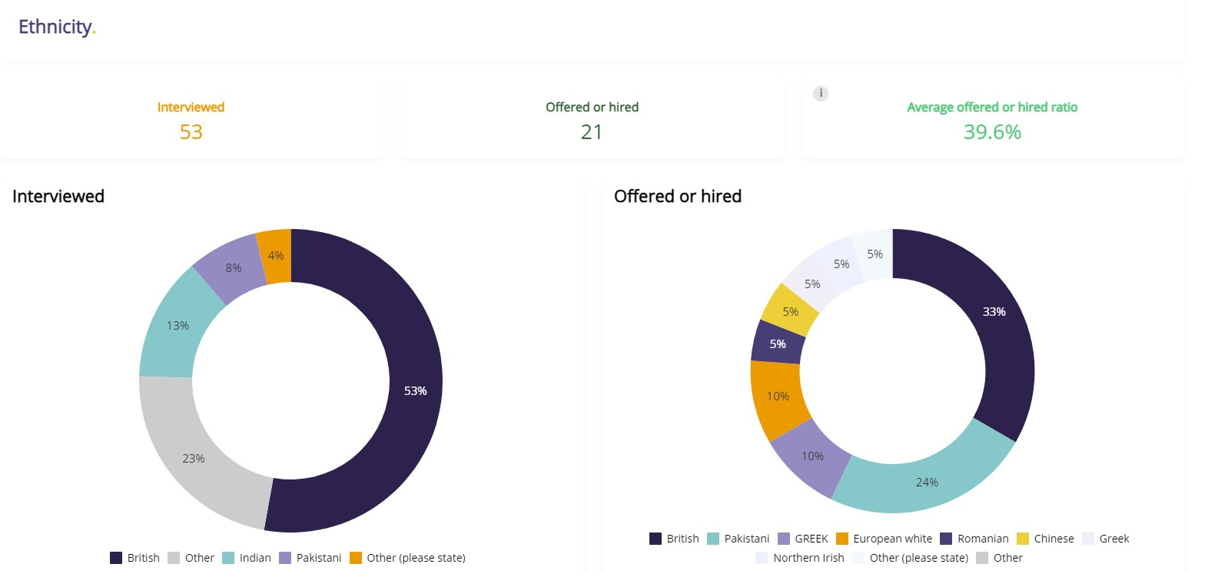

Diversity Dashboard - This report allows you to view the diversity information provided by your applicants. The data on this dashboard is refreshed weekly.

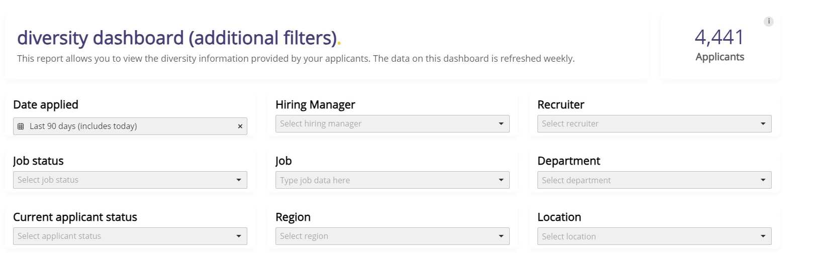
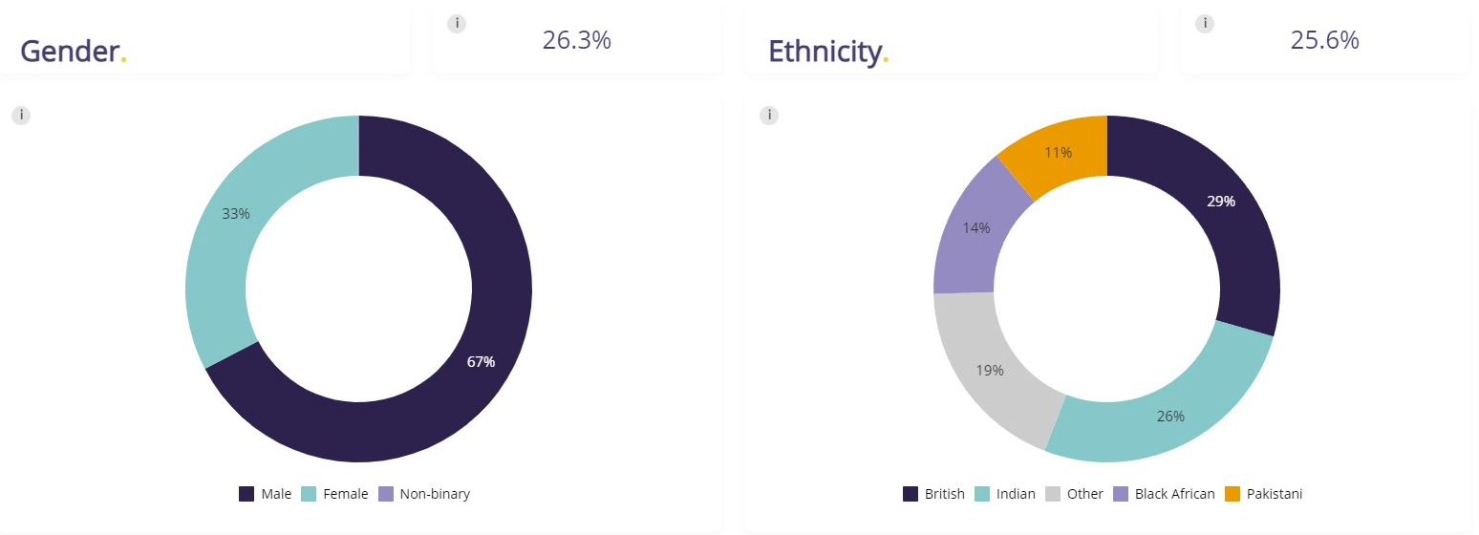
Email Templates.
Creating and using email templates.
You are able to create your own email templates within your ATS. You do this by selecting "Email Templates" from the menu.
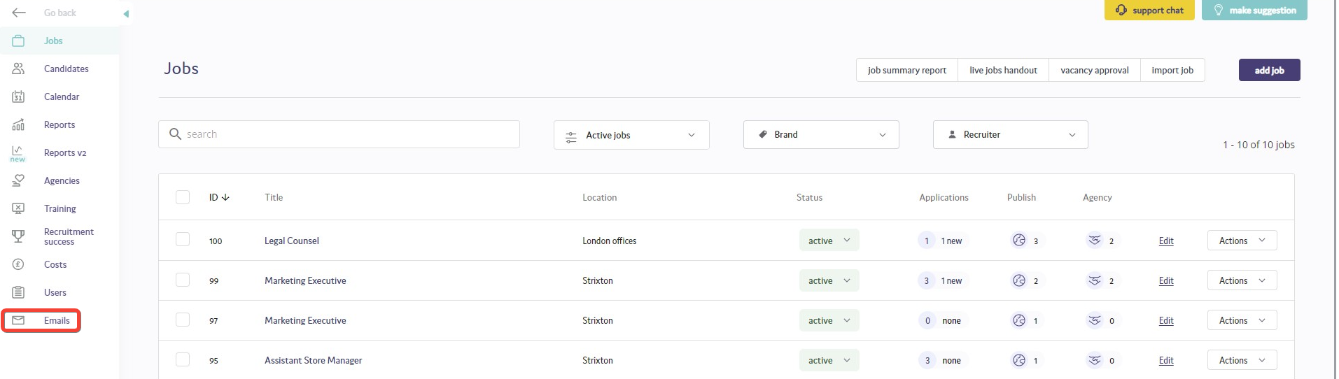

This will open the email templates admin screen.
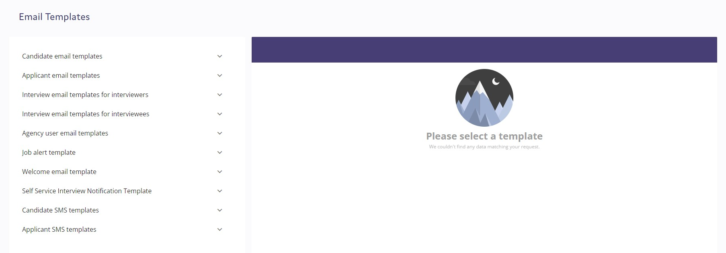
Here you will see that you can edit and create email templates that will be available in the following circumstances:
- Candidate email templates: These are available when you are in the candidate list page and you choose to select one or more candidates and select "Send email to candidate(s)".
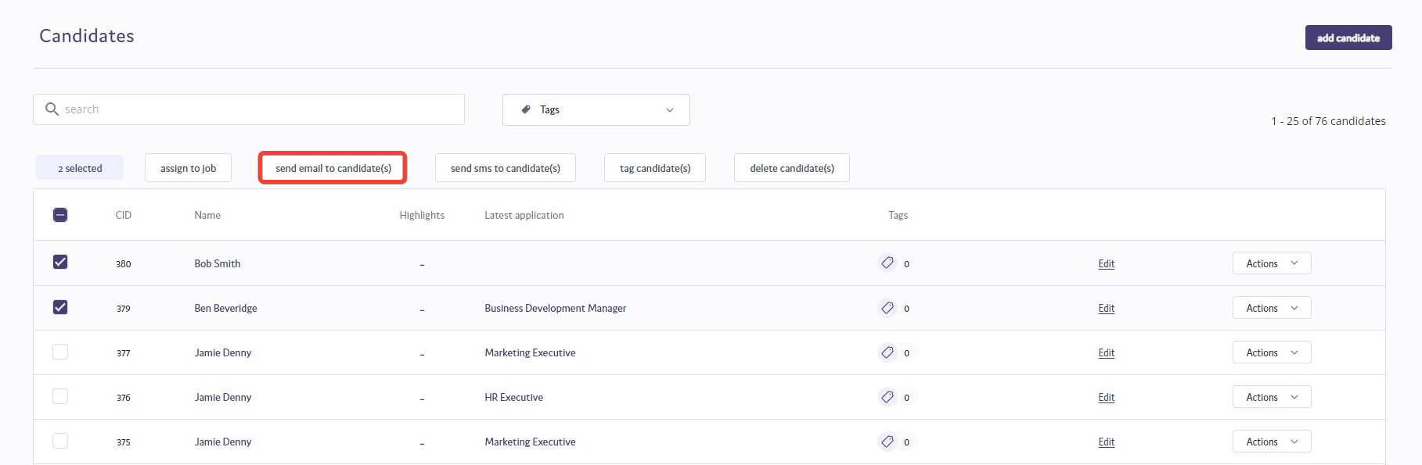
- Applicant email templates: These are available when you are in the applicant list page and you choose to select one or more applicants and select "Send email to applicant(s)".
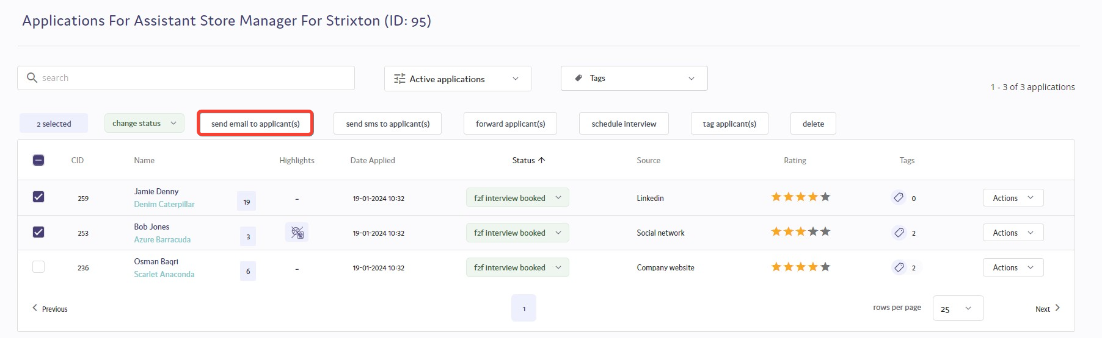

- Interview email templates for interviewers (Hiring Managers): These are available when you are in the communication stage of scheduling an interview an you select the email to send to the interviewers.
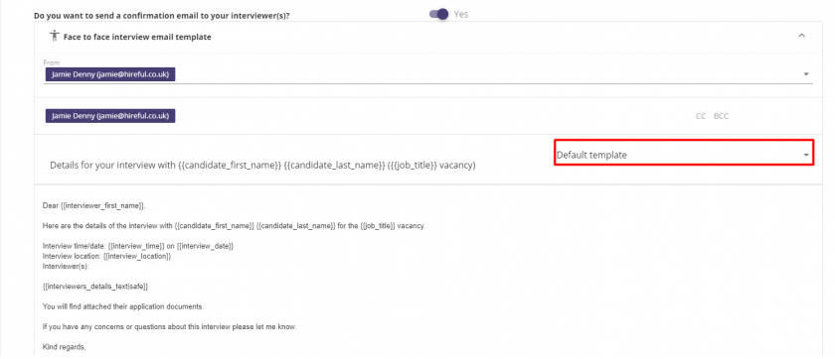
- Interview email templates for interviewees (Candidates): These are available when you are in the communication stage of scheduling an interview and you select the email to send to the interviewees.
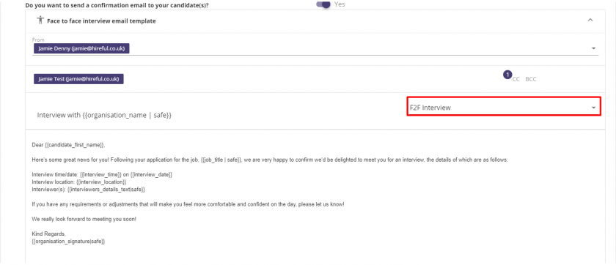
- Agency user email templates: These are available when you are in the agency list page and you choose to select one or more agencies and select send email.
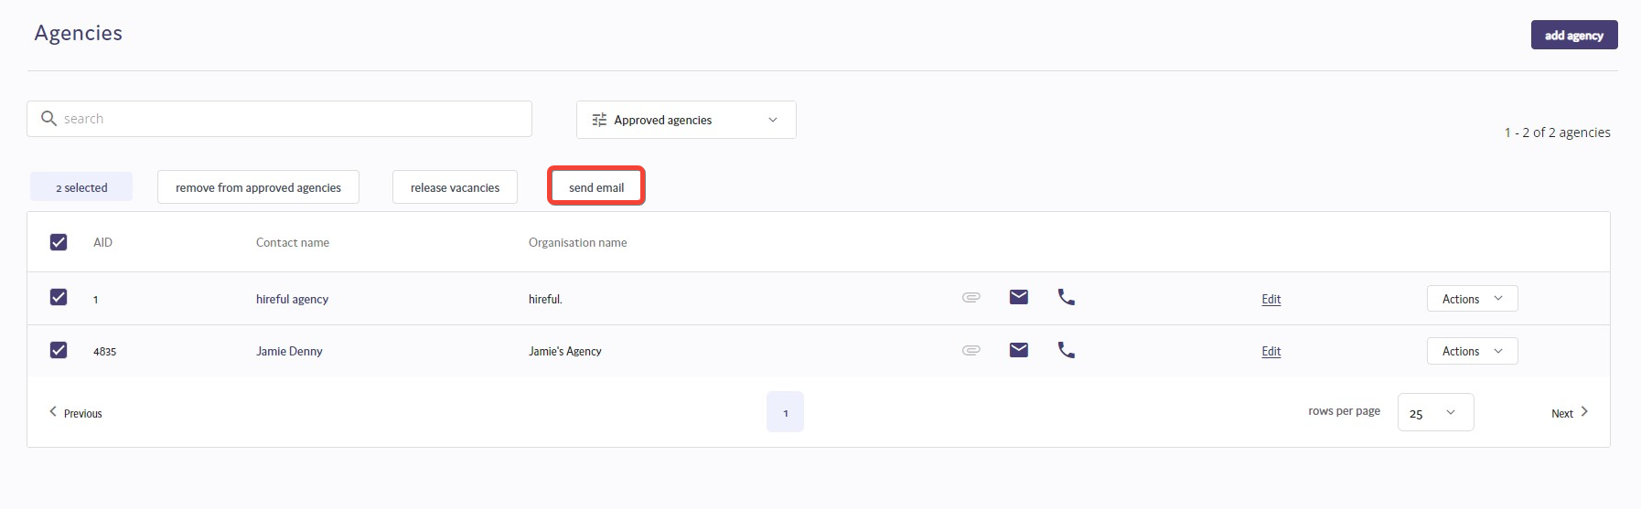
When you click on the relevant email templates option on the admin list you will see the following "Create / edit email template" screen. See below for the image and notes explaining the purpose of each field.
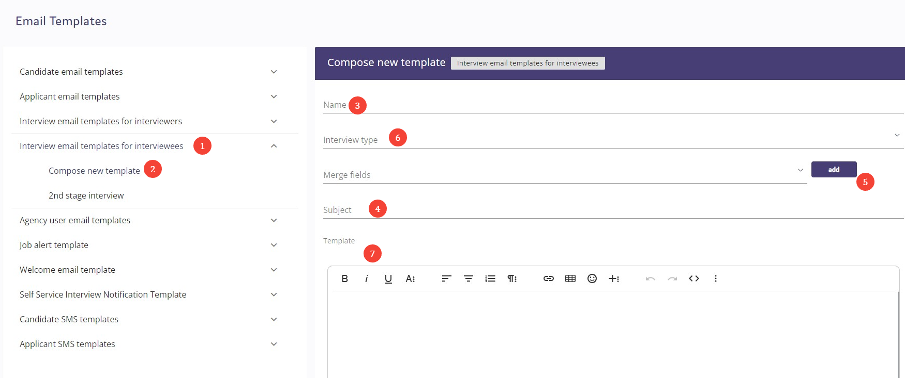

1. This field is not editable and is there to remind you of the type of email template you are creating / editing.
2. This option let you create a new template or edit and existing template.
3. This is the name that you want to give to the email template. The recipient of this email will never see the name, it will only be shown to users when selecting the email template.
4. This is where you add the subject of the email. Please note: You cannot add any dynamic data in the subject, for example, you cannot create a subject saying "Thanks for applying for our {{job_title}}" and expect the email template to add the relevant job title into the subject. The dynamic data you add via field (5) only applies to the message body (7).
5. This option allows you to choose from a large range of dynamic data which you can add to the email. The most obvious example would be the candidate's name, so you might start an email with "Dear {{candidate_first_name}}," as shown in the example below.
Please note: The options available in this field will depend on the type of email template you are creating. For example, interview templates can include interview dates, times, job details.
6. This option only appears when you are creating an interview template and serves to confirm whether you are creating and interview template for face to face or telephone interviews.
7. When you have created your email select ADD and it will be saved to the system. You can then choose to edit it at any point in the future by selecting it from the list in filed (2).
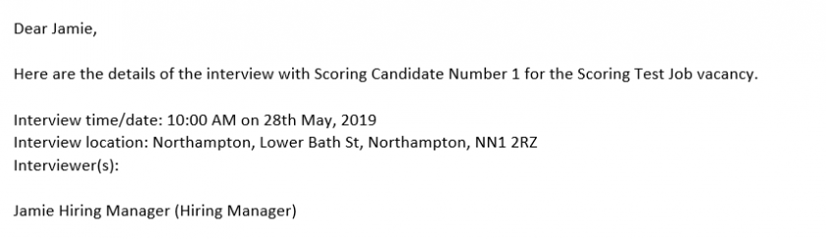
Copying an email template.
You are able to copy existing email templates by selecting the relevant template from the list in field (2). Update it to the new format you need, give it a new name (3) and finally select "SAVE AS NEW" which will allow you to create a new email template.
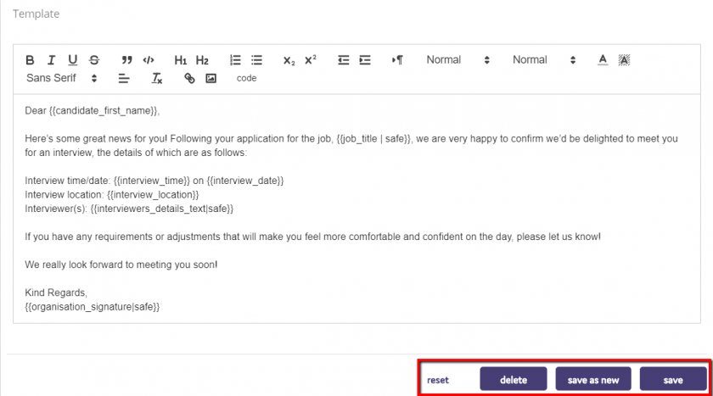
Using email signatures with email templates.
You have two options when you are looking to add a signature to your email template. Firstly, you can choose to add the "Organisation Signature". This will send the email with a signature at the bottom that is generic, for example, from "Recruitment Department". Alternatively, you can choose to select "User Signature", which will add the signature for whichever user is the choosing to use this template.

